COVID-19 Status

**Patient admitted**

**Positive**

**Negative**

Issue dental equipment

Continue with **Mouth Care Assessment**

**No**

**>24 hours**

**< 24 hours**

Length of admission

Provide mouthwash and patient info leaflets:

* **COVID-19 Mouth Care Guidance**
* **COVID-19 Mouth Care – Visual aid**

If patient has dental issues, advise to see dentist upon leaving hospital.

If a patient is not registered with a dentist, advise to use NHS direct 111 service (details on patient information leaflet).

Some patients may require a referral to community dental care from their dentist/GP.

For urgent conditions whilst an inpatient, OMFS can be contacted.

Repeat Mouth Care Assessment weekly, or if patient conditions changes

For patients requiring support for mouth care, or patients with additional mouth care needs:

Ward staff to assist/perform mouth are and record on Daily Log Sheet

If the patient has dentures, ensure a is present above their bed



**Carry out Mouth Care Assessment**

*To be carried out by ward staff; nurse or HCA with assistance from mouth care champion/doctor +/- liaison with specialist team if required.*

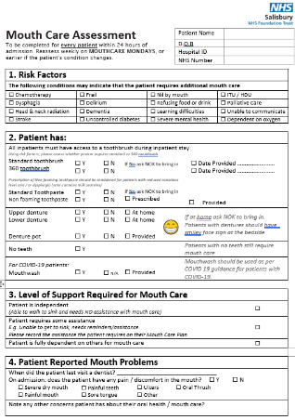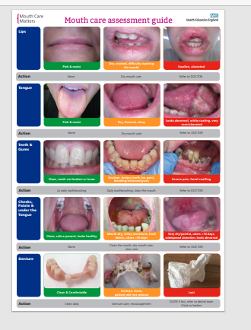

Fill in **Mouth Care Plan**, using findings in **Mouth Care Assessment**

*To be completed by ward nurse or HCA*

*with input from medical team/ SaLT/ EOLC Team/*

*other specialist team if required.*

This may change over time depending on the patients’

conditions: this must be kept up to date.

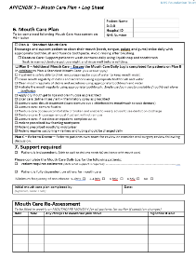

Give patient info leaflet: **Caring for your mouth when in hospital**

For independent patients, requiring standard mouth care: Patient to be responsible for own mouth care whilst in hospital

**Yes**

Does the patient have their own equipment?

Not mandatory to carry out Mouth Care Assessment.

* If patient has dental issues, advise to see dentist upon leaving hospital.
* For urgent conditions, OMFS can be contacted.