Surgical Safety Checklist (LocSSIP) for Insertion of Nasal Bridles

SIGN IN  To be completed by the individual inserting the nasal bridle | TIME OUT  To be completed by the individual inserting the nasal bridle |  |  | SIGN-OUT  To be completed by the individual inserting the nasal bridle
Patient identity:  Confirm name, DOB, hospital number: Y / N | Repeat prior to commencing procedure |  |  | Is the bridle secured with a knot?: Y / N  Ensure knot too tight to nasal septum: Y / N  Disposal of equipment safely: Y / N  Hand over to ward staff for daily reviews. Y / N  Any serious untoward incidents whilst using the nasal bridle should be escalated immediately, a Datix report must be completed and nutrition nurse specialist informed.
Procedure:
Confirm clinical indications for procedure: Y / N
(see below)
Confirm no contraindications to procedure: Y / N
(see below)
MDT discussion documented in notes?: Y / N

Ask:
Does patient have mental capacity? Y / N
If yes;
is patient aware of indications?: Y / N
has the patient given verbal consent?: Y / N
If no;
has a best interest decision been made?: Y / N

Equipment:  Check availability of nasal bridle equipment:  Signature………………………………………….. | Check that equipment is functioning: Y / N  Prepare trolley with equipment: Y / N  Signature………………………………………….. |  |  | Signature…………………………………………..
AFFIX PATIENT LABEL HERE |  | Signature | printed name |  | designation | Date:  Time:  Location:
Individual inserting nasal bridle:

Clinical supervisor (if present):

Insertion of Nasal Bridles - Local Safety Standard for Invasive Procedure (LocSSIP)
This LocSSIP applies to all nasal bridles inserted in adult patients within CDDFT Salisbury NHS Foundation Trust. The decision to insert a nasal bridle, for the purpose of retaining nasogastric and nasojejunal tubes in place, must be made following careful assessment of risks and benefits by at least two competent health care professionals including the senior doctor responsible for the patient’s care. Please refer to the Trust’s Restrictive Practice policy. Restrictive Practice Policy (microguide.global)
Sign in is the safety check that must be carried out on arrival at the procedural location for all patients undergoing invasive procedures.
- Patient identity check

- Indications checked;
- There is documented evidence of inadvertent displacement of the NG/NJ tube
- An enteral feeding tube is placed and where enteral access will no longer be available if the tube becomes misplaced or removed
- The placement of the NG/NJ tube is of high risk or technically difficult
- There is documented medical evidence for the need for essential nutrition and medication that cannot be given in any other less restrictive option.

- Contraindications checked
- Patients who have capacity and refuse treatment or where there is a valid Advanced Decision to Refuse Treatment in place which is specific to this situation. In these circumstances you must always seek advice from the Risk Department.
- Extremely confused/agitated patients who may continue to pull the tube and cause trauma to nasal septum
- Patients with basal skull fractures/facial fractures
- Patients with deviated nasal septum/mechanical obstruction of the nasal airway
- Patients with any structural deformity of the nose or nasopharynx
- Patients with severe blood clotting disorders, INR >1.5
- Patients who are unable to demonstrate appropriate response to painful stimuli, e.g. some head injuries, advanced dementia
Patients with dementia should be considered on an individual basis after consultation with the MDT and family. Tube feeding and nasal bridle placement should only be done if assessed to be in the patient’s best interest.
- Consent/ best interest process followed:
The decision to use nasal bridles should be a multidisciplinary decision between the Consultant, Nurses, Dietitians, patient and relatives. Valid consent (verbal) must be obtained and documented in the patient’s medical notes prior to using nasal bridle. If the patient lacks capacity, a formal assessment of capacity must be carried out and best interest’s decision made using the Trust recognised assessment tool (Mental capacity act, 2005), a copy of which must be kept in the patient’s medical notes. There must be a discussion and full involvement of the next of kin/family/carers prior to use. DOLS should be considered in tis instance.
Time Out must be performed immediately before the start of the procedure and should not be performed until any omissions, discrepancies or uncertainties in the sign in have been fully resolved. Performing the time out will verify patient, site and procedure as a minimum.
Sign out is the safety check carried out at the end of all invasive procedures but is carried out before the handover to the post-procedure care team. It also forms part of the WHO local safety standards for invasive procedures.

If an unexpected event occurs, document and complete and report the incident as necessary.

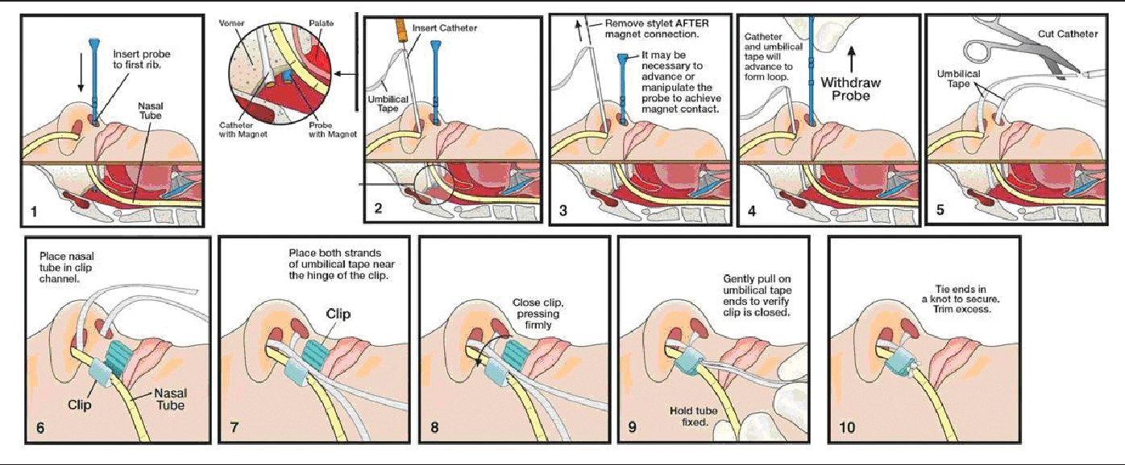

Care of patient with nasal bridle

Daily:
- Check the nasal loop tapes and clips are secure.
- Check that the clip is not causing any pressure to under-lying skin.
- Inspect the skin around the nostrils for any signs of soreness/ pressure necrosis.
- Clean around nostrils to prevent build-up of any crusting and reduce the risk of skin becoming sore.
- Apply skin barrier as required.
Refer to the nutrition nurse/ senior ward sister for advice if you have any concerns.
Nasal retaining loop removal:
If the patient becomes very agitated and is pulling aggressively at the NG tube you may have to remove the nasal bridle to prevent damage to the nasal septum. Please discuss with the senior sister on the ward, the consultant responsible for the patient or the nutrition nurse specialist first if available.
Out of normal working hours ward staff can remove the nasal bridle if becomes absolutely necessary, but please consider:
- Other methods of avoiding removing the bridle, e.g. distraction.
- How will the patient receive nutrition if the NG tube is removed?
How to remove nasal bridle:
Cut the ribbon with scissors from the opposite nostril to where the NG tube is inserted. With the clamp and the tape still attached to the NG tube, then remove the whole tube.

