Echocardiograms that have gone through the process correctly should be viewable in PACS via XDS. This means that the report has been sent from CVIS to PACS and will show as a PDF report in PACS.
To view this, find the exam you need in PACS, between the patient history and the Image thumbnails you should see a PDF icon. Double click on this. This will then open the PDF document.
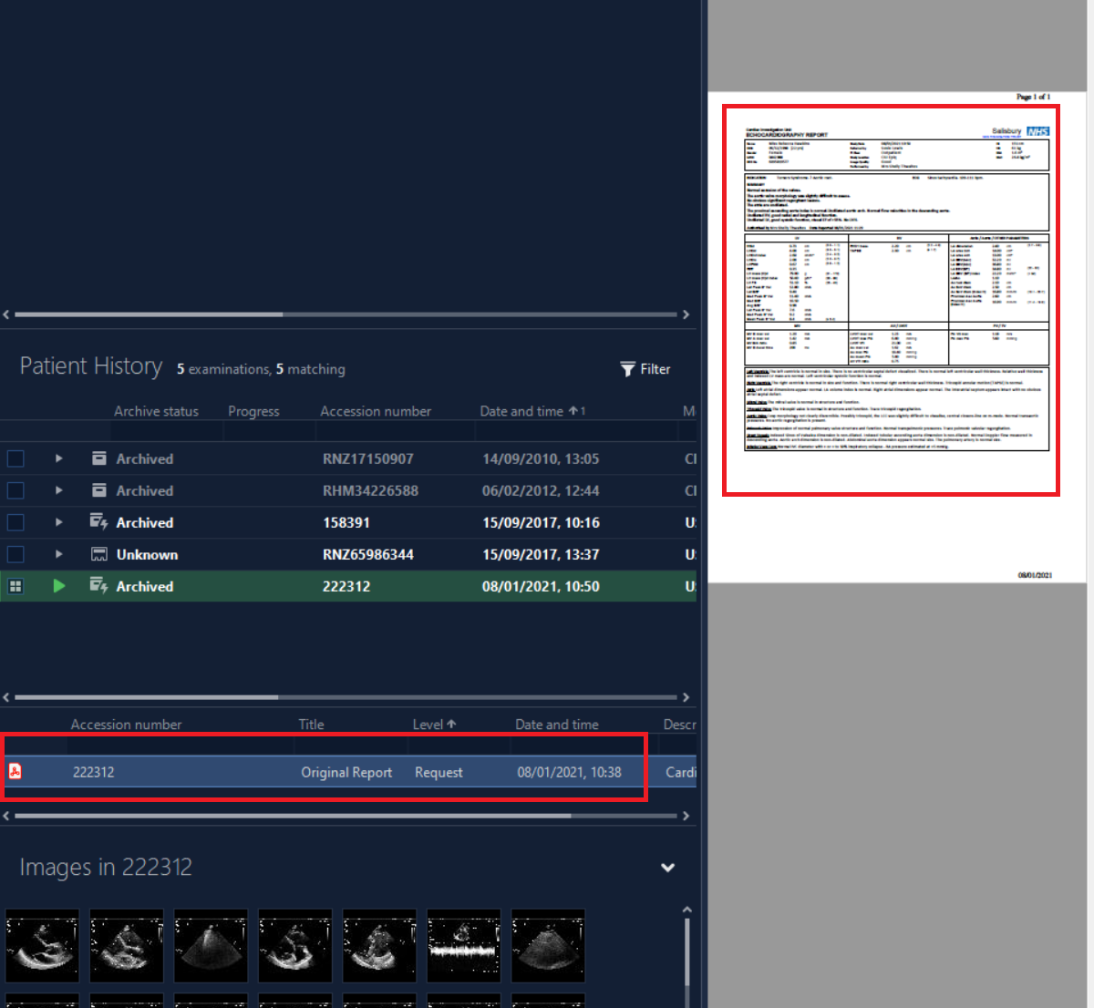
If you receive an error message to say that you are unable to view the PDF, please call 2040.
If an event is unsolicited, then CVIS will not send the report to PACS. This must be administered by the PACS Team, who will manually take the report from CVIS and add the report as an image at the end of the Echocardiograms.
You will see that there are no documents but the last thumbnail in the imaging contains the report. Open the Images by double clicking on the event to see the report.
