Appendix A
Guidance for checking authenticity of Fit Notes
There are websites where you can purchase very authentic looking fake Fit Notes for around £10. In addition, there is sophisticated editing software available which enables an original Fit Note to be manipulated into a forged Fit Note.
Consider the following when you receive a Fit Note from a member of your team:
- Does the Fit Note have a different unique ID number than Fit Notes previously submitted? All Fit Notes should have a different unique ID number at the bottom.
- Does the font change on the Fit Note, especially in the date boxes? The font should be consistent.
- Does the text fit into the boxes, especially in the date boxes? Text should not be misaligned.
- Does the GP signature always appear to be in exactly the same place in a series of Fit Notes? You would expect slight variations in the signature box.
- Is the GP signature typed? It should be a handwritten signature.
- Have the dates been altered and allegedly initialled by the GP?
- Only accept an original Fit Note if possible, not a scan or photo. Tippex for example may not be picked up on a scan.
- If an emailed Fit Note is accepted, ensure you receive the full email chain to show it has originated from a GP practice.
- If Fit Notes are handwritten, does the handwriting change or have different pens been used?
- Is the grammar poor or are there spelling mistakes on the Fit Note? Some medical conditions are tricky to spell, but a GP is very unlikely to make a spelling mistake.
- Is the amount of time off sick consistent with the illness? This is especially relevant on a handwritten Fit Note where 4 days off could easily be amended to 14 for example.
- On a printed Fit Note, the barcode can be scanned using a 2D matrix scanner to confirm that it is genuine
- If you have any suspicion, consider asking the GP Practice if the Fit Note has been issued by them. You are not asking for any confidential information, simply confirmation that the document is a genuine one issued by the Practice.

Example
- Genuine Fit Note:

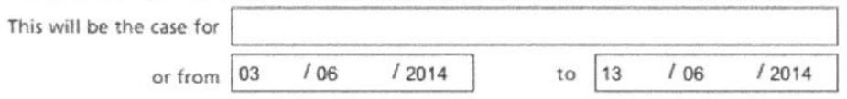
- Forged Sick Note:

The genuine Fit Note has been altered - 13 has been changed to 30. But the font of 30 is slightly bigger.
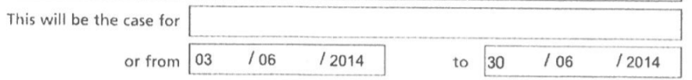

- Forged Sick Note:

The genuine Fit Note has been changed again. But 2014 is in a smaller font.
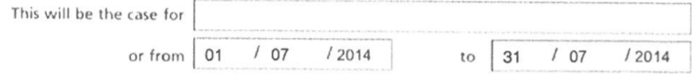
While these differences in font may be hard to spot, all three of these Fit Notes had the same Unique ID number at the bottom – this would never happen.
If you have any concerns about the authenticity of Fit Notes, contact the HR department or your Counter Fraud Specialist.

