Salisbury NHS Foundation Trust

Midwifery Preceptorship Package

Preceptorship Package
For Newly Qualified Midwives
January 2023
Maternity and Neonatal Services
Salisbury NHS Foundation Trust

Name:

Preceptor:

Line manager:

Named PMA:

Start date:

Welcome to Salisbury NHS Foundation Trust and your first post as a Registered Midwife.
The first 12-24 months of being a newly qualified midwife (known as your preceptorship period) can be stressful, and is well recognised as an intense learning period whilst you move through the transition from being a Student Midwife to becoming a responsible and accountable professional. Throughout this period you will be supported in the workplace by an experienced Registered Midwife, who will be your preceptor. Additionally, you will have support from your line manager, a preceptor when working in the community, and your peer preceptee midwives.

This booklet has been designed to support and help you through this transition. It will guide and document your development through a minimum of 12 months framework, and contains the information you need to gain valuable skills and knowledge. It is your responsibility to ensure the completion of this booklet. There are specific criteria you will need to achieve within the stipulated timeframes to be eligible for consideration of progression to become a band 6 midwife.

Learning outcomes for Preceptorship Period

At the end of the preceptorship period the midwife should be able to:
- recognise their strengths and areas in need of development - interpersonal and practice skills
- provide evidence based, woman centred care
- develop skills and proficiency in time management and prioritisation of workload
- be an effective team member
- develop confidence in their competence as a midwife
- practice to the full extent of a band 5 midwife and be working towards the job outline of a band 6 midwife

The Role and Responsibilities of the Preceptor (and line manager)

Motivate

Support Facilitate

The preceptor will facilitate the transition of the midwife from new registrant to skilled practitioner. Your preceptor will be:
- confident in their practice
- sensitive to the needs of the women/babies/families
- an effective team member
- up to date with knowledge and practice
- aware of standards and expectations set by the employer
- facilitated and supported to gain new knowledge and skills
- able to utilise constructive feedback
- respectful of diversity

In cases where skills and competencies are not being developed as expected the preceptor/line manager will work with the preceptee to develop an action plan to address this

The Role of the Preceptee

- Take responsibility for their learning and development
- Be open and receptive to feedback on their practice
- Work in partnership with preceptor to identify, plan and achieve learning needs
- Responsible for maintaining and keeping personal portfolio up to date
- Will need to be flexible in time when meeting up with preceptor and completing Preceptorship Programme.
- It’s the responsibility of the preceptee to provide evidence to support their pay progression.
- work at all times within the remit of the NMC Code and the Trust conditions of employment
- attend pre-arranged meetings
- actively engage in the preceptorship process and take full responsibility for their development, seeking out opportunities to achieve objectives set
- identify learning and development needs; Use constructive feedback positively, and share in action planning for addressing concerns where necessary.
- seek support from their line manager and/or preceptor at any time if there are any concerns

There will be a minimum of five sessions that you will be expected to attend, the first of which is the short meeting that takes place during your first induction week. Thereafter, the following four meetings will take place approximately every three months. You will be expected to engage in reflections on your clinical practice experiences with your line manager and peers at this time and are encouraged to do so throughout the first year. Hopefully this will then be embedded for your ongoing midwifery career and will thus aid you in the revalidation process.
Initial meeting | Week 1: Meeting with named preceptor
First review meeting | Week 4: Working clinically with preceptor
Second review meeting | After 2 months: Group Preceptee Day
Third review meeting | After 4 months: Group Preceptee Day
Fourth review meeting | After 6 months: Group Preceptee Day
Fifth review meeting | After 9 months: Group Preceptee Day
Final meeting | After 12 months: Formal appraisal with line manager

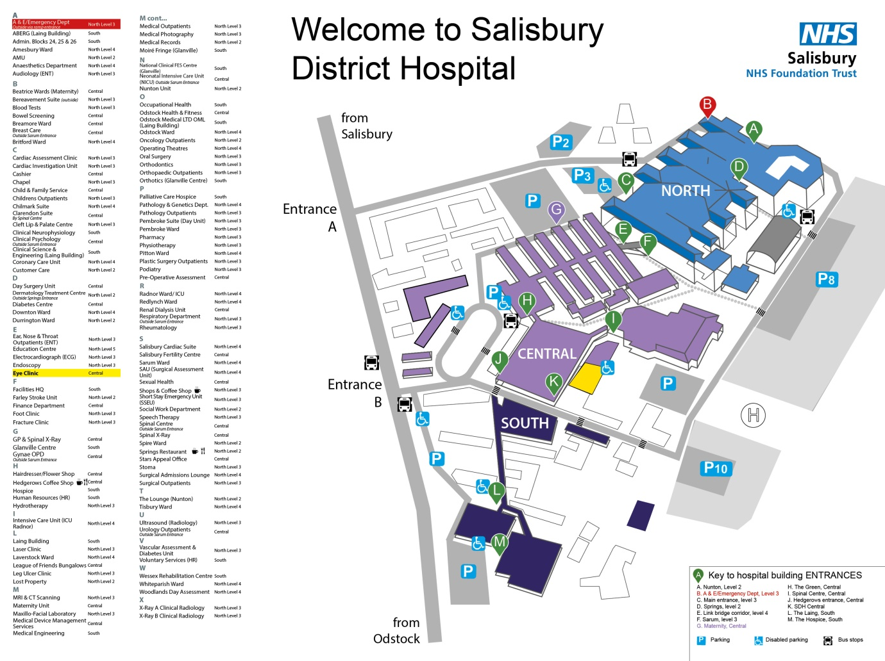
Orientating to the Maternity Unit:

Meet the Team

Role | Name | Date Met
Director of Midwifery | Joanne Hayward
Deputy Director of Midwifery | Vicki Marston
Inpatient Matron | Becky Roberts
Outpatient Services Matron | Liz Kimber
Quality and Safety Matron | Rachel Coleman
Digital Lead Midwife | Claire Lillywhite
Transformation Midwife | Emma Twine
Ward Lead Midwife | Jess Long
Safeguarding Lead Midwife | Ceri LeGresley
Lead PMA | Nicky Boardman
Community Lead Midwife | Laura Ware
Antenatal Screening Team | Kelly Henderson/  Lydia Coventry
PIMS Lead Midwife | Bea Longthorp
Fetal Surveillance Midwife | Tori Harper
Risk and Safety Lead Midwife | Bess Hadfield | Maternity Leave
Practice Education Midwife | Scarlett Leahy
Practice Education Support Midwife | Sophie Morton
Patient Experience Midwife | Alison Lambert
Bereavement Midwife | Steph Thompson
DAU and ANC Lead Midwife | Katherine Guyatt
Neonatal Manager | Geoff Dunning

Mandatory Online Training for Midwives
MLE (www.mle.salisbury.nhs.uk)
- Moving and Handling (yearly)
- Infection Prevention and Control (2 yearly)
- COSHH (Control of Substances Hazardous to Health) (2 yearly)
- Safeguarding Children (Level 2 - 3 yearly)
- Equality and Diversity (3 yearly)
- Safeguarding Adults (Level 2 3 yearly)
- Mental Capacity Act (2 yearly)
- Conflict Resolution (3 yearly)
- Data Security Awareness Level 1 (yearly)
- Fire Safety (yearly)
- PREVENT Level 1 & 2 (3 yearly)
- Teletracking (once)
- Blood Gas Analyser (ward based) (yearly)
- Freedom to Speak Up (MLE)

Perinatal Institute on E-Learning for Health (e-lfh.org.uk) (yearly)
- Growth Assessment Protocol Module 1 & 2

Blood Transfusion Competencies (e-lfh.org.uk) (2 yearly)
- Blood 01: Essential Transfusion Practice
- Blood 06: Anti-D Immunoglobulin in Pregnancy

Smoke Stop Advice on E-Learning for Health (e-lfh.org.uk) (yearly)
- Very Brief Advice (VBA – smoke stop)

K2 CTG Training (training.k2ms.com) (yearly)
- Antenatal CTG
- Intrapartum CTG
- Intermittent Auscultation

Mandatory Training to be completed in the first year:
- Practical Obstetric Multi-Professional Training Day (PROMPT) (yearly)
- Midwives’ Mandatory Study Day (yearly)
- Basic Life Support (BLS) (yearly)
- Newborn Life Support (NLS) (yearly)
- Glucose meter (Inform 2) training (2 yearly)
- Blood Gas Analyser training (yearly)
- CTG Study Day (yearly)
- Blood Transfusion Sampling and Administration competencies (once)
- Blood Collection (Blood360) (once)
- Safeguarding Children Level 3 training day (3 yearly)
- Hand Hygiene Assessment (yearly)
- Intravenous cannulation training
- Perineal Suturing training

Suggested Learning Opportunities:
- Reflect on your own clinical practice
- Attend Case Discussion and Learning sessions
- Perinatal meetings
- Clinical and Maternity Governance
- RCM meetings
- Work with student midwives (and other allied healthcare professionals)
(after 6 months)
- Attend external study days and events
- Read professional research and journals
- Attend CTG case discussions

Evidence of Experience and Practice

Workplace Experience | Date(s) | Evidence gained?
Labour Ward
Day Assessment Unit
Postnatal Ward
Alongside Birth Centre
Community Visits
Homebirth Attendance
Study Days | Date | Evidence
Trust Induction
Cannulation
Perineal Suturing
CTG study day
PROMPT
Midwives Study Day
Safeguarding Level 3
Competencies | Date | Completed checklist
Cannulation
IV drug administration
Perineal suturing
Epidural Care
Induction of Labour
Clinical Experience | Date | Evidence
High Risk/Complex Care
Obstetric Emergencies
Drug Rounds
Postnatal Management

Initial Meeting with Preceptor
Date:

Where are you starting in clinical practice? What concerns (if any) do you have? What skills do you need to concentrate on? What help do you need?

Preceptors comments:

Signed:

1st Group Preceptee Day
Date:
Please give a summary of clinical practice to date - to include skills acquired/ skills being worked on. Have you been involved in any challenging experiences? How have you been supported as a newly qualified midwife?

What will you be focussing on over the next two to three months?

What support or opportunities do you feel you need to achieve the objectives set?

Preceptor Feedback:

Signature:

2nd Group Preceptee Day
Date:
Please give a summary of clinical practice to date - to include skills acquired/ skills being worked on. Have you been involved in any challenging experiences? How have you been supported as a newly qualified midwife?

What will you be focussing on over the next two to three months?

What support or opportunities do you feel you need to achieve the objectives set?

Preceptor Feedback:

Any Actions required?

Signature:
3rd Group Preceptee Day
Date:
Please give a summary of clinical practice to date - to include skills acquired/ skills being worked on. Have you been involved in any challenging experiences? How have you been supported as a newly qualified midwife?

What will you be focussing on over the next two to three months?

What support or opportunities do you feel you need to achieve the objectives set?

Preceptor Feedback:

Any actions required?

Signature:

Final Group Preceptee Day
Date:
Please give a summary of clinical practice to date - to include skills acquired/ skills being worked on. Have you been involved in any challenging experiences? How have you been supported as a newly qualified midwife?

What will you be focussing on over the next two to three months?

What support or opportunities do you feel you need to achieve the objectives set?

Preceptor Feedback:

Has an appraisal been arranged with preceptee’s line manager?

Signature:

Preceptorship Midwife Reflection
Preceptee Name:

Date of Reflection:

Description: What happened?

Feelings: What were you thinking and feeling at the time?

Evaluation: What was good and bad about the experience?

Analysis: What else can you make of the situation?

Conclusion: What else could you have done?

Action Plan: What would you do if the same experience arose again?

Further Thoughts:

Discussed with Preceptor/Line Manager:

Date:

Preceptorship Midwife Reflection
Preceptee Name:

Date of Reflection:

Description: What happened?

Feelings: What were you thinking and feeling at the time?

Evaluation: What was good and bad about the experience?

Analysis: What else can you make of the situation?

Conclusion: What else could you have done?

Action Plan: What would you do if the same experience arose again?

Further Thoughts:

Discussed with Preceptor/Line Manager:

Date:

Preceptorship Midwife Reflection
Preceptee Name:

Date of Reflection:

Description: What happened?

Feelings: What were you thinking and feeling at the time?

Evaluation: What was good and bad about the experience?

Analysis: What else can you make of the situation?

Conclusion: What else could you have done?

Action Plan: What would you do if the same experience arose again?

Further Thoughts:

Discussed with Preceptor/Line Manager:

Date:

Completing the Preceptorship Programme
The length of your preceptorship may vary for each individual based on your own clinical experiences, confidence and self-reflection. This can range from a minimum of 12 months to 24 months. Once you feel you are competent to become a band 6 midwife, you can arrange a meeting with the education team and your line manager.
Following your preceptorship, we expect to see evidence of your learning, self-reflection on your practice and experiences and confidence to support junior colleagues/students in the workplace.
As a band 6 midwife, this is demonstrated through a professional portfolio which is reviewed every 3 years during revalidation.
We expect you to be up to date with all mandatory training and to have had an appraisal with your line manager, which is completed on ESR (Electronic Staff Record). Your clinical competencies should be well developed but it is not essential they are fully completed.
There will be a panel including the maternity education team, a community midwife and an inpatient midwife. This is where you can discuss your preceptorship experiences and how this has prepared you to transition to a band 6 midwife. Questions and discussions will be held around your abilities to risk assess, your clinical reasoning and management of a ward or a caseload of women. Feedback from colleagues, your appraisal and women/families in your care is advised.

Notes:

