CLASSIFICATION AND CLINICAL APPEARANCE OF BURN INJURY
Depth of Burn | Usual History | Appearance | Sensation | Hairs | Blisters | Outcome | Scarring
Erythema/ Superficial | Sunburn  Minor scald | Red | Painful | Present | Absent | Heals within 3-6 days | No scarring | 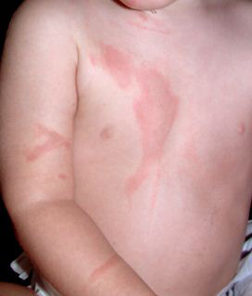
Superficial/Partial Thickness | Scalds of limited duration | Red or pink with good capillary return | Very Painful | Present | Present | Heals within14 days if infection free | No scarring | 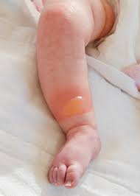
Partial Thickness/Deep Dermal | Scalds of long duration. Flame burns or contact with high temperatures of limited duration, e.g. flash flame, hot fat | Bright red with fixed staining or pale white with limited/no capillary return | Often painful around the margins with altered sensation in deeper areas | Present and easily removed or absent | Absent | May heal in more than 3 weeks | Can become  hypertrophic | 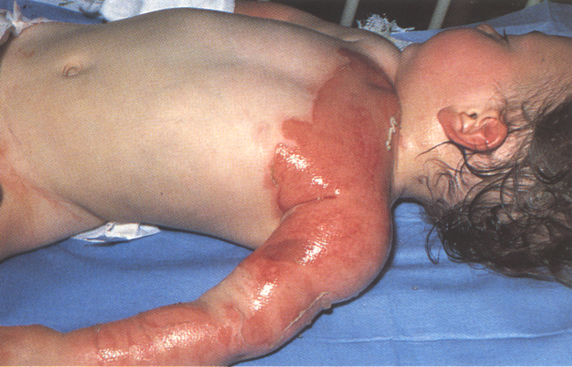
Full Thickness | Contact with high temperature for long duration, e.g. flame burns, contact burns | Charred, white/yellowish, dry with thrombosed vessels | Initially lacking sensation. Painful at later stages | Absent | Absent | May require skin grafting | Often becomes hypertrophic | 

