**BURNS**

**DRESSINGS PATHWAY**

**SUPERFICIAL PARTIAL**

**DEEP PARTIAL**

**FULL THICKNESS**

**IF FULLY DEBRIDED LEAVE IN SITU FOR..**

**7 DAYS 7 DAYS**

**5 DAYS**

Mepliex or Mepilex Ag UrgoClean Ag Aquacel Ag Extra +

WET

2 LAYERS

**BURNS GAUZE**

**BURNS GAUZE**

**BURNS GAUZE**

**BANDAGE**

**BANDAGE**

**BANDAGE**

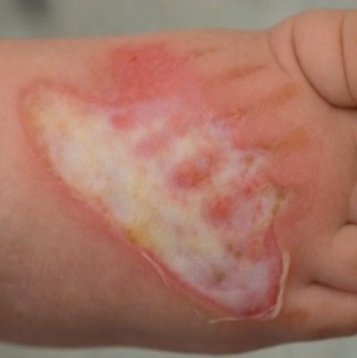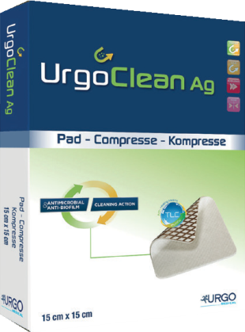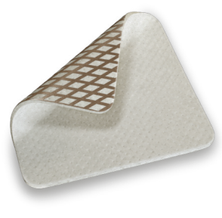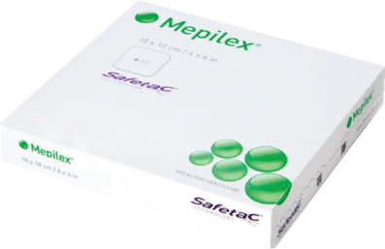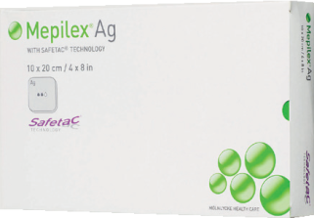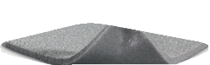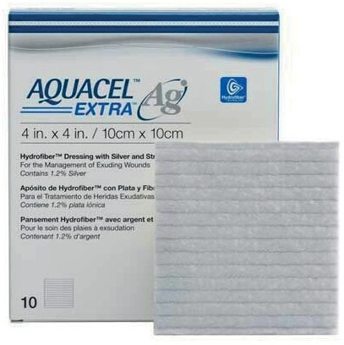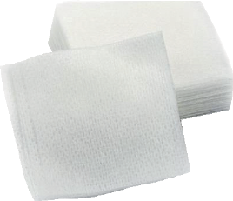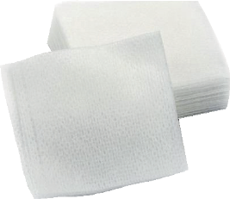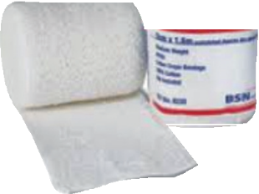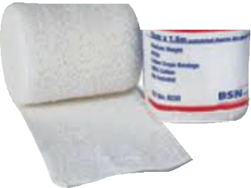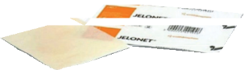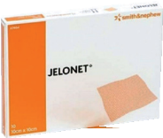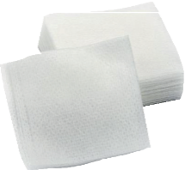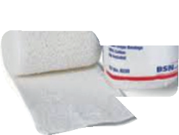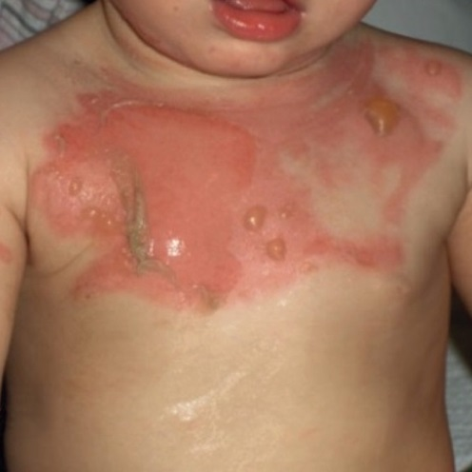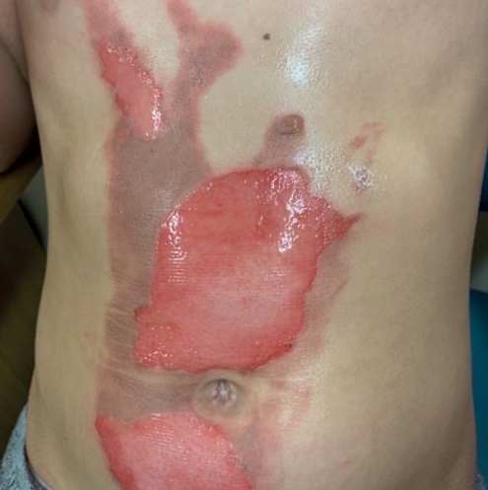

*Created by Nicola Beavan Paediatric Burns Specialist Nurse, Salisbury Hospital*