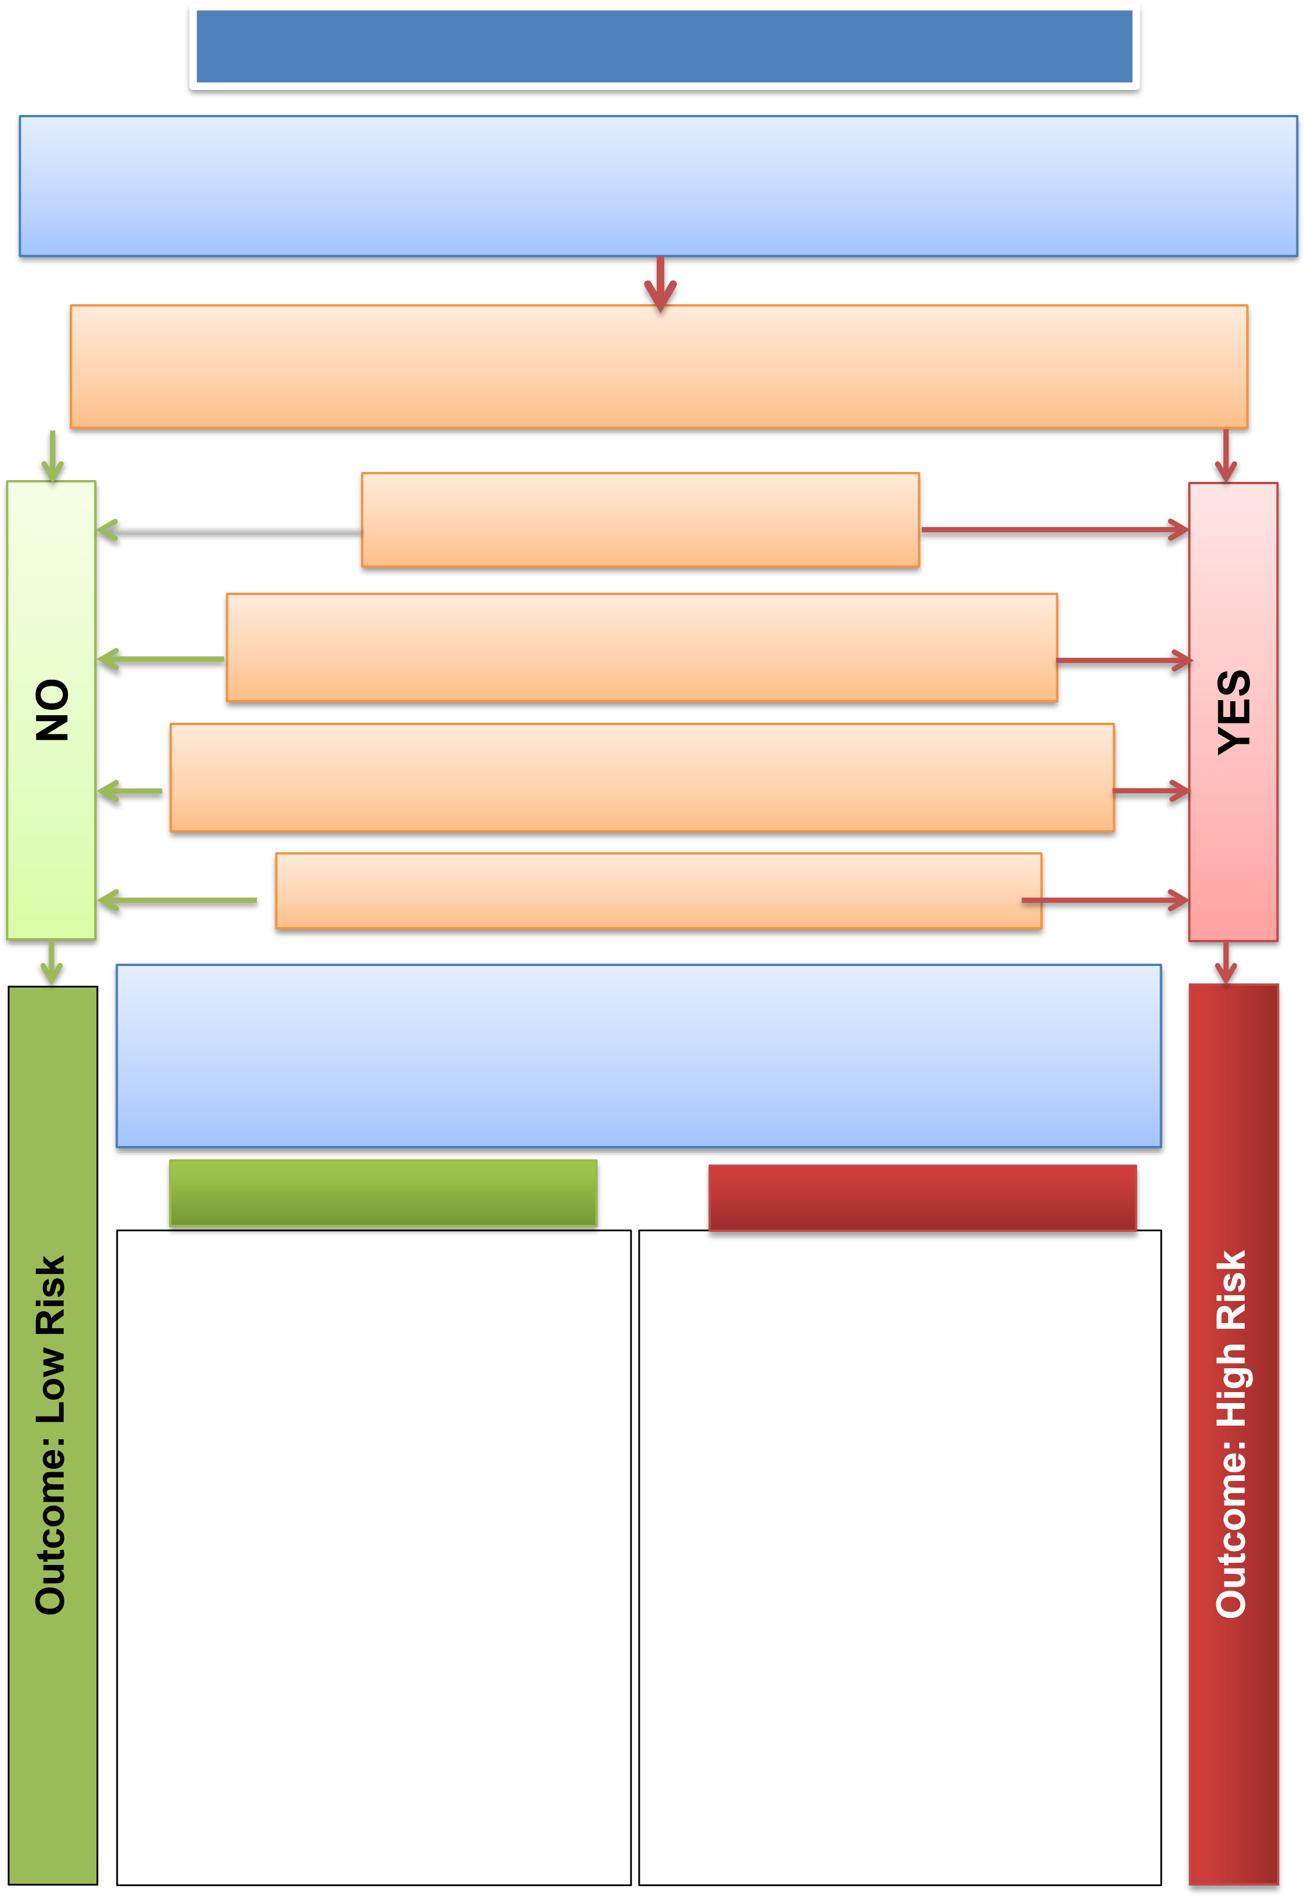

Missing Patient Flow Chart Quick Reference Guide

Adult / Child missing from ward/department – unable to contact, ward searched, mobile phoned Bleep Security on 1249
Escalate to Matron, Clinical Site & Medical Team

Has the patient ‘absconded’? Are they detained or likely to be detained under the MHA,
the MCA DoLS? Are they subject to a public health order or in custody (Police or Prison)?
Are they under 18 years of age?

Is the patient at risk of immediate threat to life?
and limb as a result being missing?

Does the patient lack mental capacity to consent to / decline care and
treatment? This should be documented or based on a reasonable belief.

Is the person likely to suffer serious harm, including risk of exploitation or abuse,
or cause serious harm to another person because of going missing.

Do you believe the patient wishes / intends to take their own life?

Be prepared to provide a clear rationale to the Police.
Ensure you have access to senior medical advice.
DON’T DELAY IF YOU THINK THERE IS A RISK
NURSE IN CHARGE TO CALL THE POLICE

LOW RISK HIGH RISK

- Ring the patients mobile & home number
- Inform Nurse in Charge, Matron, Security and Consultant
- Unable to locate or make contact with the patient, or the patient refuses to return to hospital.

Complete discharge letter and notify the GP, named contact and other relevant professional agencies (Social Care, Community Nurses).

Document all your actions and assessments in the patient’s Health Care Record.

If you receive new information that may
change the outcome, review the flowchart & escalate

- Notify the Police advising them of the risk level and your concerns.
- The Police may ask you the questions from appendix 1, 2nd page, be prepared to have the information available.
- The Police will want to speak to the last people (doctor and nurse) that saw the patient. They may need to remain in the area or leave a telephone number to speak to the police.
- Contact patients named contact.
- Liaise with clinical staff throughout regarding clinical concerns of the patient.
- Inform the Duty Manager who will escalate to the Exec Director on call.
- Document your actions in the Health Care Record and complete a DATIX incident form ticking the safeguarding box.

Missing Person Information for Police (by phone or in person)
Name & number of officers taking the report:
Patient details including Full name, DOB, Address, Telephone numbers: Preferred Name/Nickname
(INSERT PATIENT STICKER)
Brief circumstances of patient going missing:
Where last seen | When last seen |  | By whom?
Individual’s description. – Including clothing

Steps taken so far to trace the individual. (Preliminary actions undertaken)
Is this out of character |  | YES - why. |  |  | NO
Why are you concerned?
What was the reason for this patient being deemed high risk?
Any known intentions or preparations made prior to going missing? |  | YES - what. |  |  | NO
Have they taken any personal items with them? |  | YES - what. |  |  | NO
Do they have a mobile phone with them? |  | Has it been tried? |  | Number
Any known places they may go?
Are they subject to any MHA section or MCA DoLS |  | YES - What and Why |  |  | NO
Any specific medical needs that require medication |  | YES - Effects and timescales if not available |  |  | NO
Are they likely to be a victim of crime |  | YES - Why |  |  | NO
Are they likely to be a victim of abuse |  | YES (DV/Sexual/Racial/bullying/Homophobic) |  |  | NO
Are they at risk of sexual exploitation or have a Child Protection Plan |  | YES – From whom |  |  | NO
Are they likely to self-harm, attempt suicide |  | YES – Give details, including last known attempt |  |  | NO
Have they been exposed to harm in any previous missing episode |  | YES - When |  |  | NO
Do they pose a danger to themselves or any other persons |  | YES- give detail |  |  | NO
Does the missing person have a current or previous history of drug or alcohol abuse |  | YES – Give details |  |  | NO
Details of any vehicle using or normal mode of transport if none
Details of messaging and social media used |  | What format and usernames and passwords if known
What access do they have to money
Is there any other information relevant to their absence that may affect or influence a supervisor’s risk assessment?

Appendix 3

High Risk Missing Person Found Report- post incident Joint Agency Debrief

Patient Sticker | Ward / Department:  Date and Time Patient Found:  Police reference number:
Found address: | Officer Details:
DEBRIEF DATE:
Led By:
Attendees & Agency:

Missing Voluntarily? Yes / No |  | Lost or injured? Yes / No
Found at: Returned of own accord / Found at home address / Found at relative address /Found elsewhere Describe circumstances:

Found by: Family / Police / carers / Other persons / Arrested / Recovered warrant MHA / Other Describe circumstances:

Transport for return: Police provided / Carers provided / Not required / Ambulance required Describe circumstances:

Suffered harm? Unharmed / Physical injury / Sex Offence / Other crime / Abduction / Unexplained death /
Murder
Describe circumstances:

Circumstances While Missing: Slept rough / Stayed with friend / Met up with other / Went to location / Went to place previously lived or frequented / Stayed in hotel or other commercial premises / Misper refused or declined information / Not known / other Describe circumstances:

Criminal activity: No crime committed / committed crime Describe circumstances:

Time spends missing: Less than 24 hours / 24-48 hours / 3-5 days / More than 7 days Describe circumstances:

Distance away from point missing: 0-5 miles / 6-210 miles / 11-20 miles / 21-40 miles / 41-80 miles / over 81 miles / out of UK.
Describe circumstances:

Reason for going missing: Problems at home / personal problems / problems at school / other reasons / declined to give reasons / Lacks mental capacity to provide reasons Describe circumstances:

Lessons Learnt

Recommendation

