Procedural Sedation and Analgesia (PSA) by Intravenous Administration in Radiology

Pathway Insert

This page has been left blank

Pre-assessment by Interventional Radiology (IR) Nurse for
Procedural Sedation and Analgesia
Name of Nurse filling out form: Date:

To be used in conjunction with IR procedural pathway

Confirmed patient understands the nature of sedation and analgesia, with an explanation of the intended benefits of alleviating anxiety and pain during the procedure Y/N

Confirm any additional recovery time due to sedation and patient aware Y/N

Confirm nurse availability for role of sedationist Y/N

Confirm past medical history as detailed on IR procedure pathway Y/N

Exclude contraindications to PSA
- Obstructive sleep apnoea Y/N
- Breathless at rest or short of breath on lying flat Y/N
- No history of reaction or sensitivity to sedatives Y/N
Seek anaesthetic advice if ASA grade ≥ 3
- Details….

Confirm patient able to lie still for procedure (prone or supine as IR procedure requires)

Y/N
Confirm medications detailed on IR procedure pathway Y/N

Confirm allergy status Y/N
Confirm fasting instructions
Nil by mouth 6 hours, Clear fluids until 2 hours prior to procedure Y/N
Confirm transport and responsible adult to collect and Y/N
accompany patient for 24 hours

Informed of restrictions post procedure
no driving, no alcohol, not to be responsible for minors,
not to sign any legal documents for 24 hours Y/N

PIL sent to patient Y/N

Airway Assessment Guide

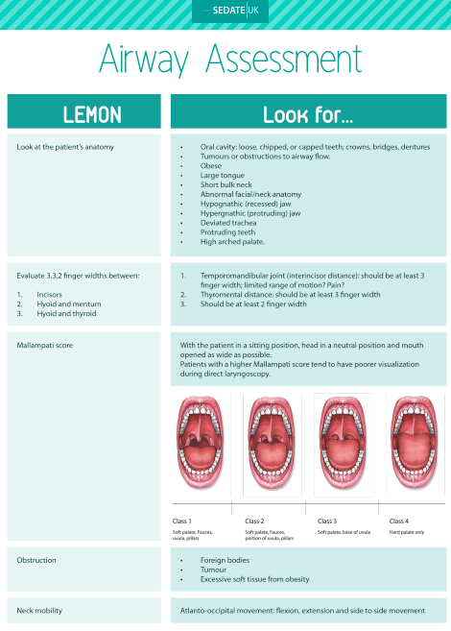

(Cook, C., Lees, M., Kellow, N., Segal, O., & Trigo, A. (2016, August). Retrieved from SedateUK: https://sedate-uk.com/wp-content/uploads/2018/08/Lemon-2.pdf)

Pre-Sedation Checklist

To be completed in addition to IR procedure checklist

Name of nurse completing form:
Date: | Procedure: | Allergies:

Medical History

Current Medication
Perform airway assessment following LEMON (SedateUK)  Any issues escalated to IR consultant | Safe airway Y/N
ASA grade: 1 2 3 | ASA 1-2 Y/N
Age:  Height:  Weight:  BMI: | BMI <35 Y/N
Fasted | Y/N
Dentures removed | Y/N N/A

Baseline Observations
BP: | HR: | RR: | S_{p}O₂:

Reviewed by IR consultant as fit to undergo PSA Y/N

Consultant Name: Signature: Date:

Procedure

Follow IR consultant direction for PSA dose administration and subsequent titration to effect administration

Interventional Radiology Patient Monitoring Chart during Procedural Sedation and Analgesia to be completed providing 5-minute observations

Record the Alertness in Sedated Patients (ASP) score

Detail medication administration on the observation chart and on the IR procedural pathway

If verbal responsiveness is lost, an anaesthetist should be sought:

Duty consultant anesthetist bleep 1713
Anaesthetic department ext 2050
ICU registrar bleep 1319
ICU consultant bleep 1373

Consider calling 2222 to request adult MET support

Prepare reversal agents and follow consultant direction

Post procedure

Patient into recovery at:

Ensure call bell to hand Y/N

Care Guidelines: | Rationale:
Monitor the patient for 30 mins, at 5-minute intervals, after last administrated PSA  Then revert to IR procedure monitoring  If the patient required reversal agents monitor at 5-minute intervals for 60 minutes.  Follow NEWS2 (trust policy) and escalate when triggers NEWS score. | To determine if the patient is recovering to pre-procedural level of consciousness  Use the dedicated sedation NEWS chart to record sedation (ASP) level  Precautionary to identify if re-sedation occurring. Preserve airway patency.  Escalate to IR consultant  Escalate if concerned contacting anesthetist on call or ring 2222 for MET response  Duty consultant anesthetist bleep 1713  ICU registrar bleep 1319  ICU consultant bleep 1373  Escalate to IR consultant  Escalate to referring team as appropriate
Patient may eat and drink as directed by IR procedural guidance and once fully awake and responsive. | Precautionary in case of post procedure complications requiring radiology intervention/surgery.
Observe for rashes, wheezing and shock. Call for help immediately if detected. This may require a MET call (2222) if the patient is having a severe reaction. | Early detection of adverse drug reaction. More likely to occur peri or immediately post procedure but can be delayed.

Radiology Discharge Criteria Post Sedation

TEST | Assessment | ü | Score
Consciousness | Fully Awake and stable vital signs |  | 2
 | waking on calling |  | 1
 | non-responsive |  | 0
Pain | Pain free |  | 2
 | Mild pain controlled by simple oral medication |  | 1
 | uncontrolled pain |  | 0
Ambulation | Able to stand and walk if appropriate |  | 2
 | dizzy when standing |  | 1
 | dizziness when supine |  | 0
Fasting/Feeding | able to drink and eat |  | 2
 | nauseated |  | 1
 | nausea and vomiting |  | 0
Urine Output | has voided |  | 2
 | unable to void but comfortable |  | 1
 | unable to void and uncomfortable |  | 0

Total score=
Score ≥8 Patient Safe for discharge
Fit for Discharge:  Care for 24hrs post sedation  Canula removed  VIP score: | Not Fit for Discharge:  Reason:  Admitted to: Time:  Medical Staff Informed  Relative Informed
Score ≤7 Continue Observation or admit

Print:…………………………………. Sign: ……………………………………. Date: ………………

