Maternity and Neonatal Services

Governance Framework

Division Responsible for Policy: | Women and Newborn Division
Name of responsible board/committee: | Women and Newborn Divisional Governance committee
Post Holder Responsible for Policy: | Director of Midwifery and Neonatal Services
Contact Details: | Vicki.marston1@nhs.net
Date Written: | May 2023
Approved By: | Maternity Governance
Date Approved: | June 2023
Approved By: | DMT
Date Approved: | November 2023
Ratified by: | CMB
Date ratified: | 15th November 2023
Date Policy Becomes Live: | December 2023
Next Due for Review: | November 2026

Table of Contents
1.0 SUMMARY 4
2.0 EQUALITY STATEMENT 4
3.0 INTRODUCTION 4
3.1 Accountabilities & Responsibilities 4
3.2 Board Safety Champion and Non-Executive Director 5
3.3 Local Maternity and Neonatal System 6
3.4 Women and Newborn Divisional Structure – Obstetrics and Gynaecology 10
3.4 Women and Newborn Divisional Structure – Maternity and Neonatal 11
4.0 ROLES AND RESPONSIBILITIES WITHIN MATERNITY AND NEONATAL SERVICES 12
4.1 Frontline Maternity and Neonatal Safety Champions 12
4.2 Quality and Safety Matron (Maternity and Newborn) 12
4.2.1 Quality and Safety Lead Midwife 13
4.2.2 Quality and Safety Midwife 13
4.2.3 Audit and Guidelines Lead 13
4.2.4 Family Experience Midwife 14
4.3 Director of Midwifery and Neonatal Services and Clinical Director of Women and Newborn Division 15
4.4 Obstetric Lead 15
4.5 Lead Obstetrician with Responsibility for Risk 16
4.6 Lead Consultant Obstetrician for Labour Ward 16
4.8 Lead Consultant Obstetric Anaesthetist 16
4.9 Antenatal and Newborn Screening Coordinator 17
4.10Neonatal Matron and Neonatal Consultant Lead 17
4.11 Neonatal Risk Nurse 17
4.12 Allocated Medical Leads for Maternity Guidelines / Audit & QI 18
4.13 Named Midwife for Safeguarding Children and Vulnerable families. 18
4.14 Lead Professional Midwifery Advocate 18
4.15 PMRT Lead Midwife 18
5.0 MATERNITY AND NEONATAL GOVERNANCE FORA 18
5.1 Maternity Risk and Governance Meeting 19
5.2 Risk Register Meeting 24
5.4 Maternity Guideline Group 24
5.4.1 National Guidance and Reporting 24
5.5 ATAIN Meeting 24
5.6 Maternity Clinical Audit Meetings 25
5.6.1 Audit Programme 25
5.6.2 UK Obstetric Surveillance System (UKOSS)/UK Midwifery Study System (UKMidSS) 25
5.8 Clinical Governance Half Day 25
5.9 ANNBS Operational Group 25
5.10 Maternity Safety Champions 27
5.11 Maternity Improvement Group 28
5.12 NHS Resolution/ CNST Maternity Incentive Scheme 29
5.13 Neonatal Governance Meeting 29
5.14 Perinatal Mortality Review Tool (PMRT) Meeting 29
6.0 Incident Reporting and Management 30
6.1 Case review and investigation process 30
6.2 Table: Case review and investigation process 32
6.2.1 Incidents graded as No Harm or Low Harm 33
6.2.2 Incidents reported as Moderate Harm or Above 33
6.2.3 OASI, Shoulder Dystocia, PPH and ATAIN 33
6.2.4 72 Hour Review/Report 33
6.2.5 Patient Safety Summit 33
6.2.6 Commissioned Clinical Review (CCR) and Serious Incident Investigation (SII) 34
6.2.7 Investigation Panel 34
6.2.9 Finalising the Report 35
6.2.10 Maternal Death 35
6.3 Decision making regarding external reporting responsibility of each case 35
6.4 Healthcare Safety Investigation Branch (HSIB) 35
6.5 Parental Involvement and Engagement 36
7.0 NHS Resolution/ Early Notification Scheme 37
8.0 MBRRACE-UK perinatal mortality 38
8.1 MBRRACE-UK maternal mortality 38
The role of candour in maternal deaths 39
9.0 Perinatal Mortality Review Tool (PMRT) 39
10.0 DUTY OF CANDOUR 40
10.1 The role of candour 41
11.2 When candour has been commenced by the clinical team responsibility 41
11.0 LEARNING AND SHARING 41
12.0 Deanery 42
Appendices Table: 43

SUMMARY

Maternity and Neonatal Services within the Women and Newborn Division is committed to ensuring that the management of risk underpins all key strategies, policies, processes and activities that lead to the achievement of the Trusts main objectives and effective undertakings. Promoting the provision of safe and effective services and therefore safeguarding against financial loss, damage to the Trust and reputation, failure to deliver key objectives or regulatory compliance and harm to service users, staff and visitors. This document should be read in conjunction with the Trust Adverse Events Reporting Policy (2021), Trust Risk Management Policy (2021) and Duty of Candour and Being Open Policy (2018).

The Trust has developed an organisational structure to ensure that there are clear lines of accountability through which risks can be communicated and managed at the correct level of the organisation. Lessons learnt will then be disseminated throughout the organisation to embed this dynamic process in the organisational and operational culture. Good risk management awareness and practice at all levels of the Trust is an essential success factor in ensuring that strategic and operational risks are managed systematically and consistently (Trust Risk Management Policy 2021).

The Women and Newborn Division strives to embed risk awareness and management at the core of its activities. The Trust recognises that it is vital to develop and maintain systems and procedures that identify and minimise risk to patients, visitors, staff, and others. All types of clinical, environmental, reputational, and organisational risks are addressed through service planning, day-to-day management and professional accountability.

Purpose and scope
This document details the local arrangements for implementation of trust processes and/or standalone arrangements for the management and reduction of risk within maternity and neonatal services. Where processes align with main trust governance structures they will not be relisted in this document.

2.0 EQUALITY STATEMENT

The Maternity and Neonatal Governance Framework forms part of Trust’s commitment to create a positive culture of respect for all individuals including staff, patients, their families, and carers as well as community partners. The intention is, as required by the Equality Act 2010, to identify, remove or minimise discriminatory practice in the nine named protected characteristics of age, disability (including HIV status), gender reassignment, marriage and civil partnership, pregnancy and maternity, race, religion or belief, sex or sexual orientation. It is also intended to use the Human Rights Act 1998 to treat fairly and value equality of opportunity, regardless of socio-economic status, domestic circumstances, employment status, political affiliation, or trade union membership, and to promote positive practice and value the diversity of all individuals and communities.

3.0 INTRODUCTION

3.1 Accountabilities & Responsibilities

The Trust Executive Board is collectively accountable for the success of the Trust, including the effective management of risk and compliance with relevant legislation and best practice. Assurance is guided by the Trust document “Accountability and Integrated Governance Framework” to which this document will become Appendixed. This document details the Trust Risk Management Strategy and Board Assurance Framework enabling the Trust to manage risk at all levels within the organisation. They have overall accountability for the governance of risk management in the Women and Newborn Division.

The Divisional Triumvirate of the Women and Newborn Division which is comprised of the Divisional Clinical Director, Director of Midwifery and Neonatal Services and Divisional Director of Operations hold overall responsibility for the implementation and monitoring of the framework within the Division. The Obstetric Lead and Director of Midwifery are the nominal Safety Champions for the division and meet with the Maternity Safety Champions on a bi-monthly basis to feedback, monitor progress and address any concerns.

The Maternity and Neonatal Quality and Safety Team has a direct relationship with all committees and the Trust Board as outlined within this document. The Board derives assurance from the assuring committees, namely the Clinical Governance Committee, the Finance and Performance Committee, People and Culture Committee and the Trust Management Committee. The governance structure and the process by which the board lead executive communicates with and obtains assurance from maternity and neonatal services are set out within this Framework document.

In December 2020 NHS England and NHS Improvement set out guidance for implementing a revised perinatal surveillance model. The six requirements for strengthening and optimising board level oversight for maternity and neonatal safety are: -

- Appoint a non-executive director to work alongside the board level perinatal safety champion to provide objective, external challenge, and enquiry.
- A monthly review of maternity and neonatal safety and quality is undertaken by the board. The Board are required to acknowledge receipt of this escalation report by way of published minutes.
- All maternity Serious Incidents (SIs) are shared with the trust board and the Local Maternity and Neonatal System (LMNS) as a minimum of every 3 months, in addition to reporting as required to HSIB.
- A locally agreed dashboard is used and draws on locally collected intelligence to monitor maternity and neonatal safety at board meetings. This is reported quarterly at the Divisional Governance meeting and the quality and safety sub-group of the LMNS.
- In collaboration with the LMNS and Regional Chief Midwife, the board should formalise how trust level intelligence will be shared to ensure early action and support for areas of concern or need.
- Review the role of the safety champion, including governance processes and key relationships to support full implementation of the quality surveillance model.

This document provides a written pathway to describe how frontline midwifery, neonatal, obstetric and Board safety champions share safety intelligence between:

- Each other
- The Board
- The Local Maternity and Neonatal System (LMNS/ICS)
- Patient Safety Networks

3.2 Board Safety Champion and Non-Executive Director

Board level safety champions (non-executive director in addition to an executive director) act as a conduit between the trust board and the frontline obstetric midwifery and neonatal champions (see 4.1).

They are responsible for:
- Adopting a curious approach to the understanding of quality and safety of services.
- Working with local maternity and neonatal champions, the Director of Midwifery and Divisional Clinical Director and the executive sponsor for the Maternity and Neonatal Safety Improvement Programme to understand, communicate and champion successes at board level.
- Jointly with frontline safety champions, drawing on a range of intelligence sources to review outcomes, including staff and user feedback to fully understand the services they champion.
- Updating Trust Board on issues requiring board level action using a board level dashboard that includes:
- All maternity and neonatal serious incidents.
- Incidents graded as moderate harm or higher.
- Trust position in meeting national ambition trajectories for stillbirth, brain injury, maternity mortality, neonatal mortality and preterm birth rates; implementation rates of current version of Saving Babies Lives Care Bundle and monthly Perinatal Mortality Rate against National Average Safe staffing levels.
- Correspondence or concerns raised by the regional midwifery and obstetric leads, Coroners, Deaneries and national bodies.
- Ensuring Duty of Candour is upheld, and that locally undertaken SI investigations meet national standards.
- Ensuring that all maternity SI reports and learning are sent to the Trust Board and LMNS for scrutiny, oversight and transparency.
- Ensuring themes from Serious Incidents, Never Events, Reviews and concerns from external parties including service users are implemented, audited and monitored for actions undertaken.
- Providing oversight and appropriate challenge in relation to evidence for the CNST maternity incentive scheme safety actions.
- Supporting the Regional Chief Midwife and regional and national maternity safety champions locally to deliver safer outcomes as per Perinatal Quality Surveillance Model.

3.3 Local Maternity and Neonatal System
Local maternity and neonatal systems (LMNS) were established in 2017 to support the delivery of safer and more personalised maternity care. They bring together providers, commissioners, local authorities, service user voice representatives and other local partners to deliver a system plan. As the maternity arm of the Integrated Care System (ICS), they are ideally placed to oversee perinatal clinical quality.
ICS have evolved to become accountable for the quality and sustainability of services. The LMNS should work with the ICS to assume a more formal role in perinatal clinical quality oversight alongside transformation and improvement activity. The LMNS will be central to the new arrangements and that this will be reflected in local planning. BSW ICS quality and contracting teams play a key role in quality oversight and integrated oversight is key.
The LMNS has an established quality and safety group which brings together clinicians from across the sector to support improvements in clinical quality and safety. Salisbury perinatal services are members of the Bath and North East Somerset, Swindon and Wiltshire (BSW) LMNS.

3.3 Maternity governance committees and reporting structure to the Trust Board

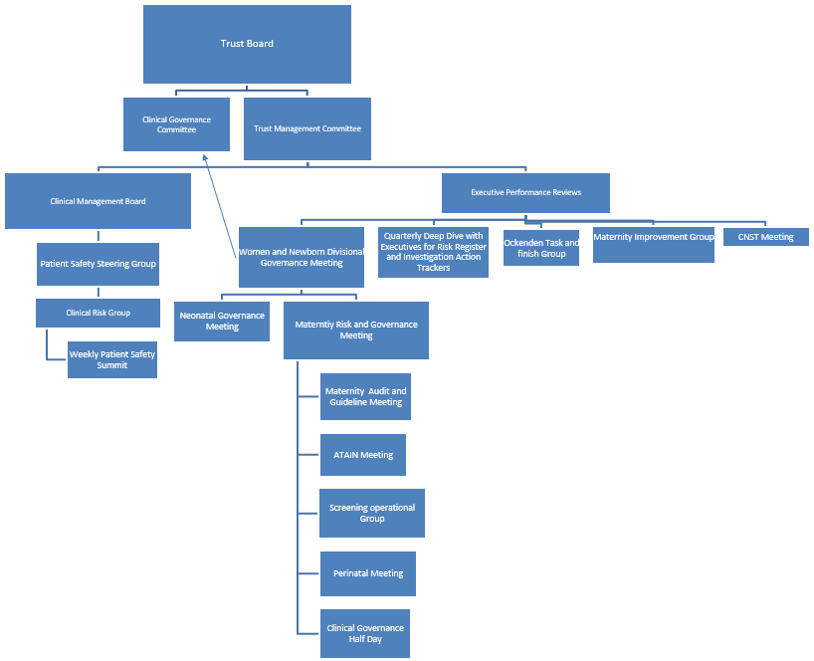

Organogram of Governance meetings into Trust Board

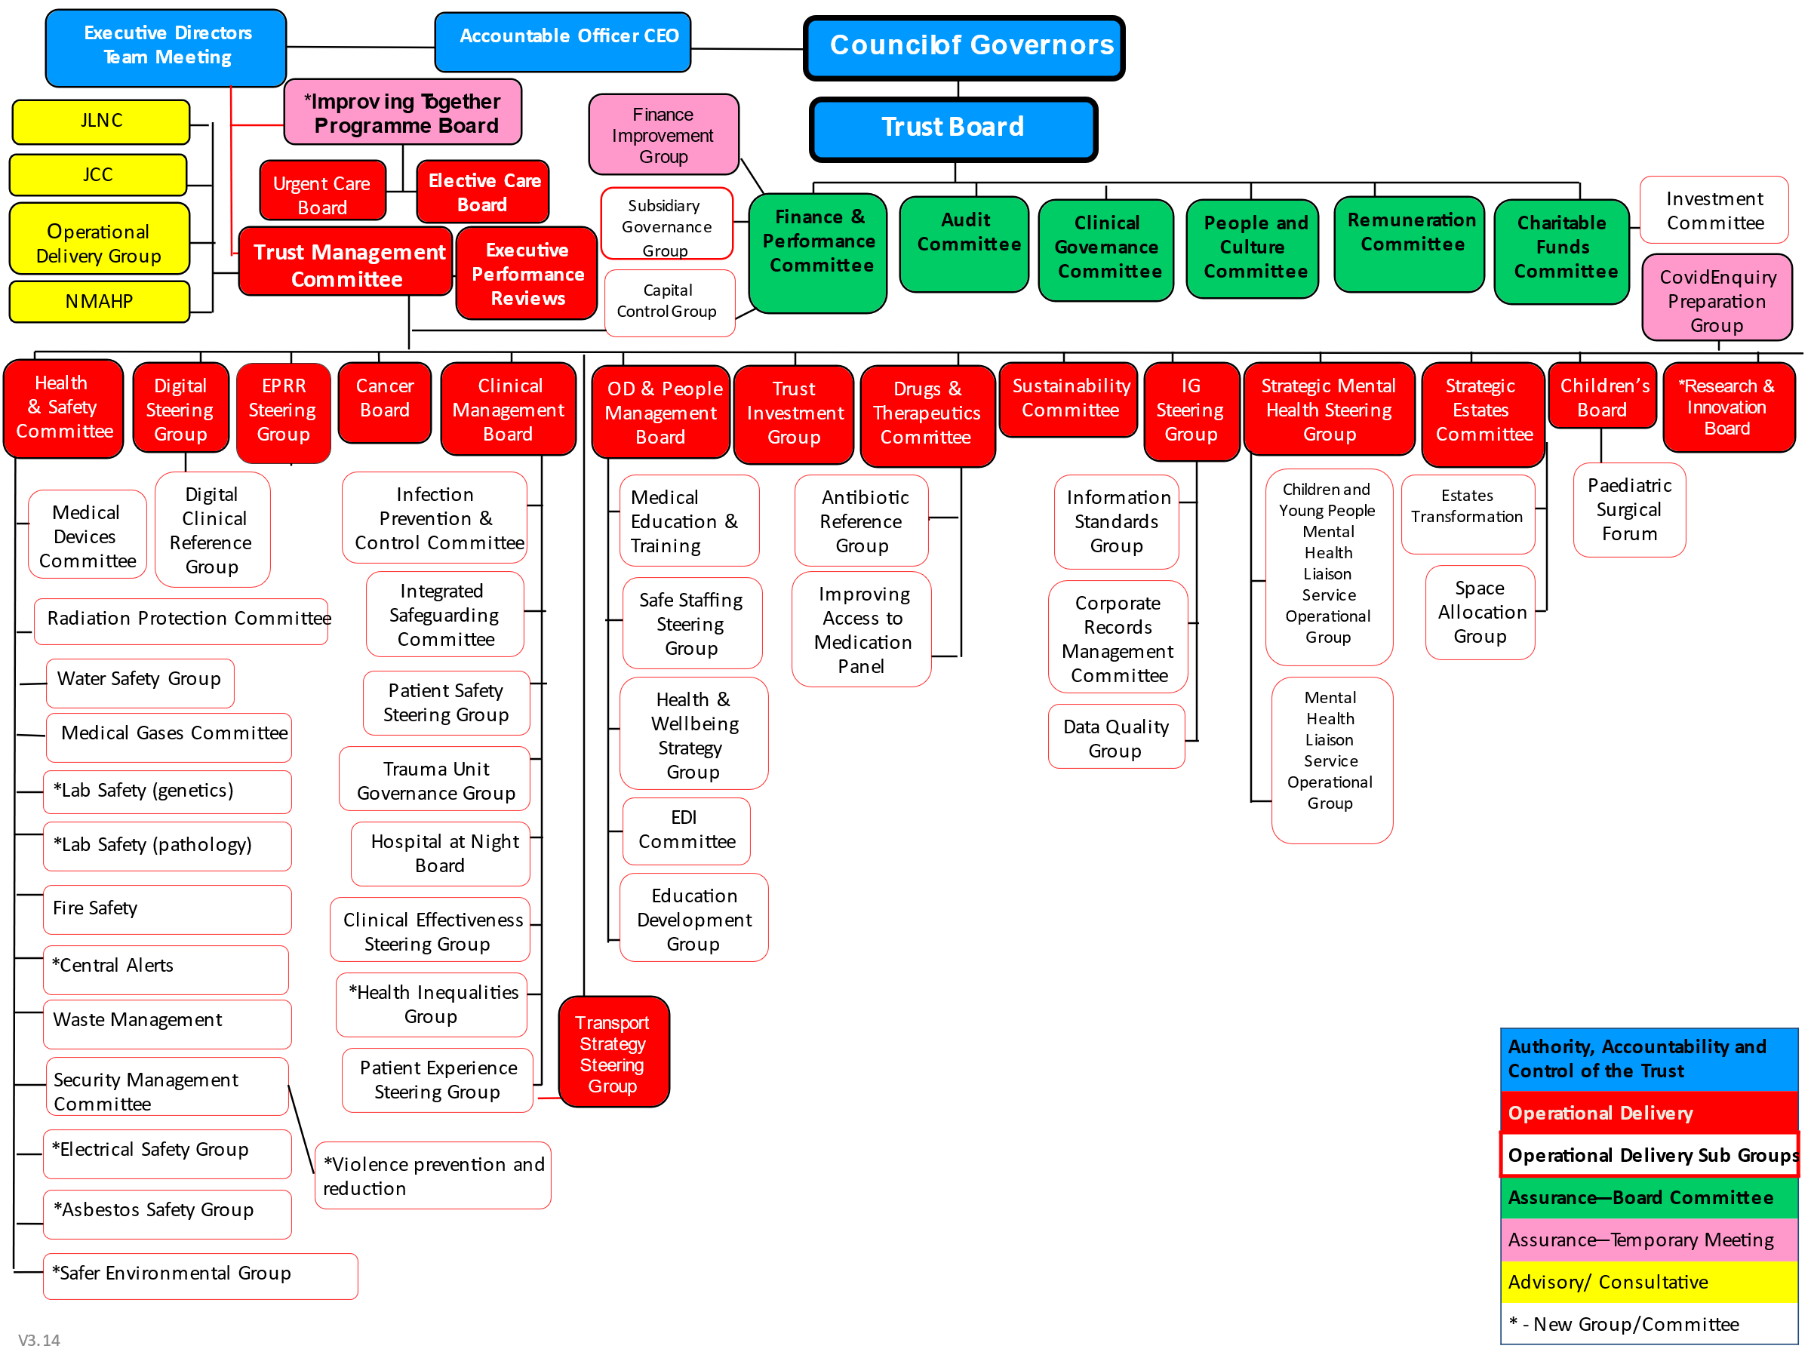

Trust Quality Governance Structure

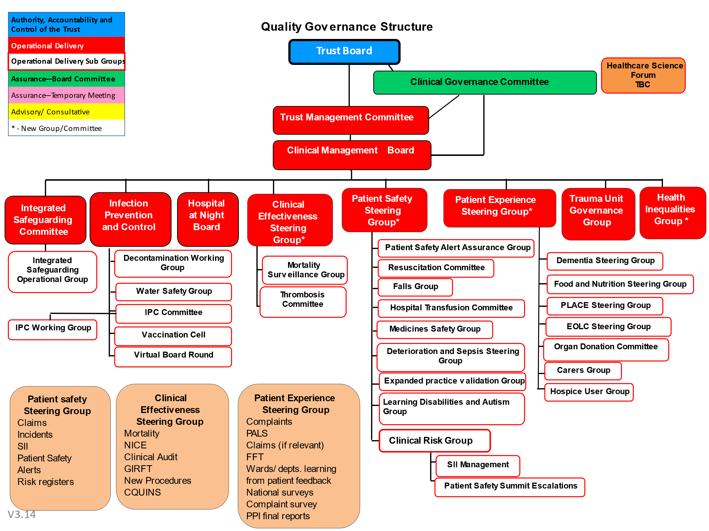

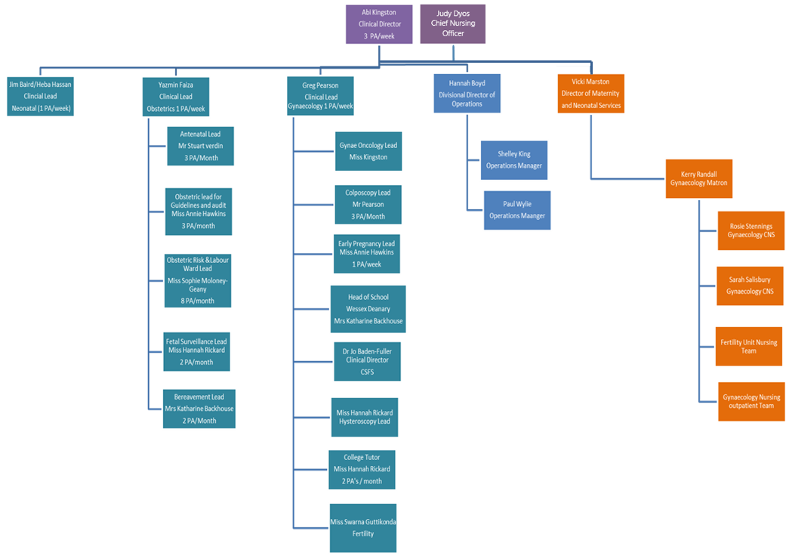
3.4 Women and Newborn Divisional Structure – Obstetrics and Gynaecology

3.4 Women and Newborn Divisional Structure – Maternity and Neonatal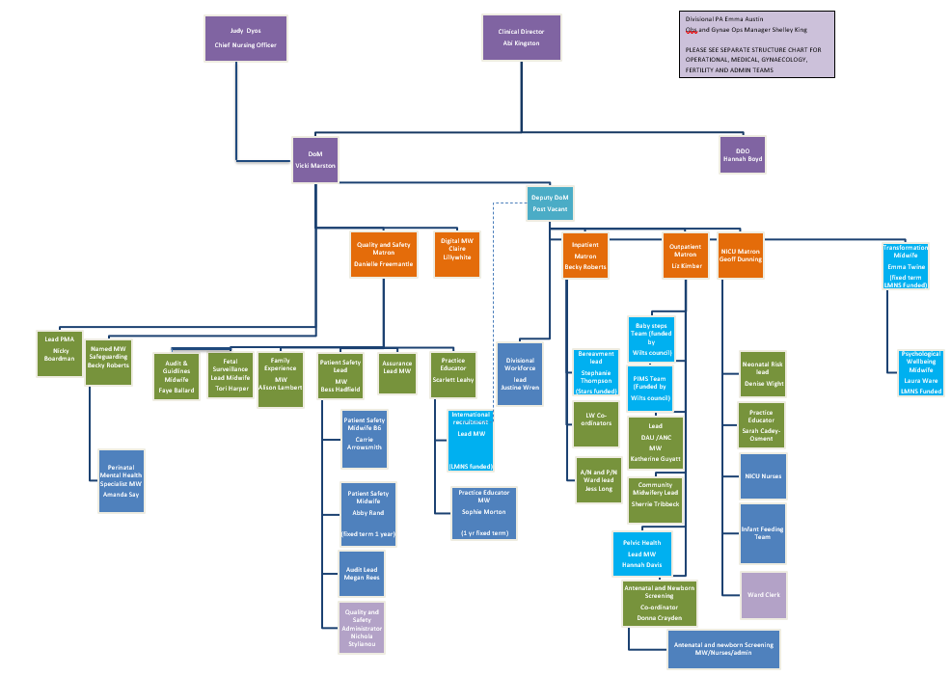

4.0 ROLES AND RESPONSIBILITIES WITHIN MATERNITY AND NEONATAL SERVICES
N.B. The roles and responsibilities described below outline responsibilities relating to governance and not the entirety of the roles.

4.1 Frontline Maternity and Neonatal Safety Champions

Every Trust in England has named midwifery, obstetric, neonatal and board level maternity safety champions responsible for working closely with their clinical network and LMS leads to champion safety at frontline and system level.

They are responsible for:
- Supporting the provision of a seamless multi-professional perinatal service responsive to the needs of women, babies and families.
- Supporting the implementation of the Neonatal Critical Care Review recommendations
- Supporting board level safety champions to represent the safety needs of their services at board level.
- Building the maternity and neonatal safety movement locally to prioritise improvement activities and adopt best practice within the organisation.
- Develop strong working relationships with and draw on insights from those leading all safety and improvement related activity in the organisation.
- Ensuring the Trust meets the standards required for effective data quality and coverage as defined by NHS Digital in the data quality standard.
- Providing scrutiny to check and challenge for the Divisional progress with achieving the requirements of the Maternity Incentive Scheme.

4.2 Quality and Safety Matron (Maternity and Newborn)
The Maternity and Neonatal Quality and Safety Matron has operational responsibility for overseeing risk management processes at departmental level and reports to the Director of Midwifery. They are supported by the Divisional Director of Operations, Head of Midwifery, Clinical Director, Obstetric Lead, Obstetric Lead for Risk and midwifery and neonatal matrons. They ensure that risk issues are discussed, controlled, actions implemented, and change communicated as below:

- Provide strategic direction to the Maternity Services in relation to the incident reporting process.
- Provide monthly reports on all clinical and non-clinical incidents to the Maternity and Neonatal Quality and Safety Group Meeting which reports to the Divisional Governance Meeting, the Trust Board and LMNS.
- Provides advice, guidance and recommendations about risk management throughout maternity and neonatal services.
- Oversees the maintenance, analysis and reporting of trends and exceptions of the maternity risk dashboard.
- Maintains oversight of CQC process and benchmarking against CQC key questions
- In conjunction with the corporate Risk Management Team have responsibility for leading and monitoring maternity and neonatal serious incident performance and for reporting incidents and overall performance to external and internal stakeholders.
- In consultation with other appropriate senior staff will determine which external stakeholders require, or potentially require, information on selected serious incidents.
- Contributing to the Divisional risk register.
- Register for alerts from all relevant bodies (e.g., NICE, RCoG, RCoA, SHOT, NHS England) to receive updates in national guidance.
- Report all relevant incidents to HSIB.
- Liaise with Trust legal department to ensure all appropriate cases are reported to NHS Resolution Early Notification Scheme.

4.2.1 Quality and Safety Lead Midwife

The Quality and Safety Lead Midwife has responsibility for the below :

- Providing professional leadership and managerial advice and support to all staff working in maternity and neonatal services with regard to incident and risk reporting, working closely with the Trust risk management department.
- Providing proactive strategy of risk management aiming to identify risks, provide protection against preventable harm to women and their babies, and employees.
- Supporting and advising staff in relation to patient safety.
- Whilst waiting for the organisation’s transition to PSIRF administering the serious incident maternity MDT panels and the resulting action plans providing feedback to relevant groups/committees and staff on emerging trends.
- Grading of incidents with severity scoring.
- Checking the quality of information provided on the incident forms for accuracy and completeness.
- Facilitating 72-hour review meetings.
- Reporting performance data to Maternity Governance and Risk Meeting, together with themes and trends.
- Identifying (via internal and external sources), managing and monitoring of risks; providing reports, information and training as appropriate.
- Completing investigation reports.
- Producing regular feedback of governance activities to staff via newsletters, noticeboards, email and attending teams’ meetings.
- Work in partnership with the Obstetric Lead for Risk and the Quality and Safety Matron to drive the safety agenda forwards and integrate with the LMNS workstreams.

4.2.2 Quality and Safety Midwife

The Quality and Safety Midwife:

  - Be responsible for ensuring coordination of clinical risk across the maternity service.
  - Work with all grades of clinical staff and managers to identify risk, carry out risk assessments and ensure the necessary actions follow and learning takes place.
  - Coordinate a planned programme related to the healthcare governance agenda together with the quality and safety team.
  - Attends women and their families on the ward providing support and listening to any issues or concerns as part of the Duty of Candour process.

4.2.3 Audit and Guidelines Lead

The Audit and Guidelines Lead Midwife is responsible for facilitating the audit and guidelines workstreams, specifically to include:

- Audit:
  - Working collaboratively with the Obstetric Audit Lead and the Quality and Safety Matron to ensure the Annual Audit Plan is maintained and includes all relevant audits required nationally and locally.
  - Facilitate and coordinate monthly audit meeting.
  - Produce monthly report to Maternity Governance and Risk Meeting of all audit activity and highlight any audit findings that require further action.
  - Supporting staff in relation to audit activity.
  - Work collaboratively with the Trust Audit Department to ensure that specialist software package (AMaT) is used to monitor audit activity and is utilised fully within the maternity and neonates.
  - Ensuring that all audits and service evaluations are registered and completed in a timely manner, and in compliance with audit best practice.
  - Working collaboratively with leads for national audits i.e., PMRT, MBRRACE, ANNBS to ensure timely reporting is produced for Maternity Risk and Governance Meeting. In addition, all national audits / NCEPOD audit action plans are reported to the Clinical Effectiveness Steering Group and Trust Audit Committee.
  - Receive feedback at the Maternity Governance and Risk Meeting
  - regarding learning identified from incident investigations that should be included in the audit programme.

- Guidelines:
    - Working collaboratively with the Obstetric Guidelines Lead and the Quality and Safety Matron and the MNVP to ensure:
    - Any local guidance not in alignment with national guidelines must be escalated to the divisional governance meeting for consideration of escalation to Trust Board and LMNS to seek agreement, this will also be captured on the guideline tracker.
    - A tracker is maintained of all Maternity guidance/documentation.
    - Facilitates the monthly guidelines meeting.
    - Publishes ratified guidance onto Micro guide.
    - Produces monthly exception report to Maternity Governance and Risk Meeting of all guidance activity and highlight any guidance issues that require further action.
    - Inform staff in line with the comms strategy, including summary of changes in practice since last version.
    - Facilitates sending draft guidance out for comment to maternity and neonatal staff, collate comments and resolve queries with the author.
    - Maintains shared network drive of any archived guidance.
    - Receive feedback at the Maternity Governance and Risk Meeting regarding learning identified from incident investigations that prompts a review of local guidance.

4.2.4 Family Experience Midwife (FEM)

- Coordinating, responding and undertaking investigations in relation to all Divisional ‘complaints’, ‘concerns’ and ‘comments. This includes resolution of real time concerns.
- Reporting to Maternity and Gynae Governance, Patient Experience Steering Group from a Divisional perspective and Divisional Governance. The FEM will produce monthly data for inclusion in the monthly Perinatal Quality Surveillance Tool report which includes experience dashboard data (number of compliments, concerns, complaints, de-escalation of concerns, family and friends’ feedback) and themes and trends from service user feedback.
- Contributing to the Exception report (offering details of complaints where doctors who are members of the Deanery have been named).
- Collaborative working with the local MNVP on outreach projects, review of themes from patient feedback/ survey.
- Will work collaboratively with MNVP and women and their families to promote coproduction.
- Coordination of the National Maternity Patient Feedback survey and the implementation of actions.
- Coordinate and undertake the Birth Reflection Service, ensuring any themes are addressed, implementation of any actions and ensuring the necessary referrals to other services have been undertaken.
- Maintain action trackers for Complaints and FFT and Patient feedback.
- Responsible for maintaining and updating the maternity website.
- Sharing ‘Maternity’ news via our social media networks.
- Provide feedback to staff from service users.
- The Family Experience Midwife is responsible for facilitating the Trust processes for drafting, ratification and publishing patient information leaflets. They will maintain patient information leaflet (PIL) information on the maternity guidance tracker.
- They will present newly ratified patient information leaflets at the Maternity Audit and Guidelines Meeting for noting and provide assurance that the PIL aligns with local and national guidance. It is best practice to appendix PILs to guidance when it is updated, and it is the long term aim of Maternity services to align documents in this way.

4.3 Director of Midwifery and Neonatal Services and Clinical Director of Women and Newborn Division

- The Director of Midwifery in conjunction with the Clinical Director are accountable for the management of risk in the Division and will ensure the process within the service reflects the organisation wide risk management strategy.
- In partnership with the midwifery, obstetric and neonatal safety champions they play an important role in supporting board safety champions to represent the safety needs of their services at trust board level and as a Divisional Triumvirate they will formally present on Maternity Services at Trust Board at a minimum of quarterly.
They are responsible for:-
- Promoting high standards of care across maternity and neonatal services.
- Providing visible leadership through modelling professional behaviours in response to safety needs.
- Promoting a culture of multidisciplinary team working with joint training, briefings and handovers.
- Working closely with and drawing on the insights from those leading safety related activity within the organisation.
- Supporting the provision of a seamless multidisciplinary service responsive to the needs of women, babies and their families.
- Acting as a conduit to share improvement priorities and best practice within the organisation.
- Supporting implementation and direction of travel of Maternity and Neonatal Three-year Delivery Plan.

4.4 Obstetric Lead
Strategic & leadership
- To develop, as part of the senior leadership team, a clear strategy & vision for obstetric services, which is centred around women’s needs and aligned with the divisional strategy and National targets.
- To identify the potential for future development of clinical services within obstetrics and ensure the implementation of agreed developments.
- To provide specific leadership to staff in maternity to ensure that they understand and own the strategy for the service and their responsibilities to support all aspects of it.

Service delivery and improvement
- To work with clinical and managerial colleagues to deliver a safe service which is high quality and within the financial envelope of the service.
- To take responsibility for providing assurance to the divisional team on all aspects of governance within obstetrics.
- To chair the maternity governance meeting and take responsibility for its assurance with the Quality and Safety matron.
- To work with the clinical staff to lead, direct and develop clinical practice within the service to improve quality and safety of obstetric high-risk care.
- To identify areas where quality improvement is needed and ensure that those improvements are made.
- To identify and lead specific cost improvement plans.

Management of medical staff
- Shared line management of medical staff in this post with gynaecology clinical lead – authorised signatory for additional payment requests, expectation of job planning with named consultant staff as agreed with CD.
- To engage with and support all grades and staff groups to promote delivery of high quality, safe and efficient care.
- Line manage Labour ward lead, risk lead, governance lead for obstetrics and antenatal service lead consultants.

The post holder is expected to identify sufficient time within their job plan to devote to this role and will be remunerated accordingly. This will be recognised as SPA activity distinct from the SPA activity required for revalidation, clinical governance and continuing professional development. Currently 1 PA

4.5 Lead Obstetrician with Responsibility for Risk

- Active participant / expert on investigation panels.
- Give expert clinical advice within the Division.
- Ensure that outcomes/recommendations are cascaded throughout the framework of clinical governance.
- To escalate issues to the Maternity Risk and Governance Meeting and provide feedback on risk management issues to clinical staff in maternity and other areas of the trust as appropriate.
- Develops and updates policies and guidelines.
- Risk management case reviews.
- Participate in 72-hour reviews as requested by the Quality and Safety Midwife
- Chairs the Maternity Risk and Governance Meeting with the Quality and Safety Matron.
- Representative at Southwest Safety Forum.
- Representative at LMNS Safety Sub Group.
- Support PMRT lead midwife with completing PMRT.
- Has one PA allocated to this role which are allocated via the medical rota to align with regular meeting commitments.

4.6 Lead Consultant Obstetrician for Labour Ward

- Provide clinical leadership.
- Attends Trust-wide Clinical Risk Group.
- Provide support for junior medical staff.
- Championing improvement within intrapartum care.
- Ensure effective teamwork.
- Develop and implement high standards of obstetric practice.
- Implement change and service improvement through attendance/leadership at the labour ward forum and obstetric consultant meetings.
- Provide expert clinical advice within the Division.
- Representative at Wessex Intrapartum Forum.
- Participate in 72-hour reviews as requested by the Quality and Safety Midwife
- Provide feedback to individuals and implement any recommended changes to clinical practice.
- Escalate issues to the Maternity Risk and Governance Meeting and provide feedback on risk management issues to staff on delivery suite and other areas of the Trust as appropriate.
- Undertake risk management case reviews and present to the Clinical Risk Group as required.
- Develops and updates policies and guidelines.

4.8 Lead Consultant Obstetric Anaesthetist

- Delivery of anaesthesia and analgesia in obstetric practice.
- Has overall responsibility for the anaesthetic service in maternity, liaising closely with the obstetric and midwifery staff.
- Develop and update policies and guidelines.
- Ensure the anaesthetic service is delivered in accordance with national recommendations.
- Contribute to discussion of risk - both actual and potential issues raised in relation to patient safety, in particular high-risk patients.
- Attend multidisciplinary risk management meetings or ensures representation in their absence.
- Participate in 72-hour reviews as requested by the Quality and Safety Lead Midwife
- Provide clinical leadership for the anaesthetists working within the labour ward.
- Participate in multidisciplinary training including PROMPT.
- Escalate issues to the Maternity Quality and Safety Meeting and provide feedback on risk management issues to staff on delivery suite and other areas of the Trust as appropriate.
- Attend relevant maternity investigation panels or will delegate an appropriate consultant anaesthetic colleague to attend.
- Has PA allocated to this role which are allocated via the medical rota.

4.9 Antenatal and Newborn Screening Coordinator

- Clinical Lead for Antenatal and Newborn Screening.
- Lead and direct the implementation of Antenatal and Newborn Screening KPI’s and local and national screening.
- Prepare and present quarterly Antenatal and Newborn Screening report at Maternity and Neonatal Quality and Safety Group Meeting.
- Monitoring the team’s compliance with KPI’s and ensure robust systems are in place to audit and develop action plans.
- Develop annual Antenatal Newborn Screening ( ANNBS) Screening Report
- Reporting and responding to Screening Incident Assessment Forms

4.10Neonatal Matron and Neonatal Consultant Lead

- Support and implement the requirements of sound clinical governance throughout the service, reviewing national benchmarks, best practice, national audits, NICE guidelines and risk registers and where necessary implementing any recommendations.
- Implementation of a comprehensive programme of quality improvement activity.
- Ensure clinical standards meet best practice standards, and that recommendations of national service frameworks are met and implemented.
- Participate in 72-hour reviews as requested by the Quality and Safety Lead Midwife
- Establish clear lines of responsibility and accountability for overall aspects of clinical care, utilising feedback loops to clinical colleagues and the outcomes of care-based audit.
- Effective implementation of policies aimed at managing risk, overseeing arrangements for preventing, reporting, investigating and acting upon adverse incidents, and identification and management of poor performance that contributes to poor team working and / or clinical risk.
- Provide expert clinical advice within the Maternity Governance and Risk Meeting.
- Ensure that neonatal risks are identified and included on the departmental risk register and as appropriate escalated to the Divisional risk register.

4.11 Neonatal Risk Nurse
- Provide feedback to individuals and implement any recommended changes to clinical practice.
- Escalate issues to the Maternity and Neonatal Governance and Risk Meeting, perinatal network and provide feedback on risk management issues to neonatal unit staff.
- Undertake risk management case reviews.
- Deputise for Neonatal Matron at governance meetings and investigation panels where necessary.
- Participate in 72-hour reviews as requested by the Quality and Safety Lead Midwife
- Manage neonatal incidents reported via Datix as per Trust policy.

4.12 Allocated Medical Leads for Maternity Guidelines / Audit & QI

- Receive feedback at the Maternity and Neonatal Quality and Safety Group Meeting regarding learning identified from incident investigations that should be included in the departments training programme.
- Provide medical leadership to the audit process.
- Provide medical leadership to the guideline ratification process.

4.13 Named Midwife for Safeguarding Children and Vulnerable families.
- Provide clinical support, expert advice and staff training on safeguarding women and their families.
- Provide feedback to individuals and implement any recommended changes to clinical practice.
- Escalate issues to the Maternity and Neonatal Quality and Safety Group Meeting, Safeguarding Steering Group and provide feedback on risk management issues to perinatal staff.
- Undertake risk management case reviews.

4.14 Lead Professional Midwifery Advocate
- The Lead Professional Midwifery Advocate (PMA) will:
- Provide direction, overall oversight of the PMA service and responsibility for implementation of the PMA Standard Operating Procedure.
- Provide support and guidance to sessional PMA’s and be part of the PMA offer for staff.
- Provide monthly data for the Director of Midwifery and will form a strong link with the Maternity Quality Safety and Education teams.
As part of the PMA team will:
- Delivery all four functions of the A-EQUIP model, identifying gaps and needs within the service through collaborative working with the Director of Midwifery, the maternity Quality & Safety Team and the Practice Education Team.
- Professional midwifery advocates replaced supervision of midwifery which was removed from statute in 2017 and replaced by the Department of Health with the A-EQUIP model.

4.15 PMRT Lead Midwife

Works closely with the Bereavement Midwife
- Recognises cases that require PMRT review.
- Engages with families.
- Arranges PMRT review with the assistance of administration staff.
- Complete information with lead obstetric consultant for risk to start PMRT review within seven working days of a death.
- Organise with the assistance of administration staff for external reviewers to attend PMRT meetings.
- Update families on progress of reviews.
- Complete PMRT report and send to appropriate consultant for debrief appointment within agreed timescales.
- Liaise with gynaecology secretaries to arrange debrief appointment.
- Complete PMRT reviews with obstetric lead for risk when requested by other organisations (reciprocal arrangements with LMNS and Wessex)
- Update and manage PMRT actions on central action tracker.

5.0 MATERNITY AND NEONATAL GOVERNANCE FORUMS

- Maternity and Neonatal Risk and Governance Meeting
- Risk Register Meeting
- Maternity Guideline Group
- ATAIN Meeting
- Maternity and Neonatal Audit Meeting
- Perinatal Meeting
- Clinical Governance Half Day
- ANNBS Forum
- Maternity Safety Champions
- Maternity Improvement Group
- Neonatal Governance Meeting
- CNST Meeting
- Ockenden Working Group
- PMRT Meeting

5.1 Maternity Risk and Governance Meeting

The core meeting for governance within Maternity Services. The Terms of Reference will include the template agenda which must be followed for every meeting. Items presented to the meeting and information produced for onward sharing as follows:

To be reported to Maternity Governance and Risk Meeting: |  |  | Onward dissemination:
From: | Frequency | Description | To: | Frequency | Description
Maternity and Neonatal Quality and Safety Team / Senior Leadership Team | Monthly | Core Patient Safety & Quality Report for Maternity and Newborn  To include:  - Maternity and Neonatal Workforce Report  - SBLv3 Summary  - Risk Register Report  - Safeguarding Monthly Report  - CNST/MIS Compliance  - Ockenden compliance  - Maternity Clinical Dashboard Exception Report  - PMRT monthly highlight report  - Maternity Patient Experience Report (inc. PALS)  - Maternity Audit bi-monthly summary report, highlighting potential risk  - Maternity Guidelines summary report, highlighting potential risk.  - Medical Trainees Report summary (Quarterly)  - MDT Training Compliance  - ATAIN summary  - ANNBS Quarterly Summary Report  - A-EQUIP quarterly highlight report.  - Perinatal Meeting highlight report  - New Patient Safety Alerts and Notices | WNB divisional Governance Meeting  Q&S report to Trust Board & LMNS safety subgroup | Monthly  Quarterly | Use template for all output (Div Gov, Board, LMNS)
Director of Midwifery / DDO | Quarterly | Midwifery and Maternity Workforce Report  Includes CNST requirements re staffing and consultant attendance on Labour ward | WNB divisional Governance Meeting  Trust Board  Trust Board | Monthly  Monthly  Bi-annually | For noting and reporting by escalation  PQSS Summary report  Bi-annual midwifery & neonatal staffing report to Board
Maternity and Neonatal Q&S Matron | Quarterly |  | WNB divisional Governance Meeting  Trust Board | Monthly  Monthly | For noting and reporting by escalation  PQSS Summary report
Named Midwife for Safeguarding | Quarterly | Safeguarding –quarterly highlight report  To include staff safeguarding training compliance. Include Serious Case Reviews/CDOP Summary | WNB divisional Governance Meeting  Trust Board  Integrated Safeguarding Operational Group  Integrated Safeguarding Committee | Quarterly  Quarterly  Monthly  Quarterly | For noting and reporting by escalation  Q&S report  Full report  Summary Report
Women and Newborn Division DMT | Monthly | CNST Maternity Incentive Scheme Monthly Highlight Report | WNB divisional Governance Meeting  Trust Board  LMNS Programme board | Monthly  Monthly  Monthly | PQSS report
Women and Newborn Division DMT | Monthly | Ockenden Recommendations Monthly Highlight Report | WNB divisional Governance Meeting  Trust Board  LMNS Programme board | Monthly  Monthly  Monthly | PQSS report
Q&S matron and Obstetric Clinical Lead | Monthly | Maternity Dashboard Exception Report | WNB divisional Governance Meeting | Monthly | For noting and reporting by escalation
PMRT Lead Midwife & bereavement lead midwife | Monthly  Quarterly | PMRT Monthly Highlight Report  PMRT Quarterly Report | WNB divisional Governance Meeting  Trust Board  Trust Board  LMNS Safety Forum | Monthly  Monthly  Quarterly  Quarterly | For noting and reporting by exception  PQSS Summary Report  Full Quarterly Report as per MIS (Q&S report)  Summary of learning from PMRT including in perinatal surveillance dashboard (Q&S report)
Patient Experience Midwife | Quarterly | Maternity Patient Experience Report | WNB divisional Governance Meeting  Trust Board | Quarterly  Monthly | Quarterly Report for noting.  PQSS report
Audit and Guidelines Midwife | Bi-Monthly | Audit Highlight Report | WNB divisional Governance Meeting  Trust Audit Committee | Bimonthly  Bi-Monthly | Summary and reporting by exception.  Summary and reporting by exception
Audit and Guidelines Midwife | Monthly | Guidelines Monthly Highlight Report | WNB divisional Governance Meeting  Patient Safety Steering Group | Monthly  Monthly | Summary and reporting by exception.  Guidance requiring Trust Ratification
College Tutor | TBC | Medical Trainees Report | WNB divisional Governance Meeting | TBC
Education Team | Monthly | MDT Training Compliance | WNB divisional Governance Meeting  EPR | Monthly  Monthly | Summary and reporting by exception.  Driver
Inpatient Midwifery Matron / Obstetric Labour Ward Lead | Monthly | Labour Ward monthly highlight report | WNB divisional Governance Meeting | Monthly | Summary and reporting by exception
Neonatal matron / Clinical Lead for Neonatal Services | Monthly | ATAIN monthly highly highlight report | WNB divisional Governance Meeting  LMNS / ICS | Monthly  Quarterly | Summary and reporting by exception.  Summary and reporting by exception
Outpatient Midwifery Matron / ANNBS Coordinator | Quarterly  Annual | ANNBS Quarterly Highlight Report  Annual ANNBS Trust Board Report | WNB divisional Governance Meeting  Trust Board  Trust Board | Quarterly  Quarterly  Annual | Quarterly Highlight Report (Q&S report)  Quarterly Highlight Report (Q&S report)  Full Annual Report
Lead PMA | Monthly | A-EQUIP Model highlight report | Trust Board Quarterly | Quarterly | Highlight Report (Q&S report)
HOM & NN matron | Monthly | Newly issued Patient Safety Alerts and Notices | WNB divisional Governance Meeting | Monthly | Highlight Report

The Maternity and Neonatal Quality and Safety Group Meeting is responsible for ensuring that the incident reporting process adheres to the Trust incident reporting and investigation policy, including reporting through relevant Trust committees as detailed in 3.3 above.

5.2 Risk Register Meeting
Membership includes Divisional Clinical Director, Divisional Director of Operations, Director of Midwifery and Quality and Safety Matron. Meets bi-monthly to discuss newly identified risks. Submissions must be in the form of a risk assessment via Datix Risk Register module. Meeting to agree risk matrix scoring and escalate to corporate team as detailed by corporate Risk Management Policy.

5.4 Maternity Guideline Group
The Maternity Guideline Group is a multidisciplinary forum to promote standards in clinical practice and ensure that referenced, evidence-based multidisciplinary maternity and gynaecology guidelines for the clinical management of all conditions are produced. The guidelines group meets monthly.

5.4.1 National Guidance and Reporting
Any relevant national publications must be brought to the attention of the Maternity governance and risk Meeting where gap analyses may be requested by the Clinical Effectiveness Steering Group. If a change in local guidance is required, then this will be passed to the Maternity Guidelines Group then on to Guidance leads for actioning. These national publications include but are not limited to:
- NICE
- RCOG/RCoA
- RCM
- MBRRACE
- NMPA
- HSIB
- UKOSS
- PMRT
- NHS England Patient Safety Alerts and Notices
- UK MIDSS
- NNAP
If the Division does not follow the national guidance, then this should be classed as “agreed noncompliant” and the discussion and decision should be reflected in the Maternity Risk and Governance Meeting minutes. All areas of noncompliance and agreed noncompliance should be escalated and noted at the Women and Newborn Divisional Governance Meeting and consideration must be made to escalation to the Trust Board and LMNS.
NICE/RCOG compliance is a rolling item on the agenda for Maternity and Neonatal Risk and Governance Meeting. As and when local guidelines need to be produced or updated to implement NICE guidance, these are included on the Maternity Audit and Guideline Group Meeting agenda and overseen by the group.

5.5 ATAIN Meeting
Avoiding Term Admissions into Neonatal Units (ATAIN). NHS England have established that over 20% of admissions of full-term babies to neonatal units could be avoided. The aim of the ATAIN workstream is to reduce the number of babies separated from their mothers in the early neonatal period, to protect the normal bonding process. If the bonding process is disrupted it can have profound effects on maternal mental health, breastfeeding and long-term morbidity for mother and child. All term babies (over 37 weeks gestation) admitted to the neonatal unit (for any duration) will be reviewed at a monthly multidisciplinary meeting. Exceptions are planned admissions and re- admissions for weight loss or jaundice. The work of the ATAIN group is central to achieving standard 3 of the Maternity Incentive Scheme. The ATAIN review will keep a rolling tracker of all eligible babies, which constitutes a rolling audit.

The Group will report monthly by exception to the Maternity governance and Risk Meeting.

5.6 Maternity Clinical Audit Meetings
The Maternity Clinical Audit Meetings takes place bi-monthly. They are a forum for staff who lead on and are involved with audits and quality improvement projects to present the results and share the learning with the wider team and receive feedback via Q&A. Audits included range from local audits to the local analyses of data from participation in national audits.

5.6.1 Audit Programme
The annual Women and Newborn Divisional Audit Programme captures participation in national audits, local audit and quality improvement activity. Additionally the Trust is now using AMAT (Audit Management and Tracking System) . It is used for Clinical Audits, Ward & Area audits, QI, service evaluation, patient/staff surveys, and NICE compliance through real-time data and action control.

Audit results and action plans are noted at the Maternity and Neonatal Risk and Governance Meeting. The results, outcomes and action plans from national reports are shared with other appropriate forum for example Clinical Governance Committee, Hospital Transfusion Committee and the Medicines Steering Group and other groups detailed in 3.3 above. Action plans may be modified at the request of the above groups.

When an audit is presented to the Audit Meeting, it must be classified as compliant or non-compliant using the parameters set out in the audit registration documentation. All non-compliant audits must have an action plan to address the non-compliant status and all audits must have a forward plan for timing of re-audit.

The midwifery and obstetric audit leads are responsible for ensuring an accurate database is kept of all audit activity and related documentation. A non-compliant audit which represents a significant risk to patient safety must be considered for entry to the Divisional risk register (see Section 5.2). In addition, a monthly summary of audit activity will be presented at the Maternity Governance and Risk Meeting.

5.6.2 UK Obstetric Surveillance System (UKOSS)/UK Midwifery Study System (UKMidSS)
UK-wide Obstetric Surveillance System to describe the epidemiology of a variety of uncommon disorders of pregnancy. Further details on what trusts should report can be found here: https://www.npeu.ox.ac.uk/ukoss

The Obstetric Lead for Risk is responsible for ensuring that all relevant cases are reported via UKOSS, the Inpatient Midwifery Matron is the lead for UKMidSS.

5.8 Clinical Governance Half Day
The agenda for this education session is prepared by the Quality and Safety team with the Obstetric and Neonatal clinical leads.

5.9 ANNBS Operational Group

Public Health England have several resources to assist NHS organisations to assess any incident which occurs within a screening programme. Within the maternity department any incident affecting antenatal or neonatal screening will be risk assessed and reported in line with the document: Managing Safety Incidents in NHS Screening Programmes.
https://www.gov.uk/government/publications/managing-safety-incidents-in-nhs-screening-programmes

Step 1: Within 3 working days of identification of the incident, the Screening Incident Assessment Form (SIAF) should be completed by the Screening Lead Midwife, presented at the next Maternity and Neonatal Quality and Safety Group Meeting and amended (if required) to reflect the discussion. The form is submitted by email to the Screening Quality Assurance Service (SQAS; Public Health England) and Antenatal and Newborn Commissioners (NHS England). All documents produced for this process must be attached to the Datix incident report.

Step 2: SQAS will recommend the categorisation and management of the incident, including timescales for completion, within 2 days. The updated SIAF is then returned to the local screening service by email.

Declaring a Screening Incident as a Serious Incident
A serious incident may be declared at any point during this 5 working day period, at which point NHS England’s Serious Incident Framework (updated 2015) will apply.
https://improvement.nhs.uk/resources/serious-incident-framework/
The provider must report the serious incident to the strategic executive information system (STEIS) (or its successor) and the responsible commissioner within 2 working days of the incident being identified as a serious incident.

It is a matter of professional judgement whether to declare a serious incident. Careful consideration of the definition is needed in each case. In most instances, the provider of the local screening service declares the serious incident after deciding this with the commissioner and informed by QA advice.

In distinguishing between a screening safety incident and a serious incident, consideration should be given to:

- whether individuals, the public or staff would suffer avoidable severe harm or death if the root cause is unresolved.
- the likelihood of significant damage to the reputation of the organisations involved.

This means that a near miss can be a serious incident where there is a significant existing risk of a system failing.

If the decision is made to report a screening incident as a Serious Incident the Maternity and Newborn Quality and Safety Matron will present details at the next weekly trust wide Patient Safety Summit meeting for formal discussion and escalation to the Board.

Figure 1: PHE Reporting and managing screening incidents flowchart: PHE 2021

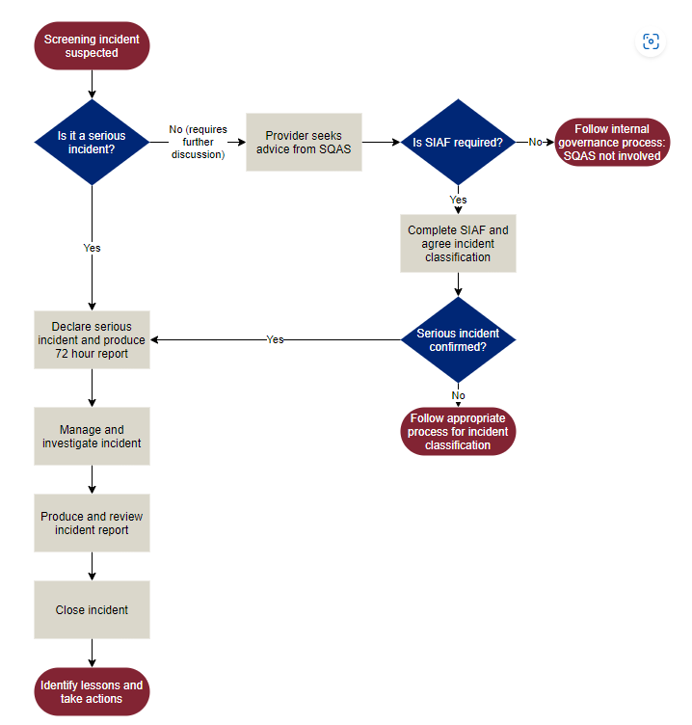

In line with national standards, the Trust has an Antenatal Quality Forum co-chaired by the Clinical Obstetric Lead for Antenatal and Newborn Screening and the Lead Midwife for Screening, with attendance form the Outpatient Matron to oversee audit, management and quality of the Antenatal and Newborn screening programmes.

The Antenatal and Newborn Screening operational group meets monthly and report to the Maternity Risk and Governance Meeting.

5.10 Maternity Safety Champions
In England, every maternity provider is expected to nominate three individuals – two on the front line, an obstetrician and a midwife, who are jointly responsible for championing maternity safety locally, and a board member. The champions on the front line have links with the board, the local maternity clinical network and the maternal and neonatal health safety collaborative in their region. The group meets monthly and provides a direct reporting route to the Trust Board for frontline clinical staff.

5.11 Maternity Improvement Group

The purpose of the Maternity Improvement Group is to monitor improvement and progress against the maternity improvement plan. It will report to the Executive Performance Review on a monthly basis and escalate any risks and barriers to improvement.

- The group chair should be the Director of Maternity and Neonatal services. In the absence of the chair, the deputy chair shall be the Head of Maternity and Neonatal services.
- Core membership shall be Director of Maternity and neonatal services, Divisional Director of Operations (Women & Newborn), Clinical Director for Women & Newborn and Clinical Lead for Obstetrics.
- Attendees outside of core members includes (but not limited to):, Maternity Quality & Safety Matron, Transformation Project Lead Midwife, Head of Maternity and Neonatal services, Maternity Outpatient Matron, Maternity Inpatient Matron, Neonatal Matron, Obstetric Lead for Risk, Obstetric Lead for Antenatal, Fetal Monitoring Lead Midwife, Fetal Monitoring Lead Obstetrician, Practice Development Midwife, Bereavement Lead Midwife, Digital Lead Midwife, Clinical Lead for Neonatal and Clinical Lead for Obstetric Anaesthetics, MNVP representative and LMNS representative.
- Core committee members should aim to attend all scheduled meetings and must attend a minimum of two thirds of meetings.
- Other attendees outside of core members may be asked to attend to support as necessary.
- The Maternity Quality & Safety Administrator shall act as Secretary to the group and shall attend to take minutes of the meeting, provide appropriate support to the Chair and group members as well as update the meeting invite with attendees as appropriate.
- The Transformation Project Lead Midwife will have oversight over the actions and maintain the progress on the maternity improvement plan.

- The meeting will be considered quorate when there:
- is a minimum of two members of the DMT or nominated deputies
- is a senior midwife (Deputy DoMN or Maternity Q&S Matron)
- is secretarial support available
- is a senior obstetrician (, Clinical Lead for Obstetrics or Obstetric Risk Lead)

5.12 NHS Resolution/ CNST Maternity Incentive Scheme

This scheme is run and administered by NHS Resolution; the aim is to support the delivery of safer maternity care through an incentive element to trusts contributions to the CNST. The scheme was developed in partnership with the national maternity safety champions and rewards trusts that meet the ten safety actions designed to improve the delivery of best practice in maternity and neonatal services. The scheme assesses the 10 safety actions which are updated each year.

A working group has been created to monitor progress towards achieving compliance with all ten components of the scheme and to collate the evidence required for the CNST submission.

Neonatal Governance Meeting
The Neonatal Governance Group is a multi-professional group of clinicians. The group has been established to oversee, review and implement local policy & procedural changes within neonatal service.
The group will review neonatal governance process including guideline creation/review, changes in practice, new equipment and service updates. It will report and disseminate learning from complaints and claims within the neonatal service, consider actions taken and ensure lessons are learnt and shared within the maternity and trust structure.

Core members:
- Neonatal Matron (Chair & Mat/Neo safety Champion)
- Consultant Neonatologist (deputy chair & Mat/Neo safety Champion)
- or representative
- Maternity Quality & Safety Matron or representative
- Postnatal Service Lead
- Inpatient matron
- Neonatal nurse representation
- Newborn Screening team representation
Attendance as requested/required:
- Consultant Anaesthetist
- Representation from Midwives and Medical staff from other areas

The group will meet bi-monthly.

5.14 Perinatal Mortality Review Tool (PMRT) Meeting

Meets monthly. The purpose of this meeting is to ensure MDT oversight of all perinatal mortality and to manage actions associated with each investigation. Cases to be reviewed are:
- All late miscarriages / late fetal losses (22+0 to 23+6 weeks gestation)
- All stillbirths from 24+0 weeks gestation)
- Neonatal death from 22 weeks gestation (or 500g if gestation is unknown) (up to 28 days after birth)
- [Neonatal deaths from 29 days after both may be reviewed but there is no statutory requirement to do so]
Attendance should be at least two members of the professional groups involved in care. There should also be an external reviewer (reciprocal agreements exist within the LMNS and Wessex).

The bereavement midwife should not chair the meeting, nor administer it as per the requirements of the CNST Maternity Incentive Scheme Year 5.

6.0 Incident Reporting and Management

Staff are required to report adverse incidents and near misses via the Datix reporting system. This is accessible via the intranet and is a web-based tool. Staff do not require a Datix login to report an incident, and all staff are empowered to make reports.

Maternity and Neonatal services have a trigger list (Appendix 13) which is displayed in each department to prompt reporting of specific incidents; however, staff are encouraged to report all concerns.

The maternity and neonatal quality and safety team will routinely triangulate data captured by the Maternity and Neonatal case management software (Euroking and Badgernet) regarding themes and trends in adverse incidents and to ensure all adverse incidents and near misses are reported.

6.1 Case review and investigation process

There are several categories of incident which must be reported and will routinely be reviewed, these include but are not exhaustive:

- Maternal death
- Maternal admission to Intensive Care Unit
- Maternal collapse e.g., eclampsia, anaphylaxis, cardiac arrest
- Massive Obstetric haemorrhage: blood loss >1500ml
- Significant event e.g., hysterectomy, uterine rupture, bladder trauma
- Retained foreign object during procedure.
- Anaesthetic complication e.g., dural tap, nerve injury, failed intubation
- Obstetric anal sphincter injury
- Shoulder dystocia
- Sequential instrumental delivery, or unsuccessful instrumental delivery
- Neonatal death
- Antepartum or intrapartum stillbirth (not planned termination of pregnancy)
- Term admission to neonatal unit
- Neonatal birth trauma e.g., laceration, fracture, nerve injury
- Undiagnosed fetal anomaly
- Neonatal neurological issue e.g., HIE, intraventricular haemorrhage, seizures
- Arterial cord gas pH <7.0 and/or base excess >-10
- Apgar score <7 at five minutes
- Severe neonatal infection e.g., line infection, necrotising enterocolitis, missed GBS, meningitis, HSV
- Pathological jaundice (ABO incompatibility, antibodies)
- Maternal postnatal readmission
- Patients fall or injury
- Venous thromboembolism in pregnancy or <6/52 postnatal
- Delay in treatment >24 hours (IOL or elective C/S)
- Equipment unavailable or failure
- Staffing or acuity problem
- Data protection or security issue
- Blood transfusion reaction, wasted blood products, issues with cross match.
- Pressure damage
- Medication error
- Staff injury including needlestick.
- Patient or visitor injury
- Violence or aggression from patient or visitor
- Nonattendance from consultant when requested as per RCOG guidance.
- Cases where concern is raised by any member of the MDT
- Cases which appear to fulfil the criteria for NHS Resolution, MBRRACE-UK reporting, Each Baby Counts, or the Perinatal Mortality Review Tool (PMRT)
- Unplanned return to theatre

This trigger list may be subject to change once the organisation transitions to PSIRF.

The perinatal trigger list is at Appendix 13.

6.2 Table: Case review and investigation process

The Maternity and Neonatal Quality and Safety Team will conduct a daily review of newly reported incidents. In addition, there will be regular triangulation of data with the maternity and Neonatal case management software (Badgernet and Euroking). Incidents will be managed as follows:

6.2.1 Incidents graded as No Harm or Low Harm or near miss
The appropriate incident handler, usually the clinical area lead midwife or doctor, reviews the information available to ensure the harm rating is correct. They are responsible for taking any appropriate actions, documenting these on Datix. Once complete, the datix status will be changed to “Final QC check and closure”. The corporate patient safety team enact final closure of the datix.

Should the incident relate to a postpartum haemorrhage and is confirmed as low harm, once the datix is completed, the notes must be passed to the Quality and Safety Midwife who will collect data for the continuous audit for PPH.

6.2.2 Incidents reported as Moderate Harm or Above
The Quality and Safety Lead Midwife/Midwife is responsible for reviewing the incident and ensuring the harm rating is correct. Where there is confirmed moderate harm or above, they will ensure that Duty of Candour Stages 1 and 2 are completed if not already actioned by clinical staff. Duty of Candour Stage 1 is recorded by way of a pre-printed sticker in the medical notes.

6.2.3 OASI, Shoulder Dystocia, PPH and ATAIN
For incidences of Obstetric Anal Sphincter Injury (OASI), Shoulder Dystocia, Postpartum Haemorrhage or Term Admission to the Neonatal Unit, the Quality and Safety Lead Midwife/Midwife will review the notes carefully to identify if there were acts or omissions which contributed to the incident. If there were no acts or omissions in care which contributed to the incident, after completing Duty of Candour Stage 1 and 2, the notes will be passed to the Quality and Safety Midwife for inclusion into the relevant continuous audit/review process. Each continuous audit will be reported monthly at the Maternity and Neonatal Quality and Safety Group Meeting. The learning from the audits will be shared at the relevant forums, e.g. Labour Ward forum.

6.2.4 72 Hour Review/Report
For all other incidents, and those in 6.2.3 above where there was an identified act or omission which contributed to the incident, the Quality and Safety Midwife will facilitate a 72-hour review which should take place within three working days of the incident. This review group should consist of a relevant MDT as follows:
- Senior Midwife for the relevant clinical area
- Member of the Maternity and Neonatal Quality and Safety Team
- Consultant Obstetrician unless incident entirely in midwifery led care
- Consultant Anaesthetist if incident involved anaesthetic care
- Consultant Paediatrician / Neonatal Matron if applicable to the incident
- Any other member of the MDT as a learning experience and to promote transparency in incident reviews
- PMA

It is essential that the review group does not contain staff who were directly involved in the incident, unless their input is required for the panel to form a conclusion.

A 72-hour report will be drafted after this review to reflect the information discussed and clearly state what level of investigation the group recommends. Any immediate actions must be clearly documented in the report. The Quality & Safety Midwife will ensure these immediate actions are captured on the Datix. The completed 72-hour report is sent to the corporate patient safety team for inclusion at the next weekly Patient Safety Summit Meeting.

6.2.5 Patient Safety Summit
Terms of reference to be published: Patient safety summit terms of reference (microguide.global)
Maternity and Neonatal Quality and Safety Matron or a nominated representative and the Obstetric Lead for Risk or a nominated representative will attend the weekly Patient Safety Summit chaired by a member of the Executive Board.

The corporate patient safety team will produce a tracker to be discussed by each Division, containing details of outstanding actions from previous meetings, new incidents of moderate harm or above, serious incident investigation (SII) and commissioned clinical reviews (CCR). In addition, any 72 hour reports prepared by the Divisional team will be presented and a decision taken on the level of investigation: either local review, CCR or SII. All HSIB cases will automatically become SII, and progress reviewed weekly via the tracker. On a monthly basis the tracker also contains details of the Divisional compliance with Duty of Candour, with data drawn directly from Datix.

If the Patient Safety Summit decides the level of investigation is either CCR or SII, terms of reference and the identity of an investigating officer (IO) shall be jointly agreed between the Patient Safety Summit and the Department.

6.2.6 Commissioned Clinical Review (CCR) and Serious Incident Investigation (SII)
The Maternity and Neonatal Quality and Safety Team assist the IO to review the incident and make contact with the family, maintaining this throughout the investigation process. The obstetric consultant responsible for the woman’s care should be informed by the Quality & safety midwife and allow opportunity for clinical follow up which must not be delayed by any investigation. Statements or first-hand accounts may be sought from staff. The IO is responsible for producing a final draft of the investigation in accordance with the Trust Serious Incident Requiring Investigation (SI) Policy (2018).

6.2.7 Investigation Panel
The Maternity and Neonatal Quality and Safety Team convene a panel who will thoroughly examine all evidence and form a view of the care provided and comparison to national guidance. The purpose of the panel is to provide assurance that a robust system review has taken place. The panel chair then drafts the investigation report and shares with the panel for review and approval. It may be necessary for the panel to re-convene to consider new evidence or to resolve differences of opinion. Should there be an unresolved difference of clinical opinion, this must be discussed at the Trust Patient Safety Summit. The panel comprises of:
- Matron or nominated deputy for the relevant clinical area
- Member of the Maternity and Neonatal Quality and Safety Team
- Consultant Obstetrician unless incident entirely in midwifery led care
- Member external to the Trust (for SII)
- Consultant Anaesthetist if incident involved anaesthetic care
- Consultant Paediatrician / Neonatal Matron if applicable to the incident
- Any other member of the MDT as a learning experience and to promote transparency in incident reviews
- PMA
- Obstetric and /or midwifery Fetal Surveillance Lead if interpretation of fetal monitoring is relevant to the case

It is essential that the review group does not contain staff who were directly involved in the incident.
Draft report to be sent to panel, clinicians involved in the case and all members of the DMT for commenting prior to CRG. Panel to make recommendations, action plan to be created by DMT using SMART actions.

6.2.8 Clinical Risk Group
The final draft report and action plan is presented to the Clinical Risk Group (CRG) which meets bi-weekly. CRG is chaired by a member of the Executive Board. Presentation is either by the IO or the Maternity and Newborn Quality & Safety Matron. CRG may request alterations to the report and when assured the report is complete ratifies the investigation and action plan. CRG recommends that the Trust Chief executive signs the final investigation report.

6.2.9 Finalising the Report
Once the report is ratified by CRG and signed off by executives, the Maternity and Newborn Quality and Safety Matron contacts the patient / family to offer an appointment to meet with themselves and a consultant obstetrician (as appropriate) in order that the learning from the report can be shared with them. Once this meeting has taken place the Maternity and Newborn Quality & Safety Matron writes to the patient/family to satisfy the requirements of Duty of Candour Stage 3 and formally concludes the report process.

Should the patient/family decline to attend a report sharing meeting, the Quality and Safety Matron drafts a letter for the Trust Chief Executive to sign. This letter satisfies the requirements of Duty of Candour Stage 3 and formally concludes the report process.
Learning from the review must be introduced into clinical practice within 6 months of completion of the panel and shared across the LMNS (Ockenden 2022).

6.2.10 Maternal Death
In the event of a maternal death, the Divisional SOP: Maternal Death should be followed. The Maternal Death Checklist Appendix to this SOP must be used to record all essential actions. The investigation process follows that of SII and/or HSIB. The Quality and Safety Matron or nominated deputy will report the death externally via MBRRACE and inform the LMNS. See Section 8 below.

Should a maternal death not be investigated by HSIB, the review panel must be chaired by an external clinician and include representatives from all applicable hospital/clinical settings.

Learning from the review must be introduced into clinical practice within 6 months of completion of the panel and shared across the LMNS (Ockenden 2022).

6.3 Decision making regarding external reporting responsibility of each case

With each case review consideration should be made as to whether the case is reportable within the national programmes:

Programme  HSIB  NHS Resolution ENS  MBRRACE-UK maternal mortality  MBRRACE-UK perinatal mortality  MBRRACE-UK PMRT | Lead Reporter  Quality and Safety Matron  Quality and Safety Matron / Legal services  Quality and Safety Matron /  Bereavement Lead Midwife  Bereavement Lead Midwife  PMRT Lead Midwife

6.4 Healthcare Safety Investigation Branch (HSIB)

HSIB investigates incidents that meet the Each Baby Counts (EBC) criteria and maternal deaths that meet HSIB criteria for investigation. HSIB have been tasked to conduct external investigations for eligible cases in NHS hospitals in England. The eligibility criteria are as follows:
- Eligible babies include those born at term (≥37 completed weeks of gestation), following labour, that had one of the following outcomes:
- Intrapartum stillbirth
- Early neonatal death when the baby died within the first week of life
- Severe brain injury diagnosed in the first seven days of life with one or more of the following:
- Diagnosed with Grade III hypoxic ischaemic encephalopathy (HIE)
- Actively therapeutically cooled
- Had all three of the following signs: decreased central tone, comatose, seizures of any kind.

Babies whose outcome was the result of congenital anomalies should be reported to HSIB as normal and are then excluded centrally by the HSIB team.

The definition of labour for Each Baby Counts includes:-
- Any labour diagnosed by a health professional, including the latent phase of labour at less than 4 cm cervical dilatation
- When the woman called the unit to report any concerns of being in labour, for example (but not limited to) abdominal pains, contractions or suspected ruptured membranes
- Induction of labour
- When the baby was thought to be alive following suspected or confirmed pre-labour rupture of membranes.

HSIB Criteria for investigation of a maternal death include: -
- All direct and maternal indirect deaths of women while pregnant or within 42 days of the end of the pregnancy. These incidents must meet the criteria set out in ‘Saving lives, improving mothers’ care’ (see Section 8.1), a report by MBRRACE-UK. We may investigate some maternal deaths which do not entirely fit within these two categories. HSIB exclude the investigation of cases where suicide is the cause of death. All maternal deaths are reported as an SII via the weekly Patient Safety Summit and the Strategic Executive Information System (STEIS).

Local & Regulatory Responsibilities
HSIB’s maternity investigations have replaced the trusts' internal maternity serious incident investigations but will still be reported as an SII internally. Maternity events that fall outside the specified HSIB criteria will be investigated as per local policy for management of incidents/serious incidents.

Duty of Candour (inclusive of HSIB information), a 72-hour report and reporting via Patient Safety Summit / STEIS will be completed at the same time as a HSIB referral. The 72-hour report will capture immediate actions / learning and these will be managed on the Divisional Tracker held by the Corporate Patient Safety Team.

The incident will also be reported to MBRRACE-UK where required. Where cases meet the criteria for reporting to the Perinatal Mortality Review Tool, the PMRT midwife and obstetric lead for risk will complete the factual information on PMRT. Once the HSIB investigation is complete, HSIB and appropriate representatives from the Trust will review the PMRT together to ensure both reports are aligned. The HSIB investigation identification number will be entered onto PMRT by the PMRT Lead Midwife.

6.5 Parental Involvement and Engagement

Parents' whose baby has died have the greatest stake in understanding what happened and why their baby died. Engaging bereaved parents in the review process and including their views and any concerns and questions they have about their care will enhance the process and ensure that from the outset the review addresses their questions. Parents, particularly mothers, are the only individuals who were present for the whole of the pregnancy and therefore have a unique perspective on everything that happened to them and their baby.

Feedback from parents will be actively sought for all cases where onward referral is indicated, or where a case is being investigated internally.

There are a series of contact points to encourage participation:
- Initial debrief / Duty of Candour conversation, including an apology to the parents
- Duty of Candour letter (which includes information on onward referral and seeks input into the process) - this is in line with the CNST standard
- Initial bereavement letter introducing the PMRT review process
- Use of PMRT parent engagement resources
- Invitation to comment on draft investigation reports for factual accuracy where appropriate
- Feedback sessions to receive results of investigations, histopathology reports, post mortem reports etc.
- Duty of candour meeting (post-investigation)

Where parents engage in the investigation process, their concerns will also inform the terms of reference for the investigation.

Consent should be sought from women for the Trust to share the woman’s contact details to enable HSIB to contact them directly and discuss the HSIB process. The referral is made via a reporting portal HSIB Investigation Management System (HIMS) by the Maternity and Neonatal Governance Team.

If HSIB accept the case they take consent for release of the woman’s records, at which point the records can be uploaded to HIMS, alongside relevant guidelines, policies and other relevant data. If HSIB accept a PMRT criteria case, they will take the lead on parental engagement / feedback, this will be explained to the family. The Trust will continue to offer bereavement support.

7.0 NHS Resolution/ Early Notification Scheme

NHS Resolution is a Special Health Authority, which operates in a similar way to an insurer by providing protection for clinical negligence to NHS hospitals. NHSR work to ensure that patients who are eligible to receive financial compensation do so as quickly as possible.

NHS Resolution’s Early Notification (EN) scheme aims to provide a more rapid, caring response to families whose baby may have suffered severe harm. On completion of the HSIB safety investigation, where a case has progressed following referral for a potential severe brain injury, a copy of the final report is shared with NHS Resolution for them to commence their in-house specialist review and decide whether:

- There is any evidence that the baby has a hypoxic brain injury that could potentially result in compensation; and
- If so, whether there are any concerns about the care provided to the mother or baby.

Further information about NHS Resolutions Early Notification (EN) scheme can be found via: Early notification scheme - NHS Resolution

During the coronavirus pandemic, NHS Resolution EN reporting moved from trust providers responsibility to a more collaborative response with HSIB. This is now to become a permanent arrangement (NHS Resolution 2022).

The HSIB / SII referral is notified by submission of the relevant notification form (NB the form is updated yearly) to the Trust’s Legal Department. The Head of Legal attends the Maternity Risk and Governance Meeting quarterly to ensure that they are aware of all cases meeting the EN scheme criteria.

- The notification asks the reviewers to make an initial assessment regarding the care provision and assess whether there was:
  - No suboptimal care
  - Suboptimal care / different management would not have made a difference to outcome
  - Suboptimal care / different management might have made a difference to outcome
  - Sub-optimal care / different management would reasonably be expected to have made a difference to the outcome

Any notification where the Trust states that different management would potentially or reasonably have made a difference to the outcome will be reviewed by NHS Resolution and a file opened (in preparation for any legal action taken). For any case opened, medical notes for the infant and woman will need to be provided with the investigation report, histology reports etc. NHS Resolution reporting of all eligible cases forms one of the criteria for the CNST incentive scheme.

NHS Resolution receives anonymised data reports from Badgernet which enables it to identify potentially missed cases. This data is not fed back routinely but is highlighted at the time of the CNST incentive scheme submission, where any perceived discrepancy between reported cases and Badgernet data will be raised and interrogated. Such cases are reported to the trust’s lead reporters to try and identify the case and ensure complete reporting.

8.0 MBRRACE-UK perinatal mortality

From 1st January 2013 onwards the following deaths eligible for notification are:-

- Late fetal losses – delivery between 22+0 and 23+6 weeks of pregnancy (or > 400g if gestation unknown), showing no signs of life.
- Stillbirths – delivery ≥ 24+0 weeks gestation (or > 400g if gestation unknown) showing no signs of life irrespective of when death occurred (for example, an intrauterine demise diagnosed at 23+5 but delivered at 24+1).
- Early neonatal deaths – death of a live born baby (≥ 20 weeks gestation or > 400g if gestation not known) occurring before 7 completed days of life.
- Late neonatal deaths – death of a live born baby ((≥ 20 weeks gestation or > 400g if gestation not known) occurring 7 - 28 completed days after birth.

It should be noted that:
- Post-neonatal deaths are exempt
- Terminations of pregnancy which fulfil any of the criteria above should be reported. (i.e. all terminations from 22+0 weeks are reported plus any terminations of pregnancy from 20+0 weeks which resulted in a live birth ending in neonatal death).

Cases are reported via the MBRRACE-UK portal which requires a log in:-https://www.mbrrace.ox.ac.uk/

The process for this is:
- Notification (all cases – as listed above)
- Surveillance audit (not required for Terminations of pregnancy)
- Perinatal Mortality Review Tool (PMRT) – if the case meets the criteria for the review (as set out in PMRT section).

Timeframe
In line with CNST the Trust is required to notify MBRRACE-UK of all eligible deaths within seven working days of the death and the surveillance information, where required, must be completed within one month of the death.

All deaths should be reviewed by the Bereavement Team and assessed for the need for MDT review. (TOP cases are not reviewed on DATIX unless there are any identified care and service delivery issues. Where appropriate the case will be presented and discussed at the weekly Patient Safety Summit and a decision made regarding the need for a formal investigation. Depending on the findings of the review, the death may require declaration as a serious incident or other investigation.
Not all eligible cases need to be reported as SIs – this will be determined by the level of harm determined at Patient Safety Summit.

If the care for the woman and/or baby was shared between more than one organisation a joint investigation should be undertaken. Consideration should be given to having representation external to the trust to ensure appropriate scrutiny during SI investigations.

The case will be reported via the MBRRACE-UK portal by the lead reporter. The MBRRACE-UK office will ensure that they receive all the relevant documentation and reports are received in order that the case can be included in the national reviews.

8.1 MBRRACE-UK maternal mortality

Eligible cases that require reporting to MBRRACE are as follows:
- Women who died in pregnancy (any gestation).
- Woman who died within 1 year of the end of pregnancy (whether the pregnancy ended through miscarriage, stillbirth, livebirth or termination).
NB The cause of death is not relevant to the eligibility.

Local Roles/Responsibilities

All maternal deaths should be presented and discussed at a 72 hour review and presented to Patient Safety Summit and a decision made regarding the level of harm. A report will always need to be written and submitted; however the circumstances of each case should be considered fully to inform the grading of the case. The case will be reported to the LMNS and ICB to ensure transparency.

Non-StEIS-declared deaths will need the final report shared with the ICB and NHS England to ensure that the learning from the case is shared.

If the care for the woman is shared between more than one organisation a joint investigation should be undertaken. All maternal death investigations should include one or more representatives external to the trust to ensure appropriate scrutiny.

All cases should be reported to the National Perinatal Epidemiology Unit (NPEU) at Oxford via telephone: 01865 289715. The case will be logged and a reference number allocated. An audit sheet and accompanying guidance will then be issued for completion to be returned with a copy of the medical notes.

The MBRRACE-UK office will ensure that they receive all the relevant documentation and reports are received in order that the case can be included in the national reviews.

The role of candour in maternal deaths

All women who die during pregnancy or within 1 year following miscarriage, termination of pregnancy or birth (whether of a live birth or stillbirth) will be investigated in line with NHS England’s protocol for maternal death and reported to MBRRACE-UK. Staff will be open and transparent in fulfilling the duty of candour which will be undertaken and completed by the lead organisation in the investigation. The role & process will align with the Trust policy ‘Duty of Candour and Being Open’ Policy.

9.0 Perinatal Mortality Review Tool (PMRT)

Please refer to Maternity Services SOP for PMRT at Appendix 14. PMRT meetings are scheduled on an ad hoc basis when required by the PMRT Lead Midwife and all eligible cases are scheduled for a MDT discussion which includes external representation as per the NPEU PMRT recommendations. Terms of reference are at Appendix 14.
PMRT reporters / users can register to gain access to the system via the following registration form, and supported / signed off by the Head of Midwifery or Consultant Lead https://www.npeu.ox.ac.uk/assets/downloads/pmrt/PMRT_registration_form_-_July_2021.pdf . On completion, this should be returned to MBRRACE-UK mbrracele@npeu.ox.ac.uk who will then contact the user with their log in details See website: https://www.npeu.ox.ac.uk/pmrt for further detailed information.
CNST / PMRT
Completion of PMRT for all eligible cases forms one of the criteria for the CNST maternity incentive scheme, with specific time frames for different stages of the review that need to be met to meet the specifications of incentive scheme. Further details relating to the CNST & dependent on what year the scheme is within can be found via: https://resolution.nhs.uk/services/claims-management/clinical-schemes/clinical-negligence-scheme-for-trusts/maternity-incentive-scheme/
A further standard within the CNST Maternity Incentive Scheme, requires all deaths that are reviewed within PMRT and any consequent action plans should be reported quarterly to Trust Board and also formulate part of the quarterly safety champion meeting discussions.
In line with CNST, all babies suitable for PMRT review will have commenced review within two months of each identified death (CNST 2021).
PMRT software includes an integrated action tracker but it is essential that the Maternity and Neonatal Quality and Safety Group Meeting are notified of all actions created by the PMRT meeting to include on the Maternity and Neonatal Quality and Safety Group Meeting action tracker.

PMRT Criteria (NPEU 2018)
The PMRT has been designed to support the review of the care of the following babies:
- All late fetal losses 22+0 to 23+6;
- All antepartum and intrapartum stillbirths;
- All neonatal deaths from birth at 22+0 to 28 days after birth;
- All post-neonatal deaths where the baby is born alive from 22+0 but dies after 28 following care in a neonatal unit; the baby may be receiving planned palliative care elsewhere (including at home) when they die.

PMRT Exclusion (NPEU 2018)
The PMRT is not designed to support the review of the following (and are therefore exempt):
- Termination of pregnancy at any gestation.
- Babies who die in the community 28 days after birth or later who have not received neonatal care.
- Babies with brain injury who survive.

Duty of Candour
All perinatal deaths will be thoroughly reviewed. The Perinatal Mortality Review Tool (PMRT) will be completed for all eligible cases as per MBRRACE-UK recommendations. Duty of candour (depending on the circumstances) will be completed, all parents will be contacted as part of the case review / bereavement input / PMRT process to input into the review process. Clinical concerns from case review will be report to the Maternity Risk and Governance Meeting and decisions made regarding the need for further review or investigation.

10.0 DUTY OF CANDOUR

Duty of Candour roles/responsibilities will align with the trust policy ‘Duty of Candour and Being Open Policy’.

Candour is described as:-

“Any person who uses the service harmed by the provision of a service provider is informed of the fact and an appropriate remedy offered, regardless of whether a complaint has been made or a question asked about it.”

The department will utilise the definitions of harm as set out in CQC Regulation 20: Duty of candour. Information for all providers: NHS bodies, adult social care, primary medical and dental care, and independent healthcare. (March 2015).

Duty of Candour will be employed where incidents fulfil the criteria which include death, prolonged psychological harm to the patient, or either moderate harm or severe harm where an incident is defined in line with definition of a notifiable safety incident as set out in CQC Regulation 20:

“Any unintended or unexpected incident that occurred in respect of a service user during the provision of a regulated activity that, in the reasonable opinion of a health care professional, could result in, or appears to have resulted in: -
- the death of the service user, where the death relates directly to the incident rather than to the natural course of the service user’s illness or underlying condition, or
- severe harm, moderate harm, or prolonged psychological harm to the service user”

Moderate harm is defined as: -
“Moderate harm means harm that requires a moderate increase in treatment, and significant, but not permanent, harm.”

Where a moderate increase in treatment is as follows: -
“An unplanned return to surgery, an unplanned re-admission, a prolonged episode of care, extra time in hospital or as an outpatient, cancelling of treatment, or transfer to another treatment area (such as intensive care).”

10.1 The role of candour

Birth is a physiological process in which complications can occur spontaneously, many being unpreventable and unpredictable, even when risk assessment and care planning has been undertaken in a timely and robust way.

Each case will be reviewed by the Maternity and Neonatal Quality and Safety Team who will assess events and determine whether harm has occurred and if so whether Candour applies. In all cases the clinical teams should ensure that they act in an open and transparent way and candour undertaken as soon as possible, to ensure women / families are kept fully informed. This should be documented in the medical notes as well as via the incident management system.

Candour will be completed for incidents if, following case review, it is considered that there has been moderate harm or above (as per the CQC definitions). The application of Candour will not be determined by the clinical outcome solely. Cases meeting the threshold for Candour will be managed in line with the Trust Duty of Candour and Being Open Policy.

Duty of Candour will be monitored by the Corporate Risk Management Team via a monthly tracker of outstanding Duty of Candour cases. Individual incident leads will receive automated email notification when Duty of Candour is applicable. In addition, the Divisional Quality and Safety Team will routinely monitor compliance and assist members of the management team to complete their statutory responsibilities.

10.2 Responsibilites when candour has been commenced by the clinical team

In all cases where Candour has commenced and/or the family have requested further contact, the Candour process will be completed (irrespective of the circumstances of the incident).
Where a staff member commences the candour process (and promises feedback and /or an investigation report) it is their responsibility to notify the Maternity and Neonatal Quality and Safety Team via Datix incident reporting. The candour conversation must be followed up in writing by a letter to the family, detailing the information discussed at the duty of candour meeting.

11.0 LEARNING AND SHARING

There are a number of routes through which learning and sharing occurs across perinatal services. The team share both good practice and congratulatory feedback and learning to improve performance / service provision as well as raising awareness of the themes and trends across the unit.

One / some / all of the below routes may be used for any cascading of learning:-

- Safety champions
- Labour Ward Forum
- LMNS
- Governance and Ward Newsletters
- Emails to staff
- Quality & Safety Noticeboards and Hot Files
- Safety Huddles: Information may be taken back from meetings by attendees, or a request made from meetings to clinical teams to include learning in the daily huddles.
- Individual staff feedback: Email feedback / meetings in person with staff members, line management or educational supervisor.
- After Action Review: supported debrief offered and conducted by relevant trained individuals (TRIM practitioner) and can include both identify learning and feedback learning from cases.
- Debrief meetings: Facilitated by line managers, Maternity and Neonatal Quality & Safety Team or PMA / Educational Supervisors following an event which is being reviewed, has been traumatic, or where significant learning has been identified.
- Education team / mandatory training: Integrating learning points from adverse events into relevant aspect of the maternity service training programmes. This is feedback to the educational lead at the monthly Maternity and Neonatal Quality and Safety Group Meeting. The learning points are included in training such as PROMPT (Practical Obstetrics Multi-Professional Training), CTG seminars and live skills and drills sessions.
- Students: Any incident involving a student midwife will be notified to the Maternity Education team who will ensure that adequate support is provided to the student via the link lecturers and cohort leads from their university.
- The Maternity and Neonatal Quality and Safety Team will engage with students in conjunction with this support mechanism during the course of a case review / investigation to ensure that the student understands why events are occurring and have sufficient support.
- Preceptors: Any incident involving a preceptor midwife will be notified to the Practice Education Midwife who will ensure that adequate support is provided.
- Trainees / doctors via Governance Half Days and Educational Supervision.
- Any learning extracted from a case review will be fed back to preceptees to ensure that they are confident in practice and are receiving both positive feedback and constructive feedback regarding any perceived areas for improvement.
- Audit and perinatal meetings: The Quality and Safety Team will be invited to present at the Divisional audit days regularly by the audit lead consultant. This is an opportunity to either discuss themes and trends or use a specific case to demonstrate how the investigation process works and share learning from a specific incident. Clinical cases are selected to be presented at the monthly perinatal meeting.

12.0 Deanery
It is now a regulatory responsibility for an employer to notify the Deanery when a doctor in postgraduate training (DrPGT) is substantively involved in a Serious Incident (SI).

Substantively involved means:
- Directly implicated as contributing to a serious incident
- Directly implicated in the response to and management of a serious incident
- Or a combination of the above

The reporting of doctors to the Deanery is agreed at the investigation panel meeting. The nominated person in the Trust for reporting to the deanery is the postgraduate training lead.

Appendices Table:
Appendix 1: Maternity and Neonatal Risk and Governance Meeting ToR and Perinatal Quality Surveillance Tool
Appendix 2: W&ND Risk Register Meeting ToR
Appendix 4: Maternity Guidelines Group ToR
Appendix 5: ATAIN Meeting ToR
Appendix 6: W&ND Clinical Audit Meeting ToR
Appendix 9: Antenatal Quality Meeting ToR
Appendix 10: Maternity Safety Champions ToR
Appendix 11: Maternity Improvement Group ToR
Appendix 12: NHS Resolution / CNST Maternity Incentive Scheme Meeting ToR
Appendix 13: Incident Reporting Trigger List
Appendix 14: PMRT SOP

NHS England and NHS Improvement (2020) Implementing a revised perinatal quality surveillance model. implementing-a-revised-perinatal-quality-surveillance-model.pdf (england.nhs.uk)
NHS Resolution. Maternity Incentive Scheme Year 5. Published 31/05/2023.

