jhiuash

**ADENOSINE PERFUSION CARDIAC**

**MRI SCAN**

**What is MRI?**

Magnetic resonance imaging (MRI) is a scanning method to look inside the body without using X rays. The scanner is a large machine shaped like a tube. It uses a strong magnetic field, radio frequency waves and a computer to build up very detailed images/pictures of the body. The images are then displayed on computer screens in the scanning control room. It is a painless and safe procedure.

For Cardiac MRI We acquire numerous images from several different angles of the heart and heart vessels. We can also see how the heart is functioning and how blood is moving through the valves and vessels by taking moving cinematic images of the heart.

**What is a Perfusion Cardiac MRI Scan?**

A perfusion cardiac MRI scan can also be called a cardiac stress scan with adenosine. It is a scan of your heart during which you are given a drug called adenosine. Adenosine mimics the effect of exercise on your heart while you are lying down in the scanner.

**Who is involved?**

The radiographer prepares you for the scan, which usually includes talking you through what is going to happen and cannulation (where a small plastic tube is inserted into a vein so injections can be administered). They will answer any questions you might have, make you comfortable within the scanner and perform the scan.

The doctor evaluates the images as they are produced while you are in the scanner. Once the scan is over they will study the images in detail before producing a report that will go to your cardiologist.

**Do I need to prepare for the scan?**

* You will need to remove any metallic objects such as jewellery, keys, money etc. before being scanned.
* You will also need to remove all clothes that have metal zips or fasteners.
* You may bring tracksuit bottoms, pyjamas, or other clothes to change into, but you will have to wear a gown on your top half.
* Your outer clothes and valuables may be stored in the secure locker provided.

**Adenosine Interactions**

Please contact the department if any of the following apply to you and have not been noted on your most recent clinic letter:

* You have asthma or use any type of inhaler
* You are currently taking Persantin (dipyridamole)
* You are currently taking aminophylline or theophylline

If you are unsure then please ask your GP or pharmacist

Author: Alice Veitch; Tom Jackson

Review : December 2024

The evidence used in the preparation of this leaflet is available on request. Please email: sft.patient.information@nhs.net if you would like a reference list.



If you need this information in another language or medium (audio, large print, etc) please contact PALS on 01722 429044 or email: sft.pals@nhs.net

You are entitled to a copy of any letter we write about you. Please ask if you want one when you come to the hospital.

Information

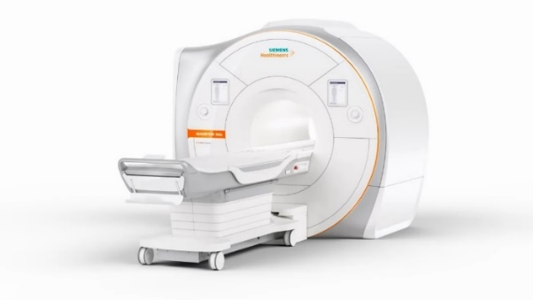

**24 Hours before the scan**

Please do not consume any caffeinated food or drink drinks for 24 hours prior to your appointment. These include:

* Tea/Coffee/decaffeinated hot drinks
* Hot Chocolate
* Fizzy (carbonated) drinks
* Chocolate
* Sweets

Also in this period you must not:

* Smoke or vape
* Take medication containing nitrates (these are commonly prescribed for patients with angina) and include
  + Nicorandil
  + Isosorbide mononitrate
  + Isosorbide dinitrate.

You can continue to use your glyceryl nitrate (GTN) spray, but please let us know when you attend your appointment.

**Will I need an injection?**

You will need to have an injection through your cannula of the adenosine and a contrast agent. The contrast dye helps certain tissues and blood vessels show up more clearly on the images.

**What is involved?**

When you arrive at the department our receptionist will book you in. Just before a radiographer takes you through for the MRI examination, we will go through the safety questionnaire and measure your weight. You will then get changed into a gown ready to go into the scanner. Once you are ready, the radiographer will escort you into either the preparation area or scanning room. Here the radiographer will explain what happens during the scan and give you the chance to ask any questions that you may have about the procedure. If you require contrast during the scan, the radiographer will insert a small cannula so it’s ready to use in the scanner.

Once in the scanning room, the radiographer will position you on the couch ready for the scan. You will lie on your back with a pillow under your head and a pad under your legs for comfort. ECG wires are then placed on your chest so we get an accurate reading of how your heart is beating. A special receiver called a coil is then placed over your chest. As the scanner makes a loud knocking sound, we will give you a set of ear defenders to wear throughout the scan. These not only reduce the noise of the scanner but mean you will be able to hear the radiographer talk to you.

You are required to repeatedly hold your breath during the scan – each breath hold needs to last for approximately 10 seconds. The radiographer will rehearse this with you before starting.

You can communicate with the radiographer during the scan and you will have an alarm buzzer to hold and use if you need any assistance.

**You need to contact us if you have…**

* a pacemaker
* a heart valve repair or replacement
* a cerebral aneurysm clip in place following brain surgery
* a stapes or cochlear implant
* a gastric band
* an endovascular stent
* a muscular or neuro stimulator device.
* or a history of a metallic foreign body in the eye

If you have any of the above or please contact **01722 429282** prior to your appointment.

**Failure to do this may mean that we need to cancel your scan.**

**The perfusion (cardiac stress) scan**

During the scan we will inject adenosine through one of the cannulas in your arm.

Adenosine is given slowly for approximately 3 minutes. It is normal to:

* Feel short of breath
* Experience some chest tightness
* Feel hot or flushed

Once we have given the adenosine, we will take a scan. At the same time we inject the contrast dye through your cannula. We will then stop the adenosine. You will notice the effects of the medication quickly wear off. You will be monitored carefully and be in constant contact with the staff.

After the adenosine has been stopped, we will take some more scan images

**How long will it take?**

Unfortunately, we cannot predict exactly how long the scan will take. Generally, the scans can take up to 60 minutes and the radiographer will be able to give you regular updates during the procedure. You can choose some music to listen to through the scan. It is very important that you remain still in the scanner and try not to shuffle around; parts of the scan may have to be repeated if you do move.

**After your scan**

After your scan we will remove the cannula. You will then be able to dress and leave the department. You will be able to eat and drink normally and restart any medication that was stopped for the scan.

**How do I get the results?**

The results will not be available immediately, as the images have to be processed by computer. A cardiac radiologist or cardiologist will study the images and send a report to the doctor who referred you for the scan. In most cases the results are made available to your referring doctor within 2 weeks. Please contact your cardiology doctor regarding your results rather than the MRI department.

**Pregnancy and Breastfeeding**

Although MRI is a safe procedure, we aim to avoid scanning during the first three months of pregnancy. If your appointment is not clinically urgent then we may wait until you have given birth before scanning you. Please contact us if you are pregnant, think you might be pregnant or are currently breastfeeding.