STANDARD OPERATING PROCEDURE
Configuration/Set up of Digital Assessments for Outpatients SOP

Version: | 1.1
Approval Committee: | SFT DrDoctor Phase 2 Delivery Group
Date of Approval: | 17/04/2024
Lead Job Title of originator/author: | Christian Dobson (Project Manager)
Date written: | 03/04/2024
Reviewed by: | DrDoctor Delivery Group (17/04/24)  Wessex Rehab Chronic Pain stakeholders (04/04/24)
Review date: | 04/04/24
Target audience: | Any members of the Wessex Rehabilitation Team that are involved with the management of the Chronic Pain Pre-Admission Questionnaire
Key words: | Digital Assessment, DrDoctor, Wessex Rehabilitation, Chronic Pain Service
Main areas affected: | Wessex Rehabilitation Centre
Summary of most recent changes: | Added guidance for second triage, paper assessment pack inserted (7.1)
Number of pages: | 8
Type of document: | Standard Operating Procedure

Purpose
The purpose of this document is to describe the Standard Operating Procedure for sending Digital Assessments via the DrDoctor portal for patients referred to the Chronic Pain Service. This will include specific information regarding the management of the Digital Assessment to be used by the Wessex Rehabilitation Chronic Pain service.
A SOP is a set of instructions to be followed in carrying out a given operation, or in a given situation, which lend themselves to a definite or standardised procedure without loss of effectiveness.

introduction
Salisbury Foundation Trust has partnered with DrDoctor to introduce a patient portal. DrDoctor is a patient engagement platform that helps the hospital to communicate effectively with patients. This is part of our ongoing commitment to provide the right care at the right time. Staff can access DrDoctor via a traditional internet browser - https://login.manage.drdoctor.co.uk. Further information regarding set up and configuration of DrDoctor including user access and SMS text messaging can be viewed on the trust website. SOP’s regarding these elements of DrDoctor can be found in section 8.1.
The DrDoctor Digital Assessment product allows a trust to send questionnaire style assessment forms to patients digitally. These assessments are accessed by the patient via a secure web application and patients are given notification of the arrival of a new assessment via SMS text and/or email (dependent on the contact information we hold for them in Lorenzo). The Digital Assessment product is also integrated with the Trust’s document management system, Cito, and patient responses will be stored here in a PDF format.
The introduction of Digital Assessments will be important in helping us monitor patients’ health, inform clinical appointments and provide patients with more suitable care.
How patients complete a digital assessment
- Patient receives a text message or email when a digital assessment has been assigned for them to complete.
- Patient clicks the DrDoctor link in the text message/email.
- Patient logs in to the secure patient portal with their last name, date of birth and postcode.
- Patient fills in the form and clicks ‘Submit’.
  - Once submitted, the patient can view a summary of their answers online at any time.
- If the patient does not complete the assessment within 13 days, the system will send out an automated reminder.
- If the patient does not complete the assessment within 14 days, the service area will instigate an alternative process (see Procedure 3).

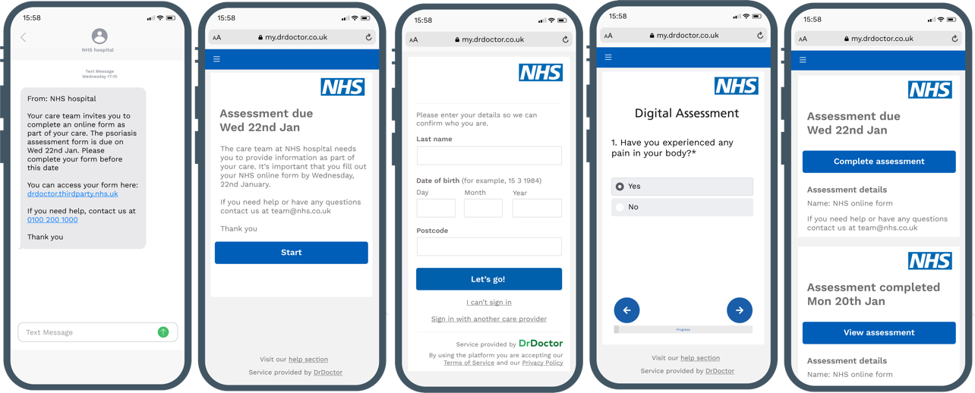

Scope
The Digital Assessment service is being rolled out to a select few outpatient services within the Trust. Patients will therefore only receive a Digital Assessment if they are under the care of an outpatient service using this functionality.

The scope of this SOP is specifically for the Digital Assessment associated with the Chronic Pain Service, run by Wessex Rehabilitation. Only patients referred to and treated via this service will receive the Digital Assessment and no other services involved.

Definitions
Patient Engagement Portal or Platform – A patient portal is an internet-based platform that lets patients view medical records, appointment information and connect with health care professionals.
PAS – Patient Administration System. A PAS captures, stores and manages essential patient details including name, address, date of birth, and comprehensive records of a patient's interactions with the hospital, across both outpatient and inpatient services. The Trust’s current PAS is Lorenzo and has a high level of security and access control, restricted by user and role profile.
Cito – The Trust’s current document management system is Cito. Patient Administration System. Cito enables users to capture, store, retrieve and share electronic documentation held in different formats (scanned paper, emails, images, electronic documents etc.) with a high level of security and access control, restricted by user, role profile or by document content or category.
HAD – Hospital Anxiety and Depression scale.
VAS – Visual Analogue (Pain) Scale
MSK-HQ – Musculoskeletal Health Questionnaire
PSOCQ – Pain Stages of Change Questionnaire

responsibilities
KEY STAFF | DUTIES / RESPONSIBILITIES
Wessex Rehab Secretaries | Assigning patients the Chronic Pain assessment to trigger the Digital Assessment process.  Monitoring responses from patients and instigating the alternative procedure when necessary for patients who have not/cannot engage digitally.  Informing the relevant colleagues (MDT) of patients who have completed the assessment, for further triage.  Ensuring correct contact information for patients in Lorenzo.
Chronic Pain Clinician | Triaging initial referral – return, forward, accept referral
MDT (Clinician, Physiotherapist, Occupational Therapist, Psychologist) | Second triage, after patient has completed questionnaire, using PDF results assigned to each patient on Lorenzo / Cito. Updating the referral to inform patient pathway (amending access plan, codes on referral, add to waitlist and/or send out appointments)

SPECIFIC PROCEDURE
The process maps supporting these procedures are in section 8.1.

Procedure 1: Sending a Digital Assessment – Booking process from Lorenzo
This section of the SOP will detail the process for how a patient will be assigned a Chronic Pain Digital Assessment. This action will be completed by the Wessex Rehab Secretaries.
- Chronic Pain Clinician reviews the initial patient referral through electronic referral system. The Doctor will accept the referral and establish whether to return, forward, or accept referrals. Accepted referrals are triaged as routine or urgent.
  - Urgent referrals will be invited to come into Wessex Rehab in person to be assessed, without digital distribution of the questionnaire.
- Wessex Rehab Secretary will then action the accepted routine referrals, collating a list of patients requiring the Digital Assessment and searching the hospital number of each patient on the DrDoctor portal, selecting ‘Add new activity’, Activity: Form, Form: Chronic Pain Clinic. The due date should be 2 weeks from the current date, to allow the patient a 2-week period to complete the DrDoctor digital assessment.
- Once the activity is added, DrDoctor will automatically distribute the Digital Assessment to the patient via a text and/or email invitation.
- If the patient does not complete the assessment by day 13, DrDoctor will automatically distribute a reminder text and/or email.

Procedure 2: Reviewing Digital Assessment Outcomes – Patient has completed the Digital Assessment
This section of the SOP will detail the process to follow if a patient has completed the Digital Assessment within 14 days of it being assigned. The Wessex Secretaries will check the assessment dashboard once weekly as a minimum to collect responses and monitor overdue assessments.
- Once the patient has completed the Digital Assessment, the response will be available to view through the following formats:
- Responses will be accessible through the DrDoctor portal within the dashboard for the Chronic Pain Clinic assessment.
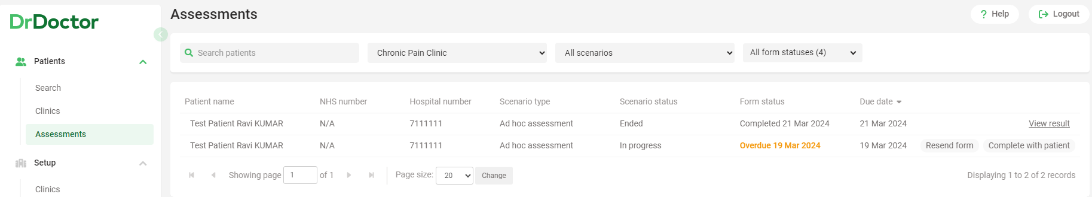

- A PDF of the patient responses will also be accessible within the Chronic Pain Clinic folder in Cito.
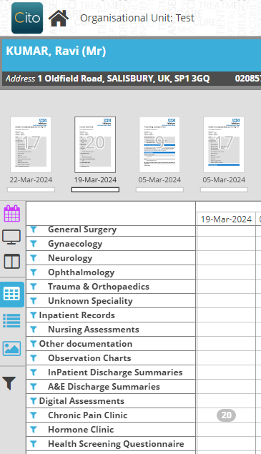
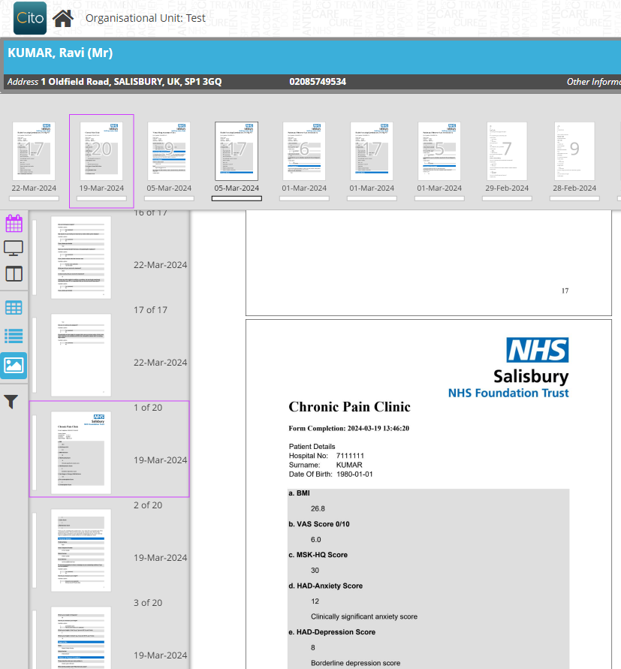

- Review the following areas of the output:
  - BMI, VAS, MSK-HQ
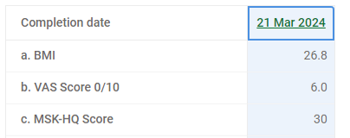
Example output on DrDoctor

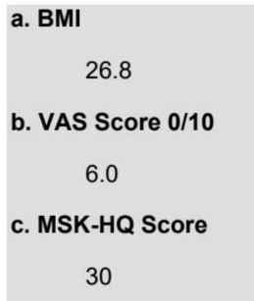
Example output on PDF in Cito

  - HAD Scores
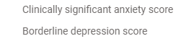
Example output on DrDoctor
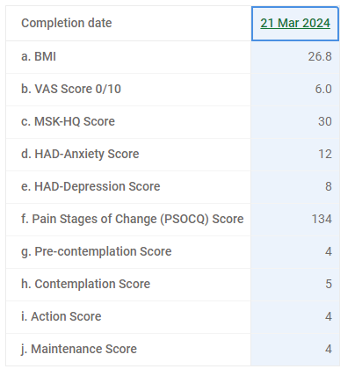
Example output on PDF in Cito
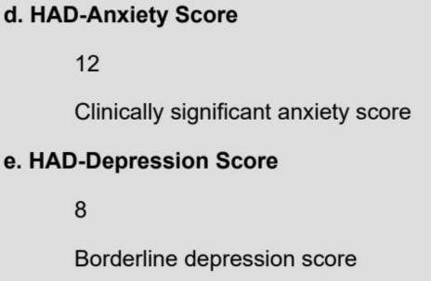

  - PSOCQ
Example output on DrDoctor

Example output on PDF in Cito
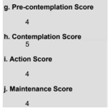

Procedure 3: Reviewing Digital Assessment Outcomes – Patient has not completed the Digital Assessment
This section of the SOP will detail the process to follow if a patient has not completed the Digital Assessment within 14 days of it being assigned, and it shows as Overdue within the DrDoctor system.
- Wessex Rehab Secretary reviews the assessment list weekly on Lorenzo to establish whether the patient has completed the Digital Assessment by the deadline.
  - If the patient has completed the assessment within the timeframe, the system will show the date of completion and have a link to view the results.
  - If the patient has not completed the assessment within the timeframe, the system will show the assessment as overdue.
- Patients who are flagged as overdue will be sent the Paper Assessment Pack (see section 7.1) by the Wessex Rehab Secretary, via post.
  - Patients are informed via the letter at the start of the Paper Assessment Pack that if the assessment is not returned, they will be discharged from the service via Lorenzo by the Wessex Rehab Secretary.
- Patient responses will be sent back to the Wessex Rehabilitation Centre either via post or in person at Reception.
- Wessex Rehab Secretary to review and score the following areas (see paper pack for scoring criteria:
  - BMI, VAS, MSK-HQ, HAD-A, HAD-D
  - PSOCQ (Precontemplation, Contemplation, Action & Maintenance scores)
- Once scored, the paper documents are scanned onto the patient profile on Lorenzo in the letters tab, before progressing to Procedure 4.

Procedure 4: Reviewing patient responses
- After completing the Chronic Pain Pre-Admission Questionnaire, patients will be triaged again by the MDT.
  - If completed via DrDoctor, the assessment responses will be available to view in both DrDoctor and Cito in the patient’s Lorenzo EPR. A list of patients will be passed from the Wessex Secretaries to the MDT team, who will view each patient’s Digital Assessment in turn, using the scores and responses as a basis for triage. It should be noted that the body map image will not display on the Cito/Lorenzo version of the assessment response, and so it may be preferable for the MDT to work through the second triage using DrDoctor.
  - If completed on paper, the assessment responses will be available to view via the Letters Tab in Lorenzo.
- The MDT will then update the Lorenzo referral as appropriate, and patient will continue along required pathway. The Wessex Secretary will then action any required next steps e.g., booking the patient for a follow-up appointment.

Forms/templates to be used

Paper Assessment Pack

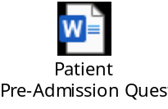

internal and external references

Internal References
DrDoctor Configuration & SMS Reminders SOP

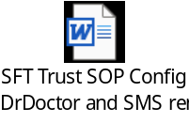

Process map of Chronic Pain Assessment process
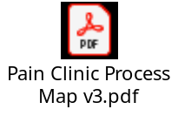

External References
DrDoctor Digital Assessments help pages
Overview of Assessments - DrDoctor Help Centre

Version history
Version | Date | Significant Changes
1.0 | 03.04.2024 | First draft of content
1.1 | 10.04.2024 | Second draft of content following review by Chronic Pain team and Abigail Whitby
1.1 | 17.04.2024 | SOP formally signed off by DrDoctor Delivery Group

