STANDARD OPERATING PROCEDURE
Configuration/Set up of Digital Assessments for Outpatients SOP

Version: | 1.0
Approval Committee: | SFT DrDoctor Phase 2 Delivery Group
Date of Approval: | 17/04/2024
Lead Job Title of originator/author: | Abigail Whitby (Project Manager)
Date written: | 06/03/2024
Reviewed by: | DrDoctor Delivery Group (17/04/2024)  Scar Management Clinic Stakeholders (20/03/24)
Review date: | 20/03/2024
Target audience: | Any therapy or administrative members of the Scar and Burns Team that are involved with the management of the Scar Management Outpatient Clinic.
Key words: | Digital Assessment, DrDoctor, Scar Management Clinic, Patient
Main areas affected: | Scar Management Outpatient Clinic
Summary of most recent changes: | Final Draft
Number of pages: | 9
Type of document: | Standard Operating Procedure

Purpose
The purpose of this document is to describe the Standard Operating Procedure for sending Digital Assessments via the DrDoctor portal for patients referred to the Scar Management Clinic. This will include specific information regarding the management of the Digital Assessment to be used by the Scar Management outpatient service.
A SOP is a set of instructions to be followed in carrying out a given operation, or in a given situation, which lend themselves to a definite or standardised procedure without loss of effectiveness.

introduction
Salisbury Foundation Trust has partnered with DrDoctor to introduce a patient portal. DrDoctor is a patient engagement platform that helps the hospital to communicate effectively with patients. This is part of our ongoing commitment to provide the right care at the right time. Staff can access DrDoctor via a traditional internet browser - https://login.manage.drdoctor.co.uk. Further information regarding set up and configuration of DrDoctor including user access and SMS text messaging can be viewed on the trust website. SOP’s regarding these elements of DrDoctor can be found in section 8.1.
The DrDoctor Digital Assessment product allows a trust to send questionnaire style assessment forms to patients digitally. These assessments are accessed by the patient via a secure web application and patients are given notification of the arrival of a new assessment via SMS text and/or email (dependent on the contact information we hold for them in Lorenzo). The Digital Assessment product is also integrated with the Trust’s document management system, Cito, and patient responses will be stored here in a PDF format.
The introduction of Digital Assessments will be important in helping us monitor patients’ health, inform clinical appointments and provide patients with more suitable care.
How patients complete a digital assessment
- Patient receives a text message or email when a digital assessment has been assigned for them to complete.
- Patient clicks the DrDoctor link in the text message/email.
- Patient logs in to the secure patient portal with their last name, date of birth and postcode.
- Patient fills in the form and clicks ‘Submit’.
  - Once submitted, the patient can view a summary of their answers online at any time.
- If the patient does not complete the assessment within 6 days, the system will send out an automated reminder.
- If the patient does not complete the assessment by the clinic appointment, the service area will instigate an alternative process (see Procedure 3).

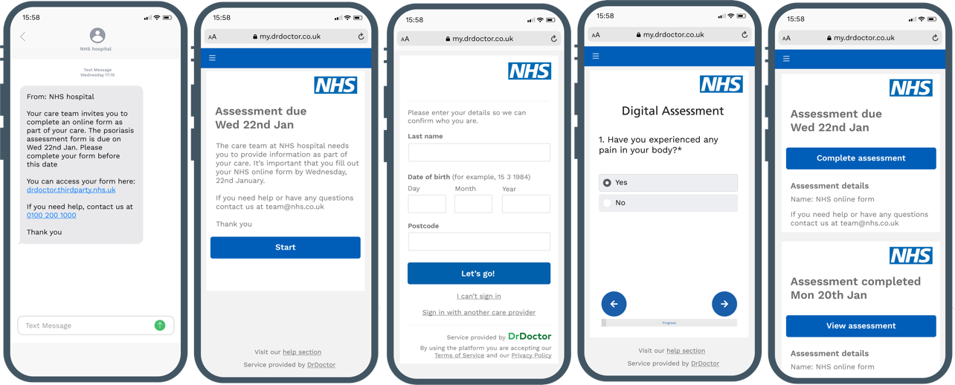

Scope
The Digital Assessment service is being rolled out to a select few outpatient services within the Trust. Patients will therefore only receive a Digital Assessment if they are under the care of an outpatient service using this functionality.
The scope of this SOP is specifically for the Digital Assessment associated with the Scar Management Clinic, run by the Burns Scar outpatient service. Only patients referred to and treated via this clinic will receive the Digital Assessment and no other outpatient clinics within the Burns Scar department are involved.

Definitions
Patient Engagement Portal or Platform – A patient portal is an internet-based platform that lets patients view medical records, appointment information and connect with health care professionals.
PAS – Patient Administration System. A PAS captures, stores and manages essential patient details including name, address, date of birth, and comprehensive records of a patient's interactions with the hospital, across both outpatient and inpatient services. The Trust’s current PAS is Lorenzo and has a high level of security and access control, restricted by user and role profile.
Cito – The Trust’s current document management system is Cito. Patient Administration System. Cito enables users to capture, store, retrieve and share electronic documentation held in different formats (scanned paper, emails, images, electronic documents etc.) with a high level of security and access control, restricted by user, role profile or by document content or category.
POSAS – The Patient and Observer Scar Assessment Scale is a verified assessment tool which measures scar quality in all types of scars by evaluating visual (e.g. colour), tactile (e.g. pliability) and sensory (e.g. itch) characteristics of the scar from the perspective of the observer and patients. The patient scale has been used within the DrDoctor Digital Assessment.

responsibilities
KEY STAFF | DUTIES / RESPONSIBILITIES
Therapy Administrator | Booking patients into the clinic appointment slots on Lorenzo to trigger the Digital Assessment process, for those referred directly or via the Consultant.  Ensuring correct contact information for patients in Lorenzo.  Booking follow-up appointments when required.  Discharging patients via Lorenzo when required.
Odstock Ward Clerk | Booking patients into the clinic appointment slots on Lorenzo to trigger the Digital Assessment process, for those referred through the Burns Dressing Clinic.  Ensuring correct contact information for patients in Lorenzo.
Scar Management Clinician or Health Care Professional | Triage referrals in terms of priority (urgent/non-urgent).  To review the returned Digital Assessment outcome forms.  Monitoring responses from patients and instigating the alternative procedure when necessary for patients who have not/cannot engage digitally.  Booking follow-up appointments when required.  Discharging patients via Lorenzo when required.  Contacting the Therapy Administrator when a follow-up appointment within this service needs to be booked or when the patient needs to be discharged.  Ensuring correct contact information for patients in Lorenzo.

SPECIFIC PROCEDURE

Procedure 1: Sending a Digital Assessment – Booking process from Lorenzo
This section of the SOP will detail the process for how a patient will be assigned a Digital Assessment through their booking onto the Scar Management Clinic on Lorenzo.
- Referrals to the Scar Management Clinic can be made through one of three routes:
  - Referrals made as an outcome of the Burns Dressing Clinic are submitted to the Odstock Ward Clerk through the patient notes.
  - Direct referrals into the Scar Management Clinic are received by the Therapy Administrator through the Electronic Referral System.
  - Referrals made by consultants are submitted to the Therapy Administrator via email or through their referral form.
- The Odstock Ward Clerk or Therapy Administrator will action the referrals and book patients within one of the following clinics, MA02160THABSMCSMPB CSMPB Mixed Thurs or MP02160THCBSMCSMPB CSMPB Mixed Thurs. Clinic bookings are set up with the following parameters:
  - Appointment type: New or Follow Up
  - Appointment format: Telephone, Face to Face or Virtual (telemedicine)
  - Appointment date: Clinics should be booked as per the timeframe requested by the referrer (this should be no later than 7 days prior to the clinic slot)
    - Note that if clinic slots are full, additional slots will be added and internal resourcing will be managed to ensure the patient can be seen.
- Once booked into the clinic slot, DrDoctor will automatically distribute the Digital Assessment to the patient 7 days prior to the clinic appointment, via a text and/or email invitation.
- If the patient does not complete the assessment within 6 days, DrDoctor will automatically distribute a reminder text and/or email.

Procedure 2: Reviewing Digital Assessment Outcomes – Patient has completed the Digital Assessment
This section of the SOP will detail the process to follow if a patient has completed the Digital Assessment by the date of the clinic appointment.
- Once the patient has completed the Digital Assessment, the response will be available to view through the following formats:
  - Responses will be accessible through the DrDoctor portal within the dashboard for the relevant clinic appointment.
    - If the patient has completed the assessment within the timeframe, the system will show the date of completion and have a link to view the results.

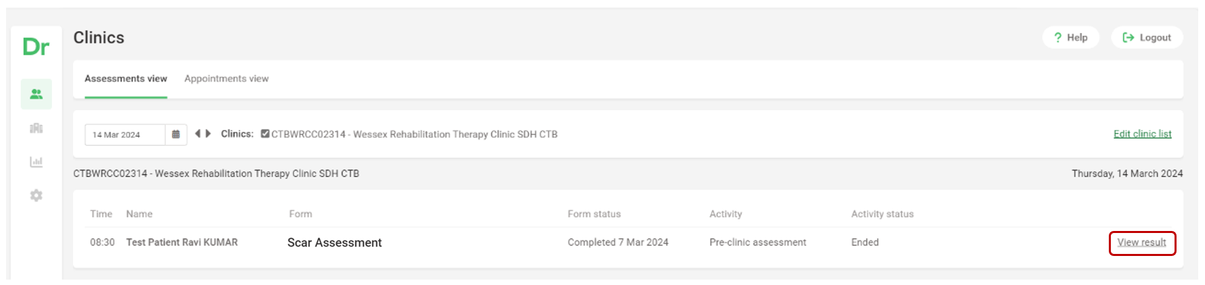

    - If the patient has not completed the assessment within the timeframe, the system will show the assessment as overdue (continue to Procedure 3).

Note: Screenshots shown are an example, clinic name will show ‘MA02160THABSMCSMPB CSMPB Mixed Thurs’ or ‘MP02160THCBSMCSMPB CSMPB Mixed Thurs’ in the Live system.
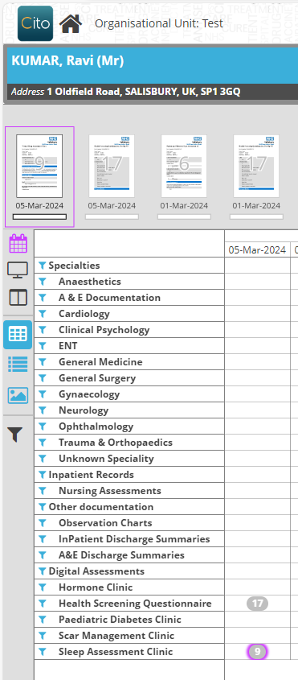
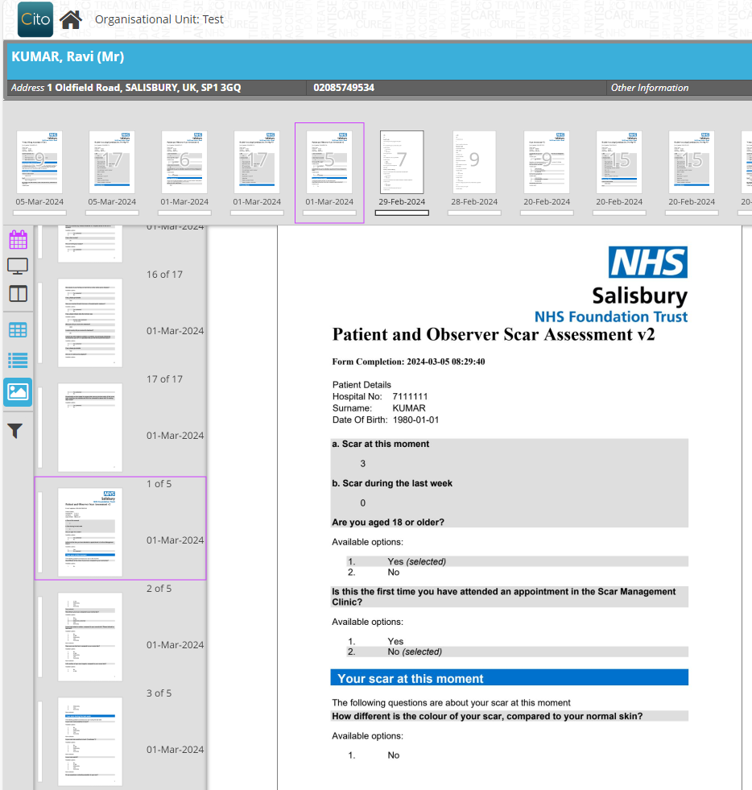
  - A PDF of the patient responses will also be accessible within the Scar Management Clinic folder in Cito.
- Review the following areas of the output:
  - POSAS Scores: Scar at this moment (score range of 5 – 25) and Scar in the past week ( score range of 5 – 55). These scores should then be recorded on the Scar Management Database on HAL.
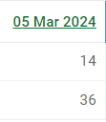
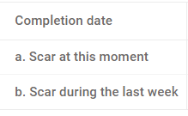
Example output on DrDoctor

Example output on PDF in Cito
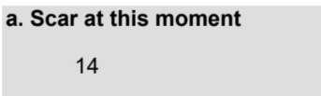
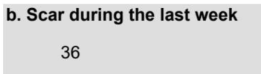
  - Patient responses to the rest of the from are available to view in both the DrDoctor and Cito output before or during the clinic appointment.
    - If it is the patient’s first appointment in the Scar Management Clinic, the Clinician will review the patient responses for the Psychology and pre-clinic questionnaire and POSAS scores.
    - If it is not the patient’s first appointment in the Scar Management Clinic, the Clinician will only review the POSAS scores (including in comparison to previous scores).
    - If the patient is identified as being under the age of 18 at the start of the assessment, there should be no data to review. If the patient is under 18 and has completed the Digital Assessment, their responses do not need to be reviewed. The clinic can continue without this information for paediatric patients.
- At the Clinic appointment, the Scar Management Clinician or Health Care Professional should ensure rge correct contact information for patients in Lorenzo. Following the completion of the Scar Management Clinic, determine whether another clinic appointment is needed.
  - If yes, the Scar Management Clinician can create a new booking within Lorenzo (see clinic details in Procedure 1). If unable to do the booking, the Scar Management Clinician should contact the Therapy Administrator via email to request another clinic appointment to be booked for the patient. Process begins again (see Procedure 1).
  - If no, the patient should be discharged via Lorenzo. This can be completed by the Scar Management Clinician, or alternatively they can contact the Therapy Administrator via email to request for the patient to be discharged.

Procedure 3: Reviewing Digital Assessment Outcomes – Patient has not completed the Digital Assessment
This section of the SOP will detail the process to follow if a patient has not completed the Digital Assessment by the virtual review clinic, and it shows as Overdue within the DrDoctor system. Note that patients under the age of 18 do not need to complete the assessment and so the Overdue status can be ignored for paediatric patients.
- Scar Management Clinician reviews the clinic list on Lorenzo and identifies that the patient has not completed the assessment within the timeframe. The system will show the assessment as overdue.
- The action required will depend on whether the clinician has access to technology during the Clinic appointment.
  - If yes, the Scar Management Clinician should complete the assessment with the patient
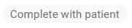
    - Select the ‘Complete with patient’ option within the clinic view.
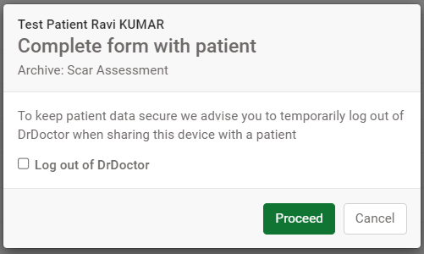
    - Untick the ‘Log out of DrDoctor’ option, then press Proceed
    - Log in to the patient’s portal using their demographic details (surname, date of birth, home postcode)
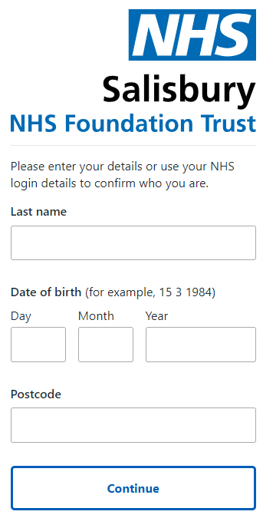
  - If there is no access to technology, the Scar Management Clinician should complete the assessment on the paper version (section 7.1)
    - Scar Management Clinician completes the assessment with the patient during the appointment (either on DrDoctor or on paper).
    - If it is the patient’s first appointment in the Scar Management Clinic, the Clinician will need to complete the Psychology, pre-clinic questionnaire and POSAS with the patient.
    - If it is not the patient’s first appointment in the Scar Management Clinic, the Clinician will only need to complete the POSAS with the patient.
- The POSAS scores should be recorded on the Scar Management Database on HAL.
- At the Clinic appointment, the Scar Management Clinician or Health Care Professional should ensure the correct contact information for patients in Lorenzo. Following the completion of the Scar Management Clinic, determine whether another clinic appointment is needed.
  - If yes, the Scar Management Clinician can create a new booking within Lorenzo (see clinic details in Procedure 1). If unable to do the booking, the Scar Management Clinician should contact the Therapy Administrator via email to request another clinic appointment to be booked for the patient. Process begins again (see Procedure 1).
  - If no, the patient should be discharged via Lorenzo. This can be completed by the Scar Management Clinician, or alternatively they can contact the Therapy Administrator via email to request for the patient to be discharged.

Forms/templates to be used

Paper Scar Management Clinic Questionnaire
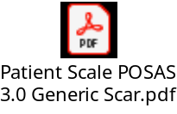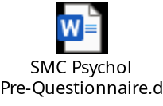

internal and external references

Internal References
DrDoctor Configuration & SMS Reminders SOP

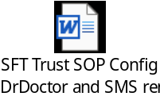
Process map of Scar Management Clinic process
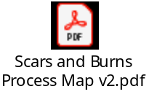
Quick Reference Guide Scar Management Clinic

External References
DrDoctor Digital Assessments help pages
Overview of Assessments - DrDoctor Help Centre

Version history
Version | Date | Significant Changes
1.0 | 06/03/2024 | First draft of content
1.1 | 20/03/2024 | Review of content with Scar Management Stakeholders
1.1 | 07/05/2024 | Quick Reference Guide attached to support go-live.

