STANDARD OPERATING PROCEDURE
Sending of Digital Letters for Outpatient Appointments SOP

Version: | 1.0
Approval Committee: | Paperlite Board
Date of Approval:
Lead Job Title of originator/author: | Chloe Stokes (Senior Project Manager)
Date written: | 22/01/2024
Reviewed by: | DrDoctor Delivery Group
Review date:
Target audience: | Booking & Admin Team/s, Service Managers, administrative support and any staff that oversee the management of Outpatient clinics.
Key words: | Outpatient, Appointment letters, letter templates, Digital Letters, Patient Portal
Main areas affected: | All Outpatient Areas
Summary of most recent changes:
Number of pages:
Type of document: | Standard Operating Procedure

purpose
The purpose of this document is to describe the Standard Operating Procedure for sending Digital Outpatient Appointment letters via the DrDoctor portal. This will include specific information regarding the management of Digital Letters.
A SOP is a set of instructions to be followed in carrying out a given operation, or in a given situation, which lend themselves to a definite or standardised procedure without loss of effectiveness.

introduction
Salisbury Foundation Trust has partnered with DrDoctor to introduce a patient portal. DrDoctor is a patient engagement platform that helps the hospital to communicate effectively with patients. This is part of our ongoing commitment to provide the right care at the right time. Staff can access DrDoctor via a traditional internet browser - https://login.manage.drdoctor.co.uk/
Further information regarding set up and configuration of DrDoctor including user access and SMS text messaging can be viewed on the trust website. SOP’s regarding these elements of DrDoctor can be found in section 7 below.
The DrDoctor Digital Letters product allows a trust to send appointment letters to patients digitally. Letters are accessed by the patient via a secure web application and patients are given notification of the arrival of a new letter via SMS text and/or email (dependent on the contact information we hold for them in Lorenzo). The Digital Letters product is designed to integrate with whichever existing 3rd party supplier the Healthcare Provider are already using for paper letter fulfilment, allowing for a workflow that will fall back to sending a paper letter by default if the patient has not viewed their digital copy. For SFT, the 3rd party letter provider is Synertec.
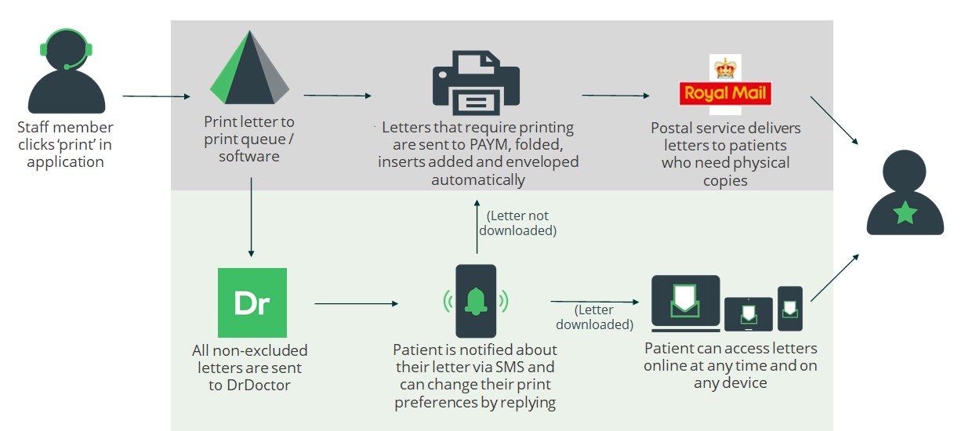

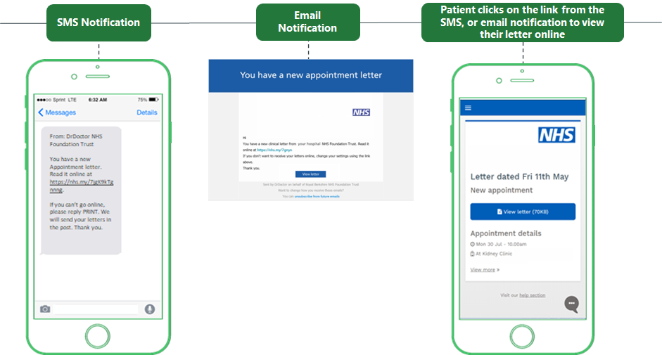

- When a letter is printed in the hospital it is handed to Synertec and then Synertec uploads the letter via the DrDoctor API
- DrDoctor will send the patient a notification by text and/or email with a link to their letter
- If the patient follows the link to the secure Patient Portal, they can log in to read and download their letter
- If the patient has not opened their letter, DrDoctor can send them a reminder a set number of days after the initial notification
- When the patient receives their first letter, they will be able to choose whether they prefer to receive paper or digital letters, these preferences can be changed at any time

Scope
For Phase 1 of the project, only Outpatient Appointment letters are in scope. This excludes clinical correspondence letters, that are sent to patients post appointment. Therefore, in order for the 3rd party letter provider system (Prism via Synertec) to action the digitising of in scope letters only, a unique identifier has been added into all of SFT’s in scope OP appointment letter templates. A visual view of this can be seen below. The unique identifier is included in the bottom right corner of all letter templates, that signals, if printed to Synertec, the letter will be sent to the patient digitally.
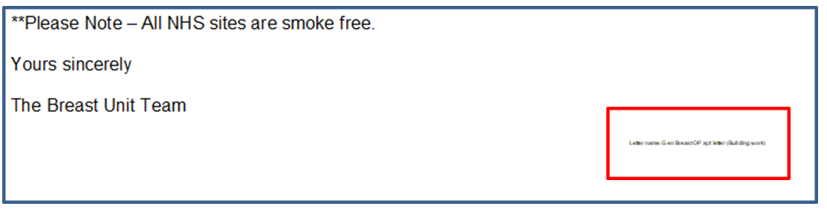
The scope for this SOP is as follows:
- Outpatient Appointment letters sent from Lorenzo – this includes original appointment letter, rescheduled appointment letters and cancelled appointment letters.
- Outpatient Appointment letters sent from Lorenzo – applies to face to face, telephone and Video appointment letters.

Definitions

Patient Engagement Portal or Platform – A patient portal is an internet-based platform that lets patients view medical records, appointment information and connect with health care professionals.
Synertec – Synertec are SFT’s offsite provider/third party supplier of printed material (inc appointment & Clinical correspondence letters)
API – Application Programming Interface. a set of functions and procedures allowing the creation of applications that access the features or data of an operating system, application, or other service.
Outsourced – Obtaining goods or a service by contract from an outside supplier.

responsibilities

KEY STAFF | DUTIES / RESPONSIBILITIES
Booking personnel | Sending OP appointment letters from Lorenzo. For outsourced letters, selecting the correct printer via Lorenzo.  Ensuring correct contact information for patients in Lorenzo.
Application Support | Managing the set up of new letter templates. Ensuring relevant new letter templates have unique identifier.
Reception Staff | Ensuring correct contact information for patients in Lorenzo.

SPECIFIC PROCEDURE
Procedure 1 - Sending a Digital Letter – booking process from Lorenzo.
Appointments should be booked in Lorenzo using existing procedures. The relevant booking letter should then be generated. Please do not remove the letter name at the bottom - the letter will not be sent digitally and may be bounced back (unique identifier needs to stay in this place exactly)
For letters to be sent digitally, the printer shown below (Prism02app-p2\MMDOTPTNT) should be selected.
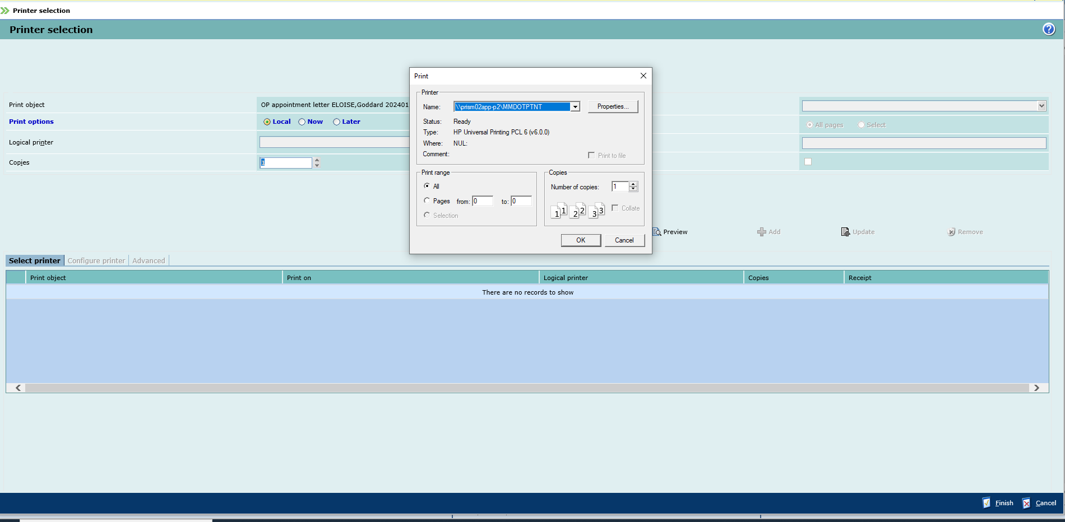
Exclusions
OP appointment letters addressed to the following patient cohorts are excluded from digital letters and therefore can either be printed in house or sent to print via Synertec (but will be printed and delivered, not sent digitally)
- Prisoners
- Letters addressed to Knook Medical Centre, BA12 0JB

Timing rules
The following bullet points describe what action will be taken by Synertec depending on the date of the appointment in question. This dictates whether or not a letter is automatically sent physically or digitally.
- Letter is generated 5-10 days before the appointment date – Digital Letter is sent and physical copy
- Letter is generated less than 5 days before the appointment date – Digital Letter only is sent
- Letter is generated more than 10 days before the appointment date – Digital Letter only is sent
- Digital letter is not read within 3 days of it being sent – physical copy is sent

Procedure 2 - Military Med Centre info
Copies of OP appointment letters addressed to patients at the below Military Med Centres will go digitally as standard (to the requested group mailbox) as well as digital versions straight to military personnel via their mobiles.

Tidworth Medical Centre
SP9 7EA
Middle Wallop Medical Centre
SO20 8DY
Bulford Medical Centre
SP4 9AD
Larkhill Medical Centre
SP4 8QY
Warminster Medical Centre
BA12 0DJ
Blandford Medical Centre
DT11 8RH

Procedure 3 - Set up of new Digital Letter Templates via Application Support
This section of the SOP will detail the process for new OP appointment letter templates to be set up in order to be sent digitally.
- When requesting a new letter template, staff must fill in the new letter template request form available via the intranet: http://intranet/departments/transformation-and-informatics-it/informatics-it/lorenzo-electronic-patient-records-epr/lorenzoepr-forms/epr-lorenzo-change-forms/
- If the letter is being printed externally, via outsourced print Synertec, individuals requesting the new template should select the relevant box. If the letter is to be sent digitally, this box must be selected.
- This request should be submitted to the Application Support team. The team will process the request and seek sign off before the new letter templates goes live. Before sign off, App support will confirm with the department that they are happy for it to be sent digitally. Application Support will then add in the unique identifier necessary for the new letter template to be processed digitally for all future instances.

Procedure 4 – Amending a patient’s letter preference
Patients can set their preference for how to receive their letters; via post or read it online (with email/SMS notifications).
They can make this change through their patient portal or via the text message prompts. If they are unable to do this, a SFT administrator can change this for them.
- Go to 'Search' under the 'Patients' section in the left bar navigation
- Search for the patient either with their NHS number or their hospital number
- Click 'Select' to view the patient's profile
- In the top right navigation click on 'Letters preference' to change their settings

internal and external references

Internal References
Lorenzo change forms
http://intranet/departments/transformation-and-informatics-it/informatics-it/lorenzo-electronic-patient-records-epr/lorenzoepr-forms/epr-lorenzo-change-forms/

DrDoctor Configuration & SMS Reminders SOP

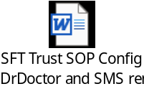

External References
DrDoctor Digital Letter help pages
https://docs.dr.doctor/en/articles/83123-overview-of-digital-letters

Version history

Version | Date | Significant Changes
0.1 | 22/01/2024 | First draft of content

