Falls Prevention Information Pack
This information pack has been given to you following your attendance at SDH after having a fall.
Falls are a common but not inevitable part of ageing. Around one in three adults over 65 who live at home will have at least one fall a year, and about half of these will have more frequent falls.
Most falls do not result in serious injury but there is a risk that a fall could cause reduced mobility and loss of confidence, resulting in reduced independence around the house as well difficulty getting out and about.
There are many different reasons why you may be more likely to fall as you get older, for example:

- Balance problems and muscle weakness
- Poor vision
- A long-term health condition such as heart disease, dementia or low blood pressure which can lead to dizziness
- Poor footwear or painful feet
- A trip on uneven paving or at home due to poor lighting or a cluttered environment

The majority of falls can be prevented with some simple changes to your lifestyle and home environment. A fall can also be a warning sign that you need a medical check-up or a medication review.

This pack contains advice and information to help reduce the risk of falling. Read through it and you can take out the useful checklists/ exercise sheets and put them somewhere you can see them e.g. on your fridge or by your bed.
For further information here are some useful contacts:

Age UK
Information on falls prevention, exercise classes and handyman services in some areas. Call free on 0800 169 6565 or see ageuk.org.uk/falls

Active Health Falls Prevention classes for WILTSHIRE
Call Sally Phillips on 07799074312 or email sally.phillips@wiltshire.gov.uk

NHS choices
These leaflets and other useful resources
nhs.uk/conditions/falls
nhs.uk/healthy-bones

Adult Social Care
For long term care provision and home adaptations
Wiltshire: 0300 4560111
Hampshire: 03005551386
Dorset: 01305221016

Staying active and steady as you get older
Increasing your physical activity along with exercises to improve your muscle strength and balance will keep you active, steady and able as you get older.
Being too sedentary, such as sitting or lying down for long periods is really bad for your health and your physical ability. It will cause you to lose muscle strength fast which will make you more prone to falling.

Tips to build regular activity in to your everyday life:

- Practice some exercises whilst doing a daily activity e.g. brushing teeth etc
- Break up any periods of sitting every hour by standing up
- Stand up and move during TV advert breaks
- Stand up while on the phone
- Use the stairs as much as possible
- Do regular housework or dance to the radio
- Playing with grandchildren
- Go for regular short walks

How active should you be?
If you are over 65 it is advised to build up to a total of 150 minutes of moderate intensity aerobic activity each week. Moderate activity will raise your heart rate and make you breathe faster and feel warmer. You should still be able to talk but won’t be able to sing the words to a song. Don't forget every 10 minutes counts! Perhaps try 30 minutes on 5 days of the week.
If you're not use to being active, start slowly. It’s never too late to start. Sessions of at least ten minutes throughout the day are a good way to start. Drink plenty of water and stop if you feel unwell or dizzy.
Strength and balance

You should perform exercises to improve your muscle strength and balance. (See attached exercise sheets)

Age UK have also put together some really useful exercise videos that you can watch and join in. They have 3 different levels so you can find a level that best suits you.

Dance with Anna https://youtu.be/x-In7Vcu4i0
Balance with Sandra https://youtu.be/HiDpYePaUHg
Strength with Alex https://youtu.be/90Khz0gNmug

Creating a Falls Plan
No one wants to have a fall, but if you live alone, or are alone for long periods, you should plan what you'll do, who you'll contact and how they'll get to you. Having a plan in place can make you feel more in control of the situation and reduce distress as well as any complications like pressure sores and dehydration.
Calling for help
You can call for help many ways. The most important thing is that the person you call expects it and knows what to do.
- Buy a mobile phone for emergencies
  - ensure it is fully charged and keep it on you at all times.
  - share your number with a relative or neighbour that way if you run out of battery or lose signal before you have a chance to talk, they'll know that you need help.
  - you can also call the emergency services for free even if you've no credit
- Use a pendant alarm or lifeline alarm

Letting help in
After calling for help you must now think about how they'll get to you. You can:
- leave a spare key with a friend, neighbour or relative you trust that lives nearby OR
- leave a spare key in a key safe – a secure box with a combination lock that you can keep outside your home. This can be accessed by anyone that you have shared the combination code with

Sharing your plan

Once you have your plan ready, it's a good idea to share this with your family and friends and let them know what to expect and what to do in the event of a fall.
If you do have a fall at home
- Don’t panic.
- Stay calm, remain positive and check if you are injured
- Call for help – be ready to give your name and address
- Decide whether or not you can get up safely. See best way to do this overleaf.

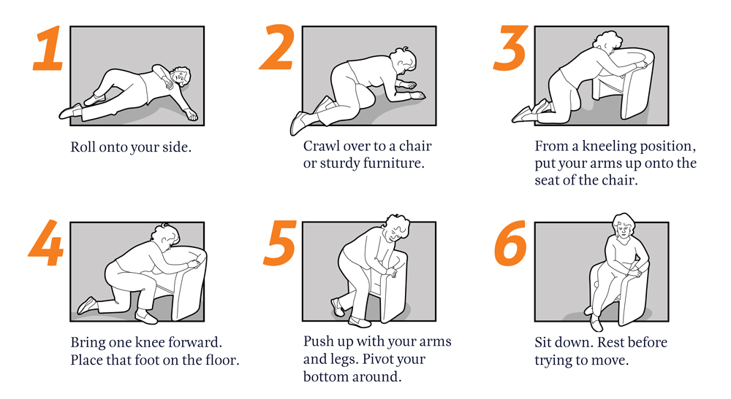

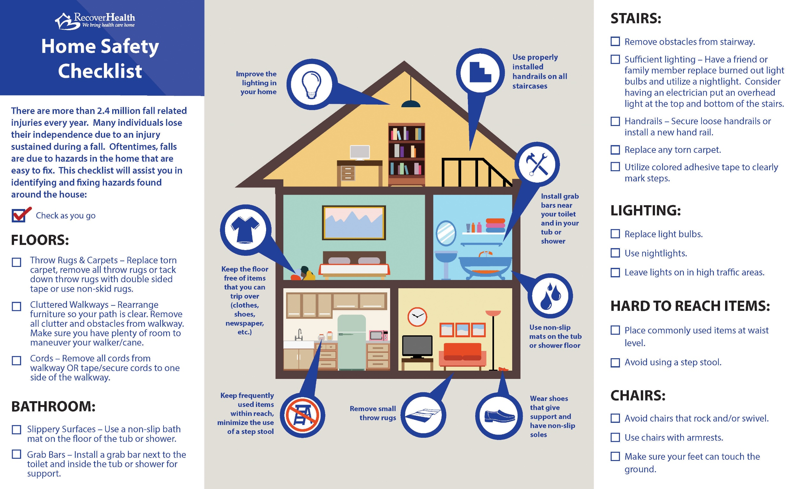

Shoe Safety Checklist

Falls are preventable. Reduce your risk of falling by changing the type of shoes you wear and complete this checklist to see if you need safer shoes. Poorly fitted footwear and foot pain can influence falls.
Take care of your feet to help you stay active and mobile. Check your feet regularly and see a podiatrist if you notice any changes.

 | YES | NO
Do your shoes fit well?
Do you mostly wear flat shoes?
Does the sole of your shoe bend at the ball of your foot, not the arch?
Does your shoe have a textured sole?
Does your shoe have a firm heel collar?
Does the heel have a rounded edge?
Does your shoe fasten to your foot with laces, straps, elastic, velcro or buckle?
If you ticked ‘No’ to any of these questions, your risk of falling may be increased.
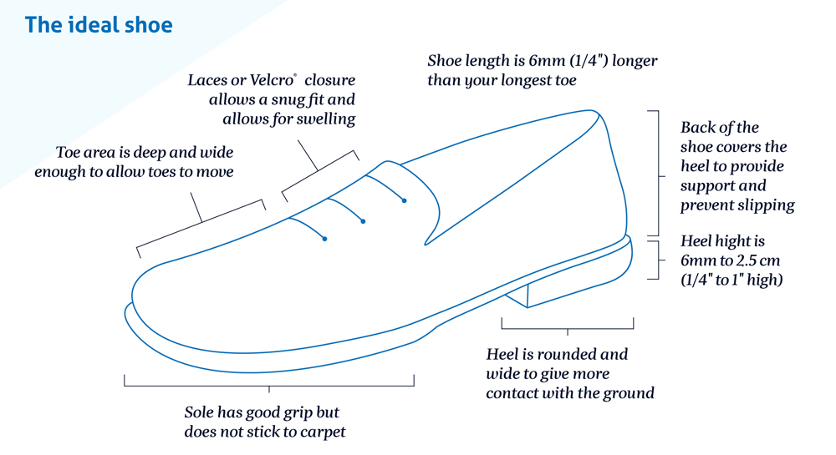

Strength and Balance Exercises

These six simple exercises will help with balance and co-ordination. It is advisable to try and do them daily. If you experience chest pain, dizziness or severe shortness of breath, stop and call your GP or call 111. A slight soreness the day after is quite normal.

Knee Extensions
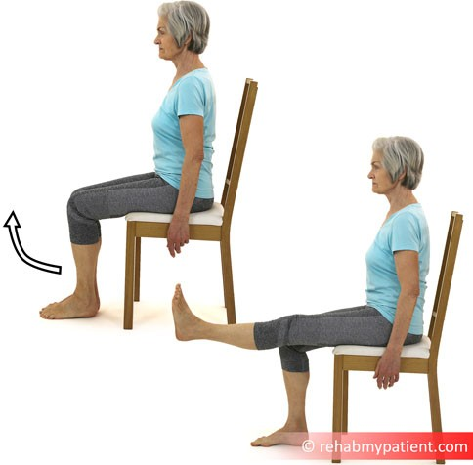
-Sit in a chair with your back well supported.
-Straighten your right leg by lifting your lower leg from the knee and keeping your thigh ﬂat against the chair.
-Hold leg straight out for 5 seconds.
-Lower slowly and place foot on the ground.
-Repeat 10 times.
-Repeat from the start using the left leg.

Make it harder:
Add a small ankle weight - start light with a 1kg weight

Mini Squat
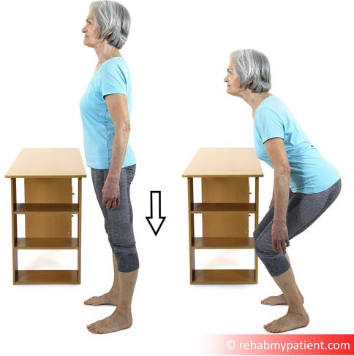
- In standing postion, face forwards holding onto a sturdy support such as a kitchen bench or heavy table
-Place your feet shoulder width apart
-Slowly bend at your knees and squat down
-Slowly stand back up
- Repeat 10 times

Make it harder:
-Get progressively lower
-Remove hands from the support if you feel steady

Calf Heel Raise
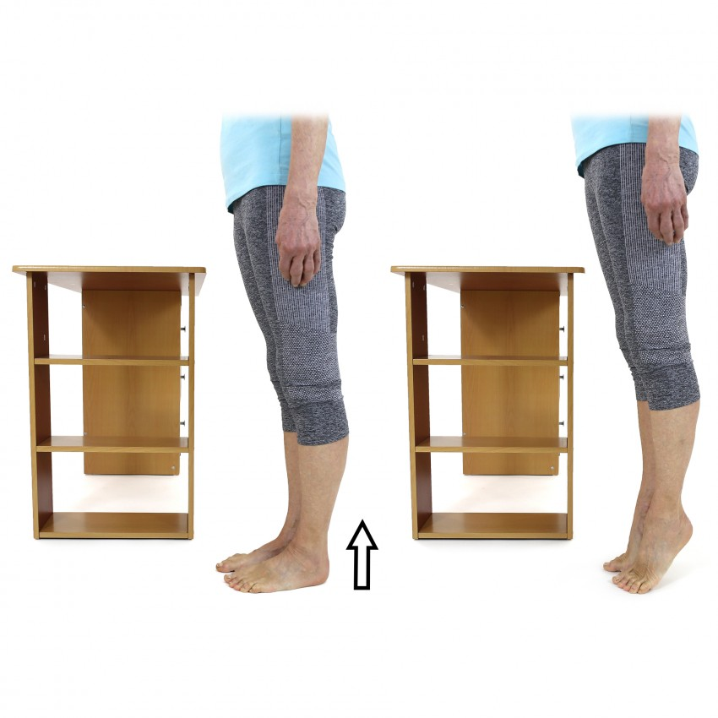
-In standing position, face forwards holding onto a sturdy support with your feet shoulder width apart
-Come up onto your toes lifting heels from the ground.
-Keep your heels raised and count to 3
-Repeat 10 times

Make it harder:
-Remove hands from the support if you feel steady

Toe Raises
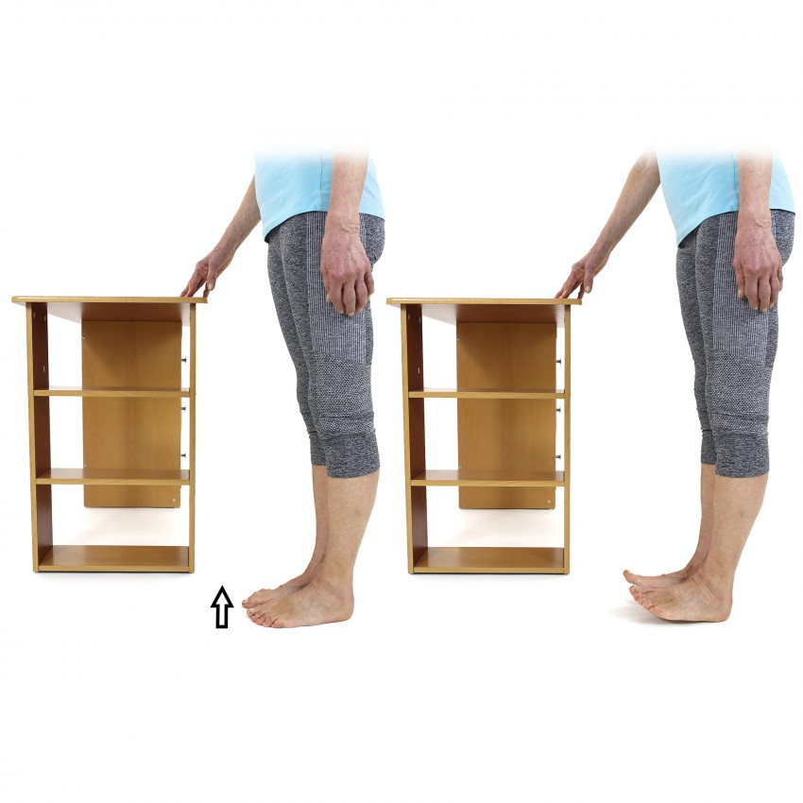
-In standing position, face forwards holding onto a sturdy support with your feet shoulder width apart
-Come back on your heels lifting toes from the ground.
-Keep your toes raised and count to 3
-Repeat 10 times

Make it harder:
-Remove hands from the support if you feel steady

Sit to Stand
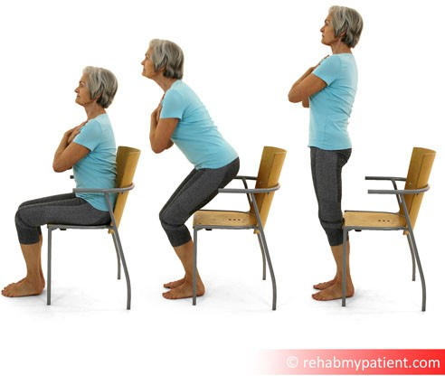
-Use a sturdy chair that is not too low
-Sit on the chair with feet ﬂat on the ﬂoor
-Lean forward and slowly stand up using your hands if needed
-Sit down again
-Repeat x 5

Make it harder:
Place your arms across your chest and stand without using your hands

Page: 1 /

Straight-Line Balance Standing
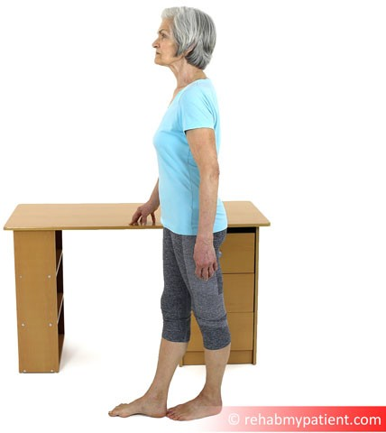
-Hold onto a support and stand up tall with feet together.
-Take a step forward with your right leg placing it directly in front of your left foot so the heel and big toe are touching
-Hold for 10 seconds making sure your foot doesn't rest against your other leg whilst balancing
-Swap legs so your left leg is in front and begin again
-Repeat twice

Make it harder:
-Remove hands from the support if you feel steady
-Close your eyes
-Increase to15 seconds

Single Leg Stand
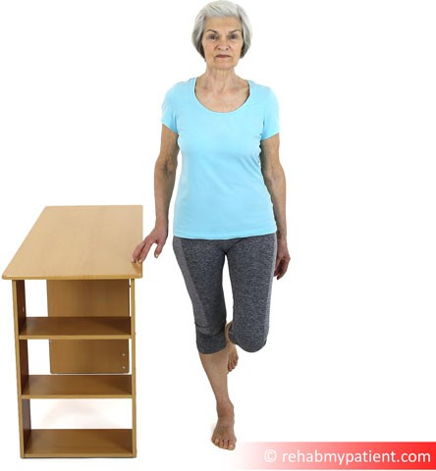
-Hold onto a support and stand up tall with feet together.
-Bend your right knee so your foot comes up oﬀ the ground
-Hold for 10 seconds
- Swap legs so your left foot is oﬀ the ground and begin from the start.
- Repeat twice

Make it harder:
-Remove hands from the support if you feel steady
-Close your eyes
-Increase to15 seconds
Notes:

