Health Screening Questionnaire
1. Personal Details | Yes | No | Answer
Who is completing this assessment? |  |  | □ The patient  □ Someone else on behalf of the  patient  Confirm your relationship to the patient:  _______________________________
Patient full name
Date of birth
NHS number
Preferred contact number
Email
Name of next of kin
Relationship of next of kin
Mobile number of next of kin
Do you require an interpreter? |  |  | If yes, what language?
Do you live alone?
Who will be looking after you for the first 24 hours when you go home? Remember to make arrangements if you think that you will require extra help at home after this procedure
Are you currently serving in the military, a veteran or part of a military family?
What is your current weight? |  |  | ___________ Kg / St and Lbs (Circle)
What is your current height? |  |  | ___________ cm / Ft and In (Circle)
Is your weight now lower than it was 3 – 6 months ago?
If yes, was this weight loss planned?
What was your weight 3 – 6 months ago? |  |  | ___________ Kg / St and Lbs (Circle)
Do you currently have a large non-healing wound or pressure ulcer? |  |  | If yes, please give details:
Do you have Crohn’s disease or Ulcerative Colitis AND are scheduled for abdominal surgery? |  |  | If yes, please give details:
2. Fitness and Frailty | Yes | No | Answer
Are you able to climb a flight of stairs or walk up a hill?
Are you able to do heavy work around the house?
Are you able to participate in strenuous sports?
Are you able to do work in the garden such as raking leaves or sweeping the drive?
If you answered no to ALL of the above, what limits you? |  |  | □ Joint / limb pain  □ Chest Pain  □ Shortness of breath  □ Other: __________________
Based on the below images and descriptions, how would you rate yourself? (Circle your answer) |  |  | 1 2 3 4 5 6 7 8 9
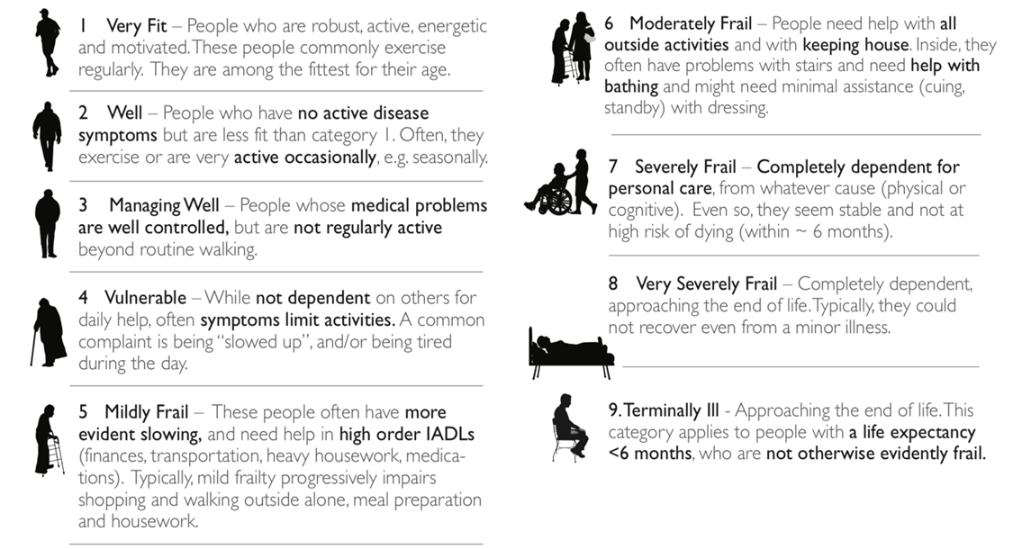
3. Heart Disease | Yes | No | Answer
Have you had your blood pressure measured in the past year?
If yes, has your blood pressure been measured as LESS than 160/100 at least once in the last year?
Have you had a heart attack?
If yes, was it in the last year?
Do you have a pacemaker or implanted defibrillator? |  |  | If yes, what do you have fitted?  □ Pacemaker  □ Implanted defibrillator
If yes, in which hospital was it implanted?
When was the device last checked?
Do you have any coronary stents?
If yes, how many stents?
What year were the stent(s) inserted?
Were you born with a congenital heart defect? |  |  | If yes, please give details:
4. Breathing Disorders | Yes | No | Answer
Do you have any lung conditions? |  |  | If yes, what condition(s)?  □ Asthma  □ Emphysema  □ Chronic Bronchitis  □ COPD  □ Bronchiectasis  □ Other: _____________________
Do you use oxygen at home?
Do you have sleep apnoea? |  |  | If applicable, please bring your CPAP machine with you into hospital
Do you have a tracheostomy?
For tobacco products (cigarettes, cigars etc), what statement applies to you? |  |  | □ I currently smoke tobacco  products  □ I am an ex-smoker  □ I have never smoked
For vaping products, what statement applies to you? |  |  | □ I currently vape  □ I am an ex-vaper  □ I have never vaped
Do you use any other products containing nicotine?
If applicable, are you currently receiving any support to give up smoking / vaping?
If applicable, would you like support to give up smoking / vaping?
If applicable, would you like to be considered for nicotine replacement therapy?
5. Hormone, Renal, Liver and Bleeding Disorders | Yes | No | Answer
Do you have diabetes (diabetes mellitus)?
If yes, is your most recent Hba1c test result greater than 69?
When was your last Hba1c test? |  |  | □ Less than 3 months ago  □ 3 – 6 months ago  □ More than 6 months ago
Have you ever been diagnosed with kidney disease?
If yes, are you on dialysis?
Have you ever been diagnosed with liver disease? |  |  | If yes, please give details
Do you have thyroid disease? |  |  | If yes, please give details
If yes, have you had a change in your thyroid medication / dosage in the last year? |  |  | If yes, please give details
Do you have a urinary catheter?
Do you suffer with anaemia?
If required, would you accept a blood transfusion? |  |  | If no, please give details
Have you ever been diagnosed as having a clot in the leg (deep vein thrombosis) or in the lung (pulmonary embolism)? |  |  | If yes, how long ago?
Have you, or any close relative, been diagnosed with any inherited blood disorder such as sickle cell disease, clotting or bleeding disorder? |  |  | If yes, please give details
Do you currently drink alcohol? |  |  | If no, move to Section 6
If yes, how often do you have a drink containing alcohol? |  |  | □ Monthly or less  □ 2 – 4 times per month  □ 2 – 3 times per week  □ 4+ times per week
How many units of alcohol do you drink on a typical day when you are drinking alcohol? |  |  | □ 1 – 2  □ 3 – 4  □ 5 – 6  □ 7 – 9  □ 10 +
How often have you had 6 or more units (if female) or 8 or more (if male) on a single occasion in the last year? |  |  | □ Never  □ Less than monthly  □ Monthly  □ Weekly  □ Daily or almost daily
6. Brain, Nerve and Musculoskeletal Disorders | Yes | No | Answer
Are you registered blind?
Do you have severe hearing loss?
Do you suffer from fits, fainting or blackouts?
Have you ever had a TIA or stroke? |  |  | If yes, how long ago?
Do you suffer with anxiety or depression which limits your lifestyle? |  |  | If yes, please give details
Do you have any learning disabilities and / or autism? |  |  | If yes, please give details
Do you have any other disabilities? |  |  | If yes, please give details
Do you have Dementia / Alzheimer’s / or other memory problems?
Do you have a spinal cord injury which has resulted in paraplegia or tetraplegia?
If yes, at what level of the spine was the injury?
Do you have any respiratory support? |  |  | If yes, please give details
Do you suffer from dysreflexia?
Do you need wheelchair access?
If yes, do you require hoisting?
7. Anaesthetics and Previous Operations | Yes | No | Answer
Have you ever had problems with a previous anaesthetic? |  |  | If yes, please give details
Have any of your blood relatives ever had problems with anaesthetics? |  |  | If yes, please give details
8. Medication | Yes | No | Answer
Are you taking any of the following medications? (Select all that apply) |  |  | □ Medicines prescribed by a GP  □ Medicines prescribed by a hospital specialist  □ Herbal medication  □ Over the counter medication  □ Recreational medication  □ Vitamins  □ Other: ____________________
Please give details of any medication you take that has NOT been prescribed by a GP |  |  | Include the name of the medicine, dose and frequency
Are you taking blood thinning tablets or injections (such Apixaban, Aspirin, Clopidogrel, Dabigatran, Dipyridamole, Edoxaban, Prasugrel, Rivaroxaban, Ticagrelor or Warfarin)?
Are you taking regular doses of opioids / pain killers such as Morphine, Oxycodone, Fentanyl, Methadone etc. (excluding codeine)?
Are you taking MAOI tablets (you will carry a card if you do)?
Are you taking steroids as inhalers?
If yes, do you carry a steroid emergency card for this?
Are you taking steroids as tablets?
If yes, do you carry a steroid emergency card for this?
9. Allergies, Infection Risks and Other Medical Conditions | Yes | No | Answer
Have you ever had a reaction to medicines or other substances (e.g., food / topical agents / latex / metal / other)? |  |  | If yes, please give details
Have you been told you have had an infection resistant to antibiotics such as MRSA, VRE, ESBL, AmpC, C.difficile, CPE or other? |  |  | If yes, please give details
Have you been an inpatient in a UK hospital in the last 12 months? |  |  | If yes, what hospital?
Have you received any medical treatment in a hospital abroad in the last 12 months? |  |  | If yes, what country?
Are you having eye surgery?
If yes, has anyone in your family ever had CJD (or other similar prion disease)? |  |  | If yes, please give details
Have you received Growth Hormone or Gonadotrophin treatment? |  |  | If yes, please indicate what the hormone was:  □ Human origin  □ I don’t know
If yes, what year did you receive the treatment?
In what country did you receive the treatment?
Is there any other medical condition or problem, not previously mentioned, monitored by your GP or a specialist that you feel we should know about? |  |  | If yes, please give details
Are you or could you be pregnant? |  |  | If Male, leave blank
Occasionally we have dates for surgery that come up at short notice. If this is the case, would you be available and like to be contacted to attend with 10 working days’ notice?

Once you have completed the assessment, please return the forms to the Pre-Operative Assessment Unit either in person or by post to the address below:

Pre-Operative Assessment Unit
Block 4 SDH Central
Salisbury District Hospital
Salisbury
Wiltshire
SP2 8BJ

