 | 

Salisbury NHS Foundation Trust

Adult Palliative and End of Life Care Strategic Plan

2023 – 2030

Vision: “Promoting Outstanding Palliative and End of Life Care for Everyone”


- Executive Summary

“End of Life Care affects us all, at all ages, the living, the dying and the bereaved.”

This strategy builds on “Ambitions for Palliative and End of Life Care: A national framework for local action 2021-2026” ¹, the regional “Vision for Enhanced Palliative and End of Life Care across the BSW Integrated Care System” (March 2021) ² and the Salisbury Foundation Trust Organisational Strategy: “Our Strategy 2022-2026”³.

It is an opportunity for Salisbury NHS Foundation Trust (SFT) to address the Palliative and End of Life Care (PEOLC) challenges, working collaboratively with the wider BSW Integrated Care System and other partners in Hampshire and Dorset. Collectively, the aim is to support the growing and changing needs of the community and together bring about societal change so that “Dying is seen as an integral part of life, as natural and predictable as being born” (Kubler-Ross).

  - Vision
Promoting outstanding Palliative and End of Life Care for everyone.

The PEOLC strategy reflects the significant changes that have occurred within the health system over recent years with the publication of the NHS Long Term Plan⁴, and the NHS People Plan⁵. The resulting integration of local health and care is driving how we provide local services with a collective responsibility to improve health and care provision. The COVID-19 pandemic has also had an immeasurable impact both on health service provision and how the population view death and dying. The pandemic has forced us to review how we prioritise and adapt our services and how we collaborate with all local partners during challenging times.

  - Aims
The SFT PEOLC aims will ensure that patients are treated with care, compassion, and kindness, and that the Trust provides a full range of services including access to appropriate specialists. Staff within the Trust will be valued and enabled to develop to provide skilled and effective care. Services will be delivered efficiently, ensuring equitable access and patient and family choice.

Aim 1: To improve the recognition of patients approaching the end of their life and have open and honest conversations with them and those important to them.
Aim 2: To have a caring, compassionate, and competent workforce to deliver excellent PEOLC for all.
Aim 3: To deliver high quality personalised care at end of life, involving patients and those important to them in decisions about their care.

  - Ambitions
To deliver these aims we will build on the Ambitions for PEOLC set out in the national framework by the National Palliative and End of Life Care Partnership (2021 – 2026),
(Figure 1).
Figure 1: National Palliative and End of Life Care Partnership Ambitions

  - Implementation of the PEOLC Strategy
Operational progress with implementation of the PEOLC Strategy will be overseen by SFT End of Life Steering Group and reported to the Trust Board and commissioners on an annual basis. The End of Life Steering Group will produce and work to an annual work plan to achieve the above ambitions. The work plan will prioritise, focus, and manage specific objectives needed to fulfil the strategy.

  - Indicators of Success
- CQC Inspection aiming for Outstanding rating.
- Strong NACEL results (National Audit of Care at the End of Life).
- Improved feedback from bereaved relatives.
- Reduction in complaints/concerns relating to end of life care.
- Increased percentage of patient’s living and dying in their place of choice.
- Increased number of patients involved in planning their future care.
- Improved recognition of patients living with uncertainty and information sharing.
- Increased numbers of patients having a ReSPECT discussion/documentation.
- Increased number of patients having a personalised care plan in the last days of life.
- Increased number of staff who have undertaken training in end of life care in all staff groups across the Trust.
- Implementation of electronic systems including SystmOne and introduction of an Integrated Care Record so PEOLC information can be shared across settings.
- Improved EOLC discharge process and data collection to evidence this.

This strategy lays out the PEOLC aspirations of SFT. Primarily there is q need to improve the recognition of patients approaching the end of their life and have meaningful conversations with them and those important to them, to enable them to live well until they die. This includes the importance of making sure these conversations are heard and shared, allowing people to die well with the right support, at the right time and in the right place.

This strategy will inform service improvement work to ensure we have a competent, confident, and resilient workforce, with the resources to provide the care required. In addition, that the collaborative work across the BSW ICS provides a sustainable future to reduce inequalities in PEOLC provision and ensure that everyone has access to outstanding palliative and end of life care.

- Strategic Context
Salisbury District Hospital is a district general hospital in south Wiltshire run by SFT. As part of the Bath, Northeast Somerset, Swindon, and Wiltshire Integrated Care System (BSW) the trust delivers a broad range of clinical care to approximately 270,000 people in Wiltshire, Dorset, and Hampshire. The Trust manages the Salisbury Specialist Palliative Care Service and has a dedicated End of Life Care team, recognising the importance of these services wherever the patient is; in their own home, a care home, in the acute hospital or Hospice, and at whatever stage of their life limiting illness.

The SFT Organisational Strategy: “Our Strategy 2022-2026” recognises through its vision, core values and behaviours, the key aspects required when providing PEOLC. Key strategic aims are to promote outstanding care for patients and their families, and to support healthcare professionals to be able to achieve this. This strategy is based on the Trust values and recognises that our patients and those important to them should be at the centre of everything it does, and that PEOLC is everyone’s responsibility.

 | Our focus is on delivering high quality, safe and person focussed care through teamwork and continuous improvement.
 | We will be open and honest, efficient and act as role models for our teams and our communities.
 | We will be action oriented and respond positively to feedback.
 | We will be welcoming to all, treat people with respect and dignity and value others as individuals.
 | We will constantly seek to improve and transform the way we work, to ensure that our services respond to the changing needs of our communities.

The Trust Strategic priorities are based on Population, Partnerships and People and these provide the context for PEOLC present and future challenges:
Population: Improving the health and well-being of the population we serve

By better understanding our population we will be in a stronger position to provide personalised PEOLC for all those that need it, irrespective of patient age, race, social deprivation, gender, or diagnosis. In addition, recognising the need to support vulnerable members of our community and ensure fair access to high quality PEOLC services, enabling all to live and die well. Population data shows that SFT supports a growing and aging population. The Wiltshire population has grown by over 17% since 2002 and the 65+ population has increased by over 30% in the last 10 years alone. This has a significant impact on healthcare services with more people living longer, with more complex and multiple health conditions. This reiterates that SFT cannot work alone and the importance of working collaboratively.

Partnerships: Working through partnerships to transform and integrate our services

The benefit of SFT managing an integrated and comprehensive Specialist Palliative Care Service on site means that both clinical and improvement work can contribute to a seamless patient journey, alongside collaborative service transformation across organisational barriers. This also means that SFT is at the heart of the BSW PEOLC Alliance, instrumental in driving positive change in care for patients. The purpose of the Alliance is to deliver the BSW Health & Care Model for the population we serve. PEOLC epitomises every aspect of this model with the emphasis on individualised care, allowing patients to live as well as they can until their death and supporting their loved ones into bereavement.

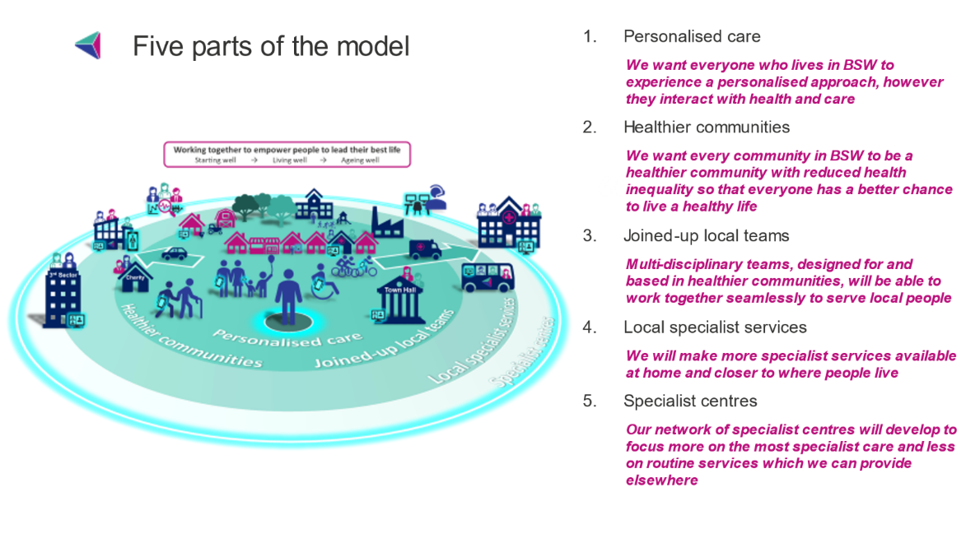
Figure 2: BSW Health & Care Model

People: Supporting our People to make Salisbury NHS Foundation Trust the Best Place to work

Our workforce is our most valuable asset. Providing high quality compassionate PEOLC relies on competent and confident staff working together with patients, those important to them and the extended team. If SFT is to provide outstanding compassionate care to its whole community it needs to attract, retain, and develop a workforce that is valued and supported and in turn is passionate about the quality of care it provides. Having a robust PEOLC training programme is vital. There is also a need to provide an environment that supports staff in the delivery of excellent care.

- National Palliative and End of Life Care Partnership Ambitions

Ambition One: Each person is seen as an individual.
I, and the people important to me, have opportunities to have honest, informed, and timely conversations and to know that I might die soon. I am asked what matters most to me. Those who care for me know that and work with me to do what is possible.

In order to have honest, informed, and timely conversations there is a need to recognise those who are approaching the end of their lives. The acute trust is excellent at recognising dying patients and supporting their last hours and days as evidenced by the NACEL audit. However, improving earlier identification of patients within the acute hospital will have a profound effect on the ability to inform, support and plan for patients’ end of life care, involving those close to them before a crisis hits. This cultural change will promote individualised care, changing the narrative from “what’s the matter with you” to “what matters to you”.
Salisbury Foundation Trust will aim to:

- Improve recognition of those approaching the end of their lives through working with colleagues in the acute trust and across the ICS.
- Involve patients and those important to them in decision making about their care and future planning through:
  - The Respect process.
  - Formal Advanced Care Planning
  - Asking “what matters to you”.
- Offer personalised holistic assessment and involve appropriate members of the wider multiprofessional team.
- Offer sensitive and timely bereavement information and support.

Ambition Two: Each person gets fair access to care.
I live in a society where I get good end of life care regardless of who I am, where I live or the circumstances of my life.

Firstly, we need to understand our population, linking in with the SFT strategic priority. SFT will use local data to inform service provision, understand vulnerable communities and how to engage, advocate and support, but most importantly listen to our community and respond.
Salisbury Foundation Trust will aim to:

- Know their community through working with partners across the ICS, using data and feedback to better serve our community.
- Collaborate closely with the Specialist Palliative Care Team and its associated charity, and other statutory and voluntary organisations to continually look at ways to improve access to specialist palliative care.
- Ensure fair access to care for those who are more vulnerable and less able to advocate for themselves.
- Promote joint working between specialist palliative care and other specialties to improve PEOLC for all, irrespective of diagnosis.
- Have robust ways to support those transitioning from paediatric to adult services with PEOLC needs.
- Embed methods for measuring patient outcomes, in order to improve patient care.

Ambition Three: Maximising comfort and wellbeing
My care is regularly reviewed, and every effort is made for me to have the support, care and treatment that might be needed to help me to be as comfortable and as free from distress as possible.

In order to provide high quality and personalised end of life care SFT needs to have a skilled and competent workforce supported by expertise from the End of Life Care Team and the Specialist Palliative Care Team. Staff need to be supported with up-to-date facilities, including an appropriate physical environment, equipment such as syringe drivers, appropriate IT resources and evidence-based guidelines and care plans.

Salisbury Foundation Trust will aim to:
- Provide an adequately staffed and competent End of Life Care Team and Specialist Palliative Care Team to support patients, those important to them and healthcare professionals 7 days a week.
- Provide skilled holistic assessment and symptom management.
- Have an adequately staffed and skilled chaplaincy service providing spiritual support for those of any or no faith.
- Continue to embed the use of the Personalised Care Framework (PCF), supporting patients and those important to them in the last hours and days of life, across the Trust.
- Continue to review, audit, and develop the PCF.
- Look at ways to improve the environment for patients dying in the acute setting, including appropriate areas for difficult conversations.

Ambition Four: Care is coordinated.
I get the right help at the right time from the right people. I have a team around me who know my needs and my plans and work together to help me achieve them. I can always reach someone who will listen and respond at any time of the day or night.

A comprehensive and fully integrated specialist palliative care service within SFT allows for a seamless patient journey across all care settings (acute, community, care home and hospice). The lack of organisational barriers allows services to be responsive and flexible ensuring that patients receive the right care, at the right time in the right place. The strong relationship between primary and secondary care around caring for patients approaching the end of their life is facilitated through the Specialist Palliative Care service and allows best practice to be shared at both patient and population levels. Collaborating with partners across the ICS and being an integral part of the BSW PEOLC Alliance means that care is co-ordinated across service boundaries and strategic developments are system wide. Enhancing this working through the implementation of SystmOne as the SPCS Electronic Patient Record (EPR) will further enhance joined-up working.

Salisbury Foundation Trust will aim to:

- Work alongside BSW ICS partners to ensure effective sharing of important PEOLC clinical information between services by:
  - Supporting the BSW PEOLC development of an EOLC integrated care record (ICR).
  - Ensuring that Trust electronic patient records facilitate sharing end of life information both within the acute trust and into the community.
  - Support the development of an electronic Respect form.
  - Ensuring that the electronic discharge process supports the sharing of key EOL information.
- Work with ICS partners to look at ways of enhancing the out of hours palliative and EOLC support that can be provided for patients, those important to them and healthcare professionals, through collaborative work as the 3 “BSW Hospices together”.
- Work with all available agencies to ensure, where possible, patients are cared for in their preferred place of care.
- Have a robust EOL Discharge process enabling those that wish to die at home to get home in a timely manner with the support they require.

Ambition Five: All staff are prepared to care.
Wherever I am, health and care staff bring empathy, skills and expertise and give me competent, confident, and compassionate care.

Providing quality end of life care is entirely dependent on having a competent and confident workforce, adequately resourced to provide compassionate care to patients and those important to them, and to colleagues. This links directly to the SFT strategic priority “People.” We need to ensure that SFT is an organisation where people want to work, to not only attract staff but also provide an environment where staff develop, grow, and choose to stay. With regard to PEOLC, if we can provide clinical support, expertise, training, and leadership, so that our staff know they are providing quality end of life care, we will have a more skilled, compassionate, and resilient workforce. This relies on leadership at Executive level to promote the importance of PEOLC supported by the PEOLC leads and the End of life Care Steering Group. SFT must aspire to a community of staff who are all willing and able, through appropriate support and training, to provide safe, effective, and compassionate PEOLC, and that we value every staff member role in providing that care.
“How we care for the dying is a litmus test for our society”⁶

Salisbury Foundation Trust will aim to:

- Ensure all staff dealing with patients and families towards the end of life have the skills and knowledge to deal with their needs with compassion and understanding.
- Make sure there is an appropriately resourced and resilient workforce.
- Support the EOL Clinical Nurse Specialist Team, Specialist Palliative Care Team and Education department to provide appropriate end of life training, communication skills training and health and wellbeing support to all Trust staff.
- Have clear governance at board level for high quality PEOLC.
- Have Trust-wide engagement with PEOLC, ensuring it is everybody’s business.
- Collaborate across the ICS and work with the BSW Academy.

Ambition Six: Each community is prepared to help.
I live in a community where everybody recognises that we all have a role to play in supporting each other in times of crisis and loss. People are ready, willing and confident to have conversations about living and dying well and to support each other in emotional and practical ways.

With the creation of Integrated Care Systems (ICS), the responsibility of SFT broadens to really make a difference to population health as a whole. This provides an opportunity to work across settings with our partners to make sure our society understands and embraces the fact that “death is a part of all our lives” (Dalai Lama). To support our society in this, we as an organisation also need to embrace it, and accept that much of the time our role is to support, treat and care for our patients and their loved ones through times of uncertainty.
This requires a change in attitudes and culture by signing up to the “what matters to you” charter and supporting the Dying Matters coalition. In addition, providing the EOLC Team and Specialist Palliative Care Teams the resource, space and voice to bring their expertise, ICS developments and national direction to build compassionate communities both within our organisation and more widely within the community we serve.

Salisbury Foundation Trust will aim to:

- Engage with our community to improve public awareness of death and dying.
- Maximise the benefit of having a specialist palliative care service within the trust to promote awareness of the end-of-life care in our community.
- Engage with volunteers to support patients and their families within the hospital and hospice to develop novel ways of working across boundaries.
- Work Collaboratively across the ICS to support the concept that we live in a society “where death is a part of life”⁷.

- References

- Ambitions for Palliative and End of Life Care: A national framework for local action 2021-2026”
- “Vision for Enhanced Palliative and End of Life Care across the BSW Integrated Care System” 2(March 2021)
- SFT Organisational Strategy: “Our Strategy 2022-2026”3
- NHS Long Term Plan
- NHS People Plan 5
- NHS “End of Life Care Strategy” 2008
- Everyday, Everyone, Dorothy House Hospice Strategic Plan 2018 - 2025

